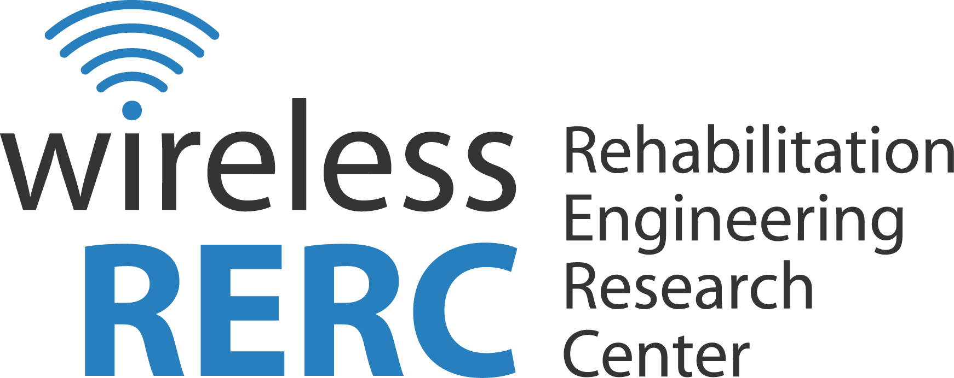
Technology and Disability Policy Highlights
Spring Issue: March – April 2016

Overview

This spring, the Federal Communications Commission (FCC) moved the needle forward on several large communications issues that impact access by people with disabilities. In April, the FCC Order concerning the Lifeline and Linkup programs [WC Docket No.11-42] took a variety of actions to create an affordable Lifeline broadband program. The Order discusses the minimum service standards for Lifeline Services, asserting that functional Internet access is essential to allow consumers to fully participate in society. The FCC also approved a real-time text proposal to ensure that people with disabilities who rely on text messaging to communicate will have accessible and effective telephone access. In anticipation of the transition from legacy telephone technology like TTY, to new, IP-based solutions, AT&T submitted an update on the status of their real-time-text (“RTT”) development efforts.
In March, the FCC sought to expand the video description rules to ensure access of video described programming to people that are blind or have low vision. Video description is the addition of audio descriptions of key visual elements of onscreen action during pauses in dialogue. Among other things, the NPRM [16-37] proposes an increase in the amount of video described programming from 50 hours per calendar quarter to 87.5 hours.
In Wireless RERC news, On April 27, 2016, Salimah LaForce and Christina Touzet presented a poster titled, Emergency Alert System (EAS) vs. Wireless Emergency Alerts (WEA), at the Disaster Response and Mitigation Forum. The research presented the background and results of research activities that examined the effectiveness of EAS and WEA to provide alerts to people with disabilities. Ed Price demonstrated the Wireless RERC's prototype of a WEA Video Platform that includes IPAWS approved symbology and presents the WEA message content as an American Sign Language (ASL) video. The Wireless RERC also hosted an Emergency Lifelines Workshop & Tabletop which included 44 individuals representing local, state, federal and academic leaders who play a role in emergency communications. This one day workshop heightened awareness about the need for accessible emergency communications and feasible approaches to ensure timely lifesaving information from the public safety officials is sent to people with disabilities.
The Wireless RERC, in partnership with AT&T Corporate Accessibility Technology Office are conducting workshops for people with disabilities, caregivers, and professionals on how to use accessibility features found on smartphones and tablets. There are seven upcoming workshops in Washington, D.C., Dallas, TX; Chicago, IL; Boston, MA; and Atlanta, GA. Wireless Independence Now! Workshops are free of charge, open to the public, and are not marketing or sales events.
Click the headings below to link directly to a particular section.

Regulatory Activities Wireless RERC Updates Publications/Reports Other Items of Interest Upcoming Events

Regulatory Activities

FCC Adopts Real-Time Text Proposal / AT&T Real Time Text Status Report
April 28, 2016 - The FCC approved a proposal to use real-time text to ensure that people with disabilities who rely on text messaging to communicate, will have accessible and effective telephone access. This technology will allow Americans who are deaf, hard of hearing, speech disabled or deaf-blind to integrate into tomorrow’s communications networks. This Notice of Proposed Rulemaking recognized real-time text as a replacement technology for TTY devices beginning in December 2017.
Real time text messaging allows text messages to be sent immediately when typed without pressing send, as a result the receiver can read what the sender is creating, allowing for a conversational interaction. An example of its potential impact is that by not requiring the users to press send, 911 call center personnel will be able to receive incomplete messages.
Real-time text enables further integration for individuals with disabilities into IP communication networks, allowing individuals to interact directly with consumers on voice phones. The rulemaking proposes that wireless phones and communication devices be able to support real-time text services and allow simultaneous text-to-voice, voice-to-text communications, real-time text support for 911 emergency communications, and be compatible with technologies like screen readers while incorporating expected voice phone features.
In anticipation of this transition, AT&T is developing real-time-text (“RTT”) to deliver enhanced, interoperable disability access over IP-based networks. On April 6, 2016, AT&T submitted to the FCC, an update on the status of their development efforts. AT&T expects to reach agreements with mobile device manufacturers to provide a RTT solution embedded within mobile devices which will be followed by a testing of that embedded solution, AT&T is hopeful that the standards will be finalized mid-to-late 2016. AT&T plans to work closely with other wireless carriers to provide interoperable RTT across carriers.

Additional Information:
FCC Adopts Real-Time Text Proposed Rulemaking
[https://www.fcc.gov/document/fcc-adopts-real-time-text-proposed-rulemaking]
IP-Voice Accessibility Status Report of AT&T
http://apps.fcc.gov/ecfs/document/view?id=60001568602

FCC Order Creates Lifeline Broadband Program
April 27, 2016 - This FCC Order concerning the Lifeline and Linkup programs [WC Docket No.11-42] takes a variety of actions to create an affordable Lifeline broadband program. The Order discusses the minimum service standards for Lifeline Services as functional Internet access is essential to allow consumers to fully participate in society. “Broadband access can help households meet their basic education needs for education, healthcare, disabilities access, and public safety.” The FCC encourages the private sector to work with the Lifeline program and providers to help make services more available and to explore options for offering accessible services and devices to consumers with disabilities. Following are some details from the Order:
- The National Verifier, a comprehensive integrator of process and systems that will determine subscriber eligibility for the Lifeline program. The National Verifier will use a variety of methods to communicate with subscribers who have limited means of communication in terms of mode and form. The FCC expects the National Verifier to provide access to subscribers with disabilities in accordance with all applicable laws and to provide service in multiple languages.
- For a lifeline-only broadband ETC offering a service for low-income subscribers with hearing disabilities, ‘media of general distribution’ may include web advertisements to reach the relevant community through other text-based methods of advertising.
- Effective digital inclusion efforts will significantly impact the lives of millions of consumers including people with disabilities.
- For many of today’s wireless consumers, specifically individuals with disabilities, text messaging is the prevalent means of communication. As a result, the FCC allows text messaging to qualify as usage for the Lifeline program.

Additional Information:
FCC 16-38, Third Report and Order. WC Docket No.11-42.
[http://transition.fcc.gov/Daily_Releases/Daily_Business/2016/db0427/FCC-16-38A1.pdf ]

FCC Releases Order on Multilingual Emergency Alert System (EAS) Messages
March 30, 2016 – In a recent Order, Review of the Emergency Alert System [EB Docket No. 04-296], the FCC continues its commitment to providing the EAS to as large an audience as possible, including those for whom English is a second language. EAS participants that make alert messages available in languages other than English are now required to report their efforts. The FCC contends that this reporting requirement will help them understand the current state of delivery of EAS messages to the multilingual population. The State Emergency Communications Committees will analyze the data to determine the availability of multilingual EAS across the United States.

Additional Information:
Order: Review of the Emergency Alert System [EB Docket No. 04-296]
[http://transition.fcc.gov/Daily_Releases/Daily_Business/2016/db0330/FCC-16-32A1.pdf]

FCC Proposes the Expansion of Video Description Rules
March 31, 2016 - The FCC seeks to expand the video description rules to ensure access of video described programming to people that are blind or have low vision. Video description is the addition of audio descriptions of key visual elements of onscreen information or action during pauses in dialogue. This would allow people who are blind or have visual impairments to fully enjoy popular television shows. The NPRM [16-37] proposes:
- An increase in the amount of video described programming from 50 hours per calendar quarter to 87.5 hours;
- An increase in the amount of network covered by the rules;
- Implement a rule that requires compliance even if a network loses their top five or top ten ranking;
- Removal of the pay TV threshold requirement for non-broadcast networks;
- Require customer service representatives with knowledge of video description; and
- Require the electronic filing of petitions for exemptions from the rules.

Additional Information:
News Release
http://transition.fcc.gov/Daily_Releases/Daily_Business/2016/db0331/DOC-338677A1.pdf

FCC Releases Public Notice to Service Providers and Manufacturers
March 4, 2016 - The FCC released a Public Notice [DA 16-248] reminding equipment advanced communications manufacturers and service providers of their requirement to maintain records of actions taken to implement accessibility requirements of the Twenty-First Century Communications and Video Accessibility Act of 2010 (CVAA). This is an annual requirement and records are kept in the Recordkeeping Compliance Certification and Contact Information Registry. The companies are asked to include:
- Details regarding consultation with people with disabilities to inform the design and development of products and services;
- Details regarding the accessibility features of the products and/or services; and
- Details regarding compatibility of their products and/or services with assistive technologies used by people with disabilities.

Additional Information:
Public Notice [DA 16-248]
http://transition.fcc.gov/Daily_Releases/Daily_Business/2016/db0304/DA-16-248A1.pdf

Corporations Send Joint Letter to FCC Regarding Lifeline
March 1, 2016 - Several organizations and corporations including AT&T, Verizon, Cox Communications, Public Knowledge, Benton Foundation, the Multicultural Media, Telecom and Internet Council, and others wrote a letter to the FCC Chairman and the Commissioners suggesting changes to the Lifeline program. They requested that eligibility and recertification services that are currently managed by service providers be turned over to a third party administrator. They also recommended that the FCC streamline the broad provider participation process to quickly provide broadband providers with the tools to administer the Lifeline program. The signatories assert that these changes will ensure that the accessibility to broadband for those who cannot afford it will continue to increase. The letter closes with,
“To fulfill the vital purpose of bringing broadband to those who otherwise cannot afford it, we want both the broadest participation possible and the flexibility to create innovative solutions. This requires a uniform national policy that, while preventing fraud and abuse, encourages maximum participation and encourages innovative ways to provide affordable broadband. Unfortunately, creating such a broadband Lifeline program is incompatible with the current process of approving authorized providers.”

Additional Information:
Letter Re: Lifeline and Link Up Reform and Modernization
[https://www.publicknowledge.org/assets/uploads/documents/Joint_Lifeline_Letter_%28FINAL__3-1-2016%29.pdf]

Wireless RERC Updates

Wireless RERC at the 2016 Disaster Response and Mitigation Forum
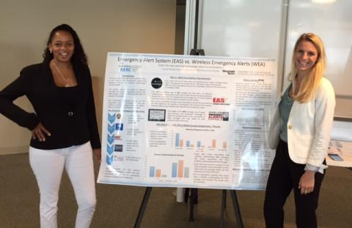
On April 27, 2016, Salimah LaForce and Christina Touzet presented a poster titled, Emergency Alert System (EAS) vs. Wireless Emergency Alerts (WEA), at the Disaster Response and Mitigation Forum held at the Garage @ Tech Square on Fifth. The research, conducted by the Wireless RERC and funded by a grant from the National Institute on Disability, Independent Living and Rehabilitation Research (NIDILRR), presented the background and results of research activities that examined the effectiveness of EAS and WEA to provide alerts to people with disabilities. Specifically, the poster included comparative analyses of the awareness of EAS and WEA messages, the accessibility of the two systems, as well as the types of protective actions taken as a result of the emergency messages.
Ed Price demonstrated the Wireless RERC's prototype of a WEA Video Platform that includes IPAWS approved symbology and presents the WEA message content as an American Sign Language (ASL) video.
The goal for the forum was to understand ways in which to advance science and technology to improve disaster response. The Forum featured two panels with federal, state and local agency representatives, as well as speakers from NGOs, industry, and academic researchers. The 2016 forum also included a reception along with a poster session that focused on technologies and applications that impact disaster response, address cutting-edge research that is being done to meet the challenges of disaster response, cover the latest disaster response policy issues, and address technology gaps that need to be filled to help identify solutions.

Additional Information:
Disaster Response and Mitigation Forum
[http://ipat.gatech.edu/disaster-response-and-mitigation-forum]

Emergency Lifelines Workshop & Tabletop Recap
The Rehabilitation Engineering Research Center for Wireless Technologies (Wireless RERC) hosted an Emergency Lifelines Workshop & Tabletop on April 14, 2016 in Atlanta, Georgia. The Emergency Lifelines Workshop & Tabletop was coordinated by Christina Touzet and held at the Georgia Tech Research Institute Conference Center. Forty-four (44) individuals representing local, state, federal and academic leaders who play a role in emergency communications were in attendance. This one day workshop heightened awareness among stakeholders about the need for accessible emergency communications and feasible approaches to ensure timely lifesaving information from the public safety officials is sent to people with disabilities.
The day began with two panels in the morning. The first panel gave an Update on Federal, State, and Local Emergency Communications, moderated by Helena Mitchell, Ph.D. The panelists included: Charles McCobb, Mary Hudak, and Susan Loeffler. Charles McCobb, from IPAWS - FEMA / DHS, gave an overview of the Integrated Public Alert and Warning System (IPAWS) and the common alerting protocol. Charles also discussed the future of emergency notification systems, and leveraging communications pathways via connected devices. Mary Hudak explained the regional level emergency communications operations and specifically how critical it is to engage the “whole community.” In order to engage with the “whole community” it is important to work with independent living centers in each state and offer assistive technology at the disaster recovery centers. “We aim to give the right information at the right time so people can make the right decisions.” Susan Loeffler provided insight on how DeKalb County Emergency Management Agency utilizes Code Red, social media and coordination with local organizations to reach their population of people with disabilities. DeKalb County issues Code Red, however only 5% of the population has opted in; as a result they are in the process of becoming an IPAWS alerting authority. Director Loeffler discussed how critical it is to create an initiative to get preparedness information out in the school system and to reach the kids who will share the information with their parents.
Figure 1: Panel #1: Charles McCobb, Mary Hudak, Helena Mitchell, and Sue Loeffler.
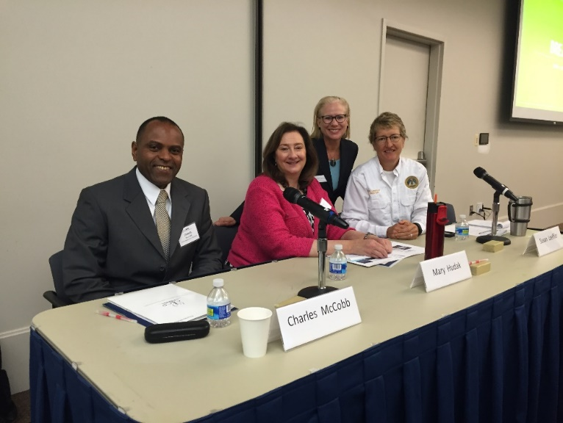

The second panel discussed State and Local Initiatives, moderated by Rick Wimberly, Galain Solutions. The panelists included: Wayne Smith, Betsy Kagey, Ph.D., Jennifer Hogan, and Kay Chiodo. Wayne Smith, Georgia Emergency Management Agency, provided insight about how the state level coordinates with the local level for emergency communications purposes. Betsy Kagey spoke about the Georgia Department of Public Health Emergency Communications initiatives and use of GIS to make responders aware of the medically at risk non-institutionalized population. Georgia has 159 counties and 18 health districts, it is necessary to connect with the populations that do not use social media and also the populations that are homebound. Jennifer Hogan spoke about the Georgia Emergency Preparedness Coalition for Older Adults and Individuals with Disabilities. She provided tips guides to attendees that provide tips for awareness to identify the unique needs of people with disabilities in an emergency. The quick reference provides specific, practical tips for working with people who have a wide range of disabilities. Kay Chiodo, CEO of DeafLink educated the audience on accessible emergency communications and how important it is to incorporate ASL video features into emergency alerts.
Figure 2: Panel #2: Wayne Smith, Betsy Kagey, Rick Wimberly, Jennifer Hogan, Kay Chiodo.
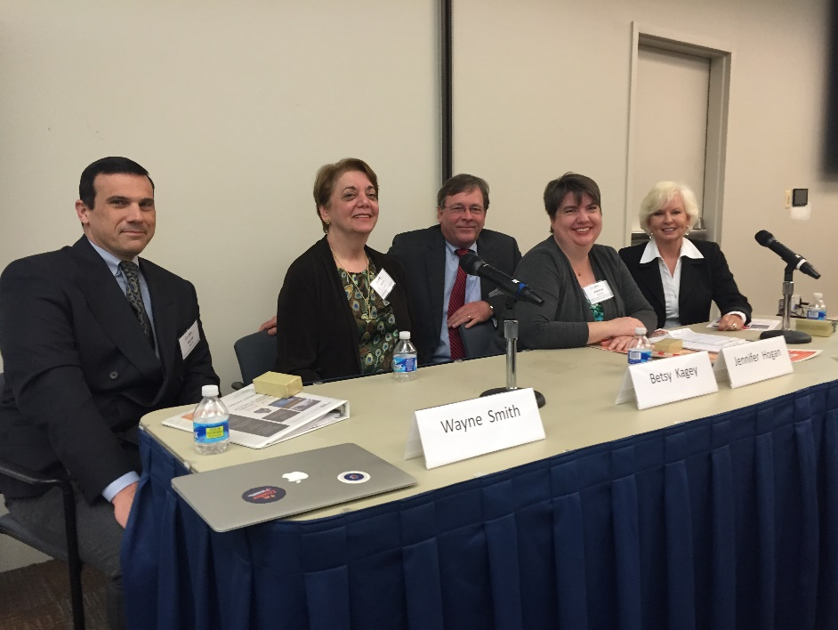

Following the two panels, at lunch time, was a poster and demo session for attendees to experience emergency communications research, technology, and additional resources. Demos included: Hamilton/Georgia Relay, FEMA IPAWS, FEMA Region IV, Georgia Emergency Preparedness Coalition, Accessible Weather App, Deaf Link Inc., Wireless RERC Research, and Accessible Wireless Emergency Alerts with ASL video feature, etc.
In the afternoon the Winter Storm Tabletop Exercise – a Discovery & Exploration was facilitated by Thomas Kempton, an emergency management consultant for the Wireless RERC. The tabletop exercise consisted of modules that reviewed different types of winter weather alerts, warnings and watches. Each table was able to discuss each of the modules as a table and troubleshoot different efforts made by agencies in relation to emergency communications. Each table discussed issues that could arise and how to communicate in an accessible manner throughout the alert and warning stages.
This tabletop exercise featured actual NWS generated weather watches and weather warnings for a winter storm in the Atlanta metro area. After presentation of each input the moderator posed a series of questions and each table was given time to discuss and then report out on what their discussions had revealed.
Attendees reported countless benefits from the day, including: greater awareness, networking, expanding horizons, gained knowledge in new areas, learned how to communicate with different agencies, excellent opportunity to learn from other experts and share mutual experiences and lessons learned, learned various challenges related to inclusion of people with disabilities or access and functional needs.
Upcoming Dates for Wireless Independence Now (WIN) - Smartphone Education Workshops for Consumers
This is the third year the AT&T Corporate Accessibility Technology Office and the Rehabilitation Engineering Research Center for Wireless Technologies (Wireless RERC) are conducting workshops for people with disabilities, caregivers, and professionals on how to use accessibility features found on smartphones and tablets. The 2016 schedule is as follows:
June 13-14 | Washington, DC | G3ict M-Enabling
June 24 | Chicago, IL | Abilities Expo
June TBD | Chicago, IL | AT&T Store of the Future
September 16 | Boston, MA | Abilities Expo
September TBD | Boston, MA | AT&T Store of the Future
TBD | Dallas, TX | AT&T Store of the Future
TBD | Atlanta, GA | AT&T Store of the Future

Wireless Independence Now! Workshops are free of charge, open to the public, and are not marketing or sales events. Participants do not need to be AT&T customers in order to attend. CART and Sign Language Interpreters will be provided as needed.
Workshops will review:
- Accessibility features found on smartphones, phablets, and tablets that use Apple or Android Operating Systems
- Accessibility resources for services, devices, and mobile applications
- Ways to improve the accessibility of devices and services
Workshops will focus on accessibility features helpful for the following users:
- People who use hearing aids
- People who use text and video services
- People who have communication difficulties
- People who have difficulty seeing
- People with attention, concentration, or sensory difficulties
- People with dexterity or mobility impairments
- Caregivers and Professionals who assist people with disabilities

Additional Information:
Check the Wireless RERC's WIN! Workshop webpage
[http://www.wirelessrerc.org/node/699?utm_source=Industry%2FCAN+Newsletter_2016-03-30&utm_campaign=Re%3AWireless+2016-03-21&utm_medium=email]

Publications/Reports

New Report Asserts Technology Fails to Meet Needs of Older People with Vision and Hearing Problems
March 10, 2016 - A study commissioned by Sense, the national charity for deafblind people in the United Kingdom, researched the experiences older people had with assistive technology. They found that service providers and assistive technology developers need to do more to meet the diverse needs of the aging population. Low awareness and availability of assistive technology were the most common problems found with adoption of the currently available technologies. The report also notes a lack of assistive technologies designed specifically for people with sight and hearing problems. The leader of the study Professor Sue Yeandle said, “Huge strides have been made in technologies which can help people with sight, hearing and other difficulties communicate with others and live well and independently. But too few of the growing number who could benefit get this equipment – and many of them lack items designed with their needs and lifestyles in mind, or don’t get the follow-up support needed to use them.”

Additional Information:

Announcement
[http://www.sheffield.ac.uk/news/nr/sense-report-deafblind-technology-1.557568]

Other Items of Interest

Telecommunications for the Deaf and Hard of Hearing is Hiring
April 29, 2016 - Telecommunications for the Deaf and Hard of Hearing (TDI) is seeking to hire for the position: Product Manager, Speech-to-Text Captioning Project. TDI is seeking a talented and versatile professional for the position of Product Manager for its soon-to-be developed, Speech-to-Text Captioning/Caption Correction, a two-year long grant project. Responsibilities include: surveying, accessing, preparing forecasts and analyses, planning, introducing, and marketing/developing the new product while maintaining professional and technical knowledge. Qualifications: Master’s degree is preferred, 3 years job related work experience, knowledge of technology, knowledge of disability access, successful experience in grant writing and project management, and a proven network of contacts and relationships with community leaders and service providers. For more information visit the TDI Website. The salary range for this position is $70,000-$85,000, depending on education and experience. TDI is an affirmative action/equal opportunity employer. All applicants must submit a cover letter and resume electronically, which includes a list of at least three professional references and compensation requirements via email to TDI Executive Director Claude Stout at cstout@tdiforaccess.org. APPLICATIONS MUST BE RECEIVED BY 5 P.M. ON OR BEFORE THE CLOSE OF DAY, May 25, 2016.

Additional Information:
TDI Website
[https://tdiforaccess.org/job/product-manager/]

New Accessible Technology Section Added to ADA.gov
April 24, 2016 - The Department of Justice has launched a new Accessible Technology section for ADA.gov, its Americans with Disabilities Act (ADA) website. Within the accessible technology web page are four subsections, including: enforcement, technical assistance and guidance, regulations, and technology initiatives. The enforcement web site reviews how the Department’s enforcement efforts have helped ensure that people with disabilities can access websites, electronic book readers, online courses and point-of-sale devices. The training and technical guidance web site provides guidance regarding website accessibility. The regulation development web site provides additional information from the provisions of Title II and III including information on web access, information and services and equipment, furniture and public accommodations.

Additional Information:
Accessible Technology Section
http://www.ada.gov/access-technology/guidance.html

NCD Funding Opportunity: Evaluate the Impact of Section 503 Rehabilitation Act Amendments
April 21, 2016 – The National Council on Disability (NCD) released a notice of funding for a cooperative agreement. Applicants are given the opportunity to propose methods for determining the impact of increasing employment opportunities for people with disabilities. The project seeks to examine the implementation and projected effectiveness of the amended Section 503 regulations that became effective in March 2014. Among other things, the resultant report is expected to develop recommendations for improving employee self-disclosure rates and discuss the Office of Federal Contract Compliance Programs’s role in improving contractor compliance. The award amount is $100,000 and proposals are due May 31, 2016.

Additional Information:
Funding Announcement
[
http://www.ncd.gov/newsroom/2016/funding-opportunity-section-503-amendments-report]

Netflix to add Audio Description to Their Video Content
April 14, 2016 - The American Council of the Blind (ACB) reached an agreement with Netflix to provide audio access to users who are visually impaired. Specifically, Netflix will provide ‘audio description’ to make movies and videos accessible for people that are blind or have low vision. Television and movie studios will create audio description tracks and provide them to Netflix. Netflix will also make their website and application accessible to individuals who use screen-reading software. According to the press release, “These improvements will provide people who are blind or low vision with unparalleled access to online video entertainment services currently enjoyed by millions of Americans.”

Additional Information:
Press Release
[http://dralegal.org/featured/netflix-enhance-access-customers-blind/]

National Disability Institute Launches Assistive Technology Loan Program
April 5, 2016 – The National Disability Institute (NDI), in partnership with Spring Bank and Bronx Independent Living Services, announced the launch of an Assistive Technology (AT) Loan Program in selected areas of New York. This program is funded by the U.S. Department of Education, Office of Special Education and Rehabilitative Services (OSERS) and will provide low-interest loans to people with disabilities, older adults and veterans who reside in New York City, Nassau County, Suffolk County and Westchester County. The loans range from $500 to $10,000 for up to 36 months and include home and vehicle modification, ramps, computers, hearing aids and other equipment that will increase individuals’ independence, productivity and quality of life to benefit individuals with disabilities in New York. The program is anticipated to expand to New Jersey in the near future.
“Affordable loans for assistive technology are another step in the right direction of making sure all people with disabilities can participate more fully in the marketplace. These loans are also crucial in helping individuals live as independently as possible in the community by giving them access to the resources they need to succeed.” Brett Eisenberg, BILS Executive Director
For more information including and assistive technology guide for New York and New Jersey and an AT Loan Program Fact sheet visit: http://www.realeconomicimpact.org/asset-development/assistive-technology-loan-program

Additional Information:
Press Release
http://www.realeconomicimpact.org/news/?id=1583

Facebook Accessibility Tools
April 5, 2016 - Facebook for iOS rolled out automatic alternative text (alt text) to provide people who are visually impaired or blind with a text description of a photo using recognition technology. Individuals using screen readers are now able to hear a list of items that may be shown in a photo. This feature is now available in English and Facebook plans to roll out the feature on additional platforms, in different languages and other markets soon. The launch of automatic alt text is just the beginning of Facebook’s creation of new technology for a more inclusive experience.

Additional Information:
Facebook Blog
https://code.facebook.com/posts/457605107772545/under-the-hood-building-accessibility-tools-for-the-visually-impaired-on-facebook/

Twitter Makes Images Accessible With Alternative Text
March 29, 2016 - People can now use alternative text to add descriptions to the images they tweet, so people with vision disabilities can know who or what is being depicted in the photo. It is now an enablable feature in the Twitter app. Twitter is also extending this feature to other products like REST API and Twitter Cards. Selecting the compose image descriptions option in the Twitter app’s accessibility settings will activate the alt text feature. Currently, the alt text feature is only available for the mobile Twitter app used on iOS and Android platforms.

Additional Information:
Twitter Blog
[https://blog.twitter.com/2016/accessible-images-for-everyone]

DOL Unveils New Web Tool to Help Make Online Applications More Accessible for People with Disabilities
March 23, 2016 - TalentWorks, announced by the U.S. Department of Labor’s Office of Disability Employment Policy, is a free tool to help employers ensure the accessibility of their online applications. This tool provided basic knowledge on accessibility as well as tips for making web interviews and online applications more accessible. Deputy Secretary of Labor Chris Lu said, “The U.S. Department of Labor is committed to helping employers improve their recruitment and hiring processes. With resources like TalentWorks, employers can build a diverse, more inclusive workforce by ensuring their organization’s virtual door is open to everyone.”

Additional Information:

News Release
http://www.dol.gov/newsroom/releases/odep/odep20160323

NV Access and The Paciello Group Partnership Concerning Web Accessibility
March 23, 2016 – NV Access and Paciello Group are partnering to provide professional web testing accessibility services to NV Access’ clients. James The, NV Access Executive Direction had this to say, “The Paciello Group are world renowned for their excellent work in web accessibility, but beyond that, we have a great deal of respect for the team’s obvious passion for and dedication to the field. We are very pleased to be partnering with The Paciello Group to provide high quality web accessibility consulting and testing to our clients.”

Additional Information:
Press Release
[https://www.paciellogroup.com/blog/2016/03/the-paciello-group-and-nv-access-announce-partnership/]

NCD Commends Senate Committee for Hearings on Self-Driving Cars
March 16, 2016 - The Senate Commerce Committee began hearings on self-driving vehicles with industry witnesses to explore “advancements in autonomous vehicle technology and its anticipate benefits for Americans.” Autonomous vehicles hold abundant potential for people with disabilities and seniors who currently do not have access to transportation. When the needs of individuals with disabilities, including blindness, are considered during the development stage of these products, everybody benefits from access to travel and commerce. At this stage, it is critical to involve disability advocates to ensure accessibility of this emerging technology in the future. The National Council on Disability (NCD) is proud to have represented the disability community from the beginning of federal policy conversations on this new emerging technology.

Additional Information:
Newsroom Story
[https://www.ncd.gov/newsroom/2016/national-council-disability-commends-senate-commerce-committee-hearings-self-driving]

Amazon and NFB Announce New Project to Improve Accessibility of Online Educational Content
March 2, 2016 - Amazon and the National Federation of the Blind (NFB) announced that they will be working together to enhance accessibility of educational reading technology for students with low vision or those who are deaf-blind. They will be leveraging Amazon’s educational platform to develop accessibility solutions for educational content and resources. Rohit Agarwal from Amazon had this to say, “We are seeing educational institutions embrace digital learning for its ease of access to a large selection of learning resources for students. This shift provides a great opportunity to improve accessibility for blind students. By collaborating with the National Federation of the Blind, we hope to advance accessibility for all content, platforms and applications that Amazon develops to better serve K-12 and higher education students.”

Additional Information:
Press Release
[https://nfb.org/national-federation-blind-and-amazon-join-forces-improve-accessible-reading-experiences-blind-and]

Upcoming Events

NENA 2016
The National Emergency Number Association (NENA) will hold its annual conference on June 11-16, 2016 in Indianapolis, IN. At NENA 2016, you learn about the public safety issues of today and tomorrow, and acquire practical, real-world know-how that you can apply immediately. Join thousands of public safety professionals, telecommunications specialists, and policymakers for a week filled with opportunities to discuss the issues facing public safety and build the skills necessary to tackle these challenges head on.

Additional Information:
Conference Website
[https://www.nena.org/?NENA2016]

M-Enabling Summit
The M-Enabling Summit, produced by G3ict, will be held in Washington D.C. on June 13 – 14, 2016. Senator Edward J. Markey will be a keynote speaker, discussing the promotion of digital accessibility for older adults and people with disabilities. Senator Markey has been heavily involved with encouraging equal access for all consumers to all technologies. He will also be highlighting obligations under the Americans with Disabilities Act, including information and communication technologies along with environment and transportation.

Additional Information:
Summit Website
[
http://m-enabling.com/theconference.html]

Association of People Supporting Employment First (APSE) 2016
APSE 2016 will convene in Cincinnati, OH, June 21-23, 2016. The annual National APSE Conference brings together businesses, individuals with disabilities and community leaders from across the country and around the world to network and discuss state-of-the-art strategies to ensure equitable employment for citizens with disabilities.

Additional Information:
Conference Website
[http://apse.org/conferences-training/national-conference/]

Technology and Disability Policy Highlights, Spring Issue: March - April 2016

The Technology and Disability Policy Highlights (TDPH) reports on national public policy events and tracks emerging issues of interest to individuals with disabilities, researchers, policymakers, industry, and advocacy professionals. The TDPH is published monthly by the Wireless RERC. The Wireless RERC is a research center that promotes universal access to wireless technologies and explores their innovative applications in addressing the needs of people with disabilities. For more information on the Wireless RERC, please visit our web site at [http://www.wirelessrerc.org].
For further information on items summarized in this report, or if you have items of interest that you would like included in future editions, please contact this edition’s editors Christina Touzet [christina@cacp.gatech.edu], Dalton Nechanicky [Dalton@cacp.gatech.edu] or Salimah LaForce [salimah@cacp.gatech.edu].
_________________________________________________________________________________
This is a publication of the Rehabilitation Engineering Research Center for Wireless Technologies supported by the National Institute on Disability, Independent Living and Rehabilitation Research (NIDILRR grant number 90RE5007-01-00). NIDILRR is a Center within the Administration for Community Living (ACL), Department of Health and Human Services (HHS). The contents of this newsletter do not necessarily represent the policy of NIDILRR, ACL, HHS, and you should not assume endorsement by the Federal Government

