Rehabilitation Engineering Research Center
for Wireless Inclusive Technologies

State of Technology Forum
Include. Innovate. Transform.

March 23-24, 2021
Contents
Welcome 4
PROJECT DIRECTORS 6
FORUM COMMITTEE 6
FORUM STAFF 6
ADVISORY BOARD 7
RESEARCHERS 7
PROGRAM AGENDA 8
R&D SHOWCASE 11
Speaker Bios 13
Paul M.A. Baker, Ph.D. 13
Steve Bauer, Ph.D. 13
Avonne Bell, J.D. 14
Guillermo (Bill) Belt 14
DeeDee Bennett Gayle, Ph.D. 15
John Bricout, Ph.D. 15
Kay Chiodo 16
Young Mi Choi, Ph.D. 16
James M. Coughlan, Ph.D. 17
Claire Donehower, Ph.D. 17
Dave Dougall, MBA 18
Joan Durocher, J.D. 19
David Dzumba, M.S. 19
Brad Fain, Ph.D. 20
Sarah Farmer 20
Maribeth Gandy Coleman, Ph.D. 21
Julienne A. Greer, Ph.D. 21
Salimah LaForce, M.S. 22
Maureen Linden, M.S. 22
Helena Mitchell, Ph.D. 23
Nathan W. Moon, Ph.D. 23
Karen Peltz Strauss, J.D. 24
Richard Ray 25
Paul Schroeder 25
Bruce Walker, Ph.D. 26

Welcome
Welcome to the Rehabilitation Engineering Research Center for Wireless Inclusive Technologies (Wireless RERC) 2021 State of Technology (SoT) Forum – a by-invitation event, bringing together a community of like-minded individuals focused on enhancing the lives of people with disabilities. 2020 was a horrific year – the Covid-19 global pandemic led to more than 500 thousand lives lost in the U.S. alone. Devastating natural disasters; painfully evident social injustices and attacks on democracy revealed our economic and social inadequacies. On the plus side, 2020 did not slow down the Wireless RERC, but continued to contribute to our accomplishments spanning the past 20 years to move the dial toward a more inclusive society.
Over the life of the Wireless RERC, new generations of users with disabilities have embraced ever-changing wireless technologies, leading designers and manufacturers to incorporate universal design to serve everyone. In parallel, Wireless RERC capacity building efforts have introduced students to the importance of accessibility and usability research and development. As a result, more graduates are taking their training into the government, industry, non-government organizations (NGO), and academic workforce.
This 2021 virtual SoT is robust yet compact. We have successfully accomplished many of our goals in this 5-year grant cycle because of our amazing team at Georgia Tech and our partners at Georgia State University and the University of Texas, Arlington. Our diverse Advisory Board has contributed insights on technological and access issues. We have raised the bar for better user experiences, next-generation technologies, auditory devices, wearable displays, emergency lifelines, robotics, and augmented reality, among other projects.
Over the next few days, we will share highlights from the team, and hear from experts on how to implement research findings and policy to invent a powerful future where no one is excluded on the basis of disability. We feel confident that with your input and engagement, we will cultivate next-generation research and development activities that will advance the agenda towards the full inclusion of people with disabilities. Thank you for being a part of this critical dialog.

- The Wireless RERC Team
Helena Mitchell, Ph.D., Principal Investigator, Wireless RERC
Center for Advanced Communications Policy (CACP) Paul M. A. Baker, Ph.D., Co-PI/Operations Manager, Wireless RERC, CACP

This Forum is funded by the National Institute on Disability, Independent Living, and Rehabilitation Research (NIDILRR grant number 90RE5025-01). NIDILRR is within the Administration for Community Living (ACL), Department of Health and Human Services (HHS). The opinions expressed during the Forum do not necessarily represent the policy of NIDILRR, ACL, HHS, and you should not assume endorsement by the Federal Government.
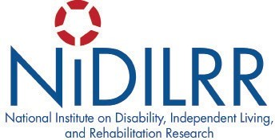
ASL & CAPTIONING SPONSORED BY

Partners

PROJECT DIRECTORS
Paul M. A. Baker, Ph.D., CACP John Bricout Ph.D., UMN/UTA
Maribeth Gandy Coleman, Ph.D., IMTC Claire Donehower Ph.D., GSU
Brian Jones, M.S., IMTC Salimah LaForce, M.S., CACP
Maureen Linden, M.S. BME, CIDI Nathan Moon, Ph.D., CACP
Bruce Walker, Ph.D. School of Psychology

FORUM COMMITTEE
Helena Mitchell, Chair
Salimah LaForce, Co-chair & Logistics
Paul Baker, Publications
Kameron Barrow, Branding
Karen Peltz Strauss, National Disability Consultant

FORUM STAFF
Dara Bright, GT
Janet McKinney, GT
Anushri Kumar, GT
Maureen Linden, GT
Natasha Malmin, GSU/GT
Matt Soffel, GT

ADVISORY BOARD
Bill Belt, Momentum Dynamics David Dougall, Blackberry Limited David Dzumba, Microsoft
Joan Durocher, NCD Avalyn Jackson, AT&T
Elizabeth Vega, TracFone Wireless

RESEARCHERS
Dara Bright, M.S., GT
Priscila Cacola, Ph.D., UTA
Kay Chiodo, Deaf Link
Young Mi Choi, Ph.D., SID, GT
Brad Fain, Ph.D., CACP, GT
Sarah Farmer, CACP, GT
Noelle Fields, Ph.D., UTA
Julienne Greer, Ph.D., UTA
Patty Griffiths, Ph.D., CIDI, GT
Dan Heller, Deaf Link
Eli Jimenez, Ph.D., GSU
Frank Lucia, Consultant
Josephine Mhende, GSU
Liz Persaud, CIDI, GT
Samantha Peters, M.S., CIDI, GT
Carolyn Phillips, M.S., CIDI, GT
Peter Presti, Ph.D., IMTC, GT
Glenn Shell, Deaf Link
Erin Vinoski Thomas, GSU
Ben Thompson, IMTC, GT
Jeff Wilson, Ph.D., IMTC, GT
Ling Xu, Ph.D., UTA
Clint Zeagler, Ph.D., IMTC, GT

PROGRAM AGENDA

Tuesday, March 23rd
8:45 – 9:00 Get Connected – Stay Connected
Technical Setup

9:00 – 9:10 Welcome and Opening Remarks
Helena Mitchell, Principal Investigator, Wireless RERC

9:10 - 9:30 Rapid Fire Research
Short targeted highlights of research projects
Young Mi Choi, Augmented Reality as a Design Tool John Bricout, Socially Assistive Robot for Respite Care
9:35 – 10:20 A Discussion of the State of Research
Facilitator, Paul M.A. Baker, Wireless RERC
Nathan Moon, Survey of User Needs Paper Presentation
A discussion on the asked and unasked research questions that could generate new evidence, practices, and innovations for the field.
Together we will identify how research can better inform inclusive technology policy and regulations.

10:20 – 10:30 10-MINUTE BREAK

10:30 – 11:00 Lightning Development Demos
A quick look at exciting projects with promising potential
Maureen Linden and Brad Fain, Inclusive Emergency Lifelines Maribeth Gandy Coleman, Wearable Design Tool
James Coughlan, Tactile Graphics Helper

11:05 – 11:50 A Discussion of the State of Technology Development
Facilitator, Maribeth Gandy Coleman, IMTC
Bruce Walker, Swan 2.0 Paper Presentation
A discussion on the direction of development needed to move the needle forward on transformational technologies for access and inclusion. We will identify how changes in technology can more universally result in inclusive products and services, including what needs to be preserved and sustained for compatibility purposes.

11:55 – 12:40 A Discussion of the State of Stakeholder Engagement
Facilitator, Karen Peltz Strauss, National Disability Consultant David Dzumba, Microsoft
Richard Ray, City of Los Angeles (Retired)
A discussion of mechanisms to engage consumer, industry and governmental stakeholders in policy and technology development to advance the mission of access and inclusion. Session will include a history of, and novel methods for, high impact stakeholder engagement, including the use of accessibility teams, advisory bodies, dispute resolution, and other collaborative methods to meet the accessibility challenges of evolving 21st century technologies.

12:40 – 12:45 Instructions for Day 2
Salimah LaForce, Wireless RERC

Wednesday, March 24th
9:15 - 9:30 Welcome Back and Get Connected Again - Technical Setup

9:30 – 10:00 Highlights of Selected Papers
Claire Donehower, Facilitating Social Connectedness
Sarah Farmer, Personas for Technology Policy Design
Julienne A. Greer, Theatre and Robots
10:00 – 10:05 InsightOut - Video Presentation
10:05 – 10:25 Perspectives
Avonne Bell, CTIA
DeeDee Bennett, SUNY-Albany David Dougall, BlackBerry Limited
A distillation of day one discussions and kickoff for the closing session. Reactors will share their observations, professional takeaways, recommendations as to how to implement ideas that arose during the Forum.
10:30 – 11:45 Themed Discussion
“The best way to predict the future is to invent it.” ~Alan Kay, computer scientist

Facilitator, Helena Mitchell, Wireless RERC
- What are the issues that researchers, technologists, and stakeholders believe need attention now?
Brad Fain, Center for Advanced Communications Policy Kay Chiodo, Deaf Link

- What are the remaining challenges and opportunities for the future?
Joan Durocher, National Council on Disability
Paul Schroeder, American Printing House for the Blind

- So, what are the next steps to help define what lies ahead?
Bill Belt, Momentum Dynamics
Stephen Bauer, National Institute on Disability, Independent Living, and Rehabilitation Research

11:45 – 12:00 Wrap-up & Thank You
Salimah LaForce, Forum Co-Chair, Wireless RERC

R&D SHOWCASE

Augmented Reality as a Design Tool
The project is exploring the use of Augmented Reality and Tangible Augmented Reality for assessing the usability of products and services. The goal is to understand barriers and factors that impact their accuracy so that designers can confidently use them to reduce the time and cost of improving wireless product designs.
Team: Young Mi Choi, Ted Kim, Karan Jain, Akash Talyan, Santiago Arconada

Socially Assistive Robot for Respite Care
Our project is a proof-of-concept study that explores the feasibility of robot respite for older adults who are caregivers of adult children with intellectual and developmental disabilities (IDD). It was developed to address the strain of caregiving for older adults, by leveraging the capacity of a humanoid social robot (‘Pepper’) to engage their adult child with IDD in an interactive, relational capabilities-building learning scenario.
Team: John Bricout, Julienne Greer, Noelle Fields, Priscila Tamplain, Kristen Doelling, Bonita Sharma, Gajendran Palaniyandi

Inclusive Emergency Lifelines
The Emergency Inclusive Lifelines Project developed wireless communication protocols and interfaces for adopted and emerging wireless technologies used in all stages of emergencies (before, during, and after emergencies). Specific projects characterized the most accessible emergency notification signaling for emergency alerts for people with sensory disabilities. Further, we have developed interactive tools to compare WEA comprehension on multiple platforms.
Team: Maureen Linden, Colin Ahn, Kay Chiodo, Dan Heller, Anushri Kumar, Salimah LaForce, Pete Presti, Glenn Shell, Ben Thompson

FirstNet Inclusive Information Streaming System
The FirstNet project seeks to identify requirements for FirstNet enabled technologies to assist first responders in meeting the needs of people with disabilities during emergencies. The requirements will be generated based on structured interviews and surveys with both first responders and people with disabilities who have had experience interacting with first responders in emergency situations.

Team: Sarah Farmer and Brad Fain

Wearable Technology Designer’s Web Tool
The Wearable Technology Designer’s Web Tool is for designers to use at the beginning of the design process. The tool presents a series of questions, as the designer provides answers about their project, the tool compiles a set of design and accessibility considerations along with a heat map of where on the body their wearable device might be located. The tool also alerts the designer if the choices they are selecting will impact any users with disabilities.
Team: Maribeth Gandy Coleman, Clint Zeagler, Scott Robertson, Rishabh Ghora, Rohan Bawa

Tactile Graphics Helper
The Tactile Graphics Helper (TGH) project is a smartphone/tablet app that uses the device’s camera to track a student's fingers as he/she explores a tactile graphic and allows the student to gain clarifying audio information about the tactile graphic without sighted assistance.
Team: Val Morash, Giovanni Fusco, James M. Coughlan

Speaker Bios

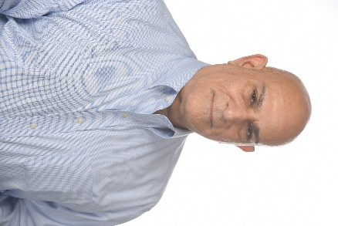
Paul M.A. Baker, Ph.D. is Senior Director, Research and Strategic Innovation, at Georgia Tech’s Center for Advanced Communications Policy (CACP), and Interim Chief Operations Officer, Center for the Development and Application of IoT Technologies (CDAIT). He is also a Principal Research Scientist with the School of Public Policy. Paul serves as Co-PI, project director and operations manager of the Rehabilitation Engineering Research Center for Wireless Inclusive Technologies (Wireless RERC). He is currently researching the role of innovation networks in workforce development, policy approaches for advancing technology and universal accessibility goals for persons with disabilities; the operation of online communities and virtual spaces, and the public sector use of information and communication technologies (ICT’s). Baker earned his Ph.D. in Public Policy from George Mason University, a Master’s in Urban Planning from University of Virginia, and a B.S. in Zoology from University of Wisconsin.

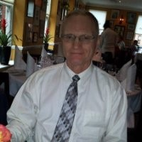
Steve Bauer, Ph.D., since 2014 has been a program officer at the US National Institute on Disability, Independent Living, and Rehabilitation Research (NIDILRR). In 1992, he earned a PhD in Electrical and Computer Engineering from SUNY Buffalo, and was formerly a co- or principal-investigator for several NIDILRR–funded Rehabilitation Engineering Research Centers and Disability Rehabilitation Research Projects. Steve’s expertise pertains to technology development, transfer, and adoption (non-governmental and governmental perspectives, optimization of), assistive services and products (industries, models, design, classification of), and the administration, monitoring, and management of federal grant programs. It’s been Steve’s great privilege to work closely and become friends with many brilliant, innovative, and passionate people throughout his long career.

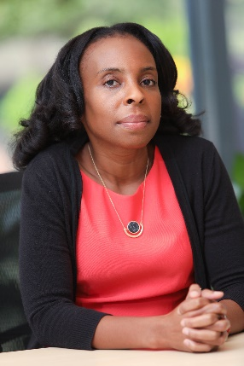
Avonne Bell, J.D. is the Director, Connected Life at the wireless industry association, CTIA, where she focuses on policy and le- gal issues for wireless communications vertical sectors like connected and automated vehicles, drones, and telehealth. Bell is an alumna of the Wireless RERC. She worked as a graduate research assistant with the Center for Advanced Communications Policy while pursuing her master’s degree in public policy at Georgia Tech. She credits that position with introducing her to the area of communications and internet policy, which has been her focus ever since. Bell worked as a homeland security and telecommunications policy consultant for several years before deciding to pursue her law degree at George Washington University. Since law school, she has been a fellow with the FCC’s Office of General Counsel, senior government affairs manager at the Telecommunications Industry Association, and an Associate at the firm Kelley Drye & Warren. Bell also holds a bachelor’s degree in Aerospace Engineering with Information Technology from the Massachusetts Institute of Technology.

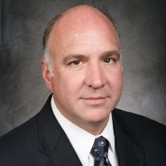
Guillermo (Bill) Belt is senior director of standards development and technology policy at Momentum Dynamics, which develops high power inductive charging technologies for the automotive and transportation industries. Before joining Momentum Dynamics, Belt was president of Cinturon, LLC, which specializes in representing the interests of companies that fuel progress by building products and services needed to improve our lives. He has served more than 30 years in the high-tech sector, mostly on broadband internet deployment, technology standards development, and the public policies that drive innovation. Before founding Cinturon, Belt was senior director of technology and standards for the Consumer Technology Association (CTA). CTA owns and produces CES, the world’s largest annual technology trade show. Belt led standards development projects and provided key engineering and technology policy support to CTA member groups. Tech standards produced under Belt’s leadership are referenced by the EPA, DOE, FTC, FCC and other government agencies. Belt represented CTA’s technical interests in industry and international venues related to spectrum management and policy, accessibility, product safety and energy efficiency. Belt is a frequent speaker at industry conferences and seminars and has been widely quoted in the press. Belt holds a B.S. in electrical engineering from Syracuse University.

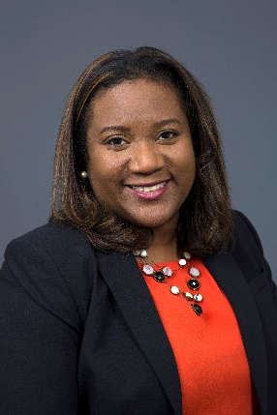
DeeDee Bennett Gayle, Ph.D. is an Associate Professor in the College of Emergency Preparedness, Homeland Security, and Cyber- security at the University at Albany, State University of New York. Her research interests include emergency management, socially vulnerable populations during disasters, emergency communications, disaster policy, and mobile wireless communications. Of note, she was the PI for the NSF INCLUDES -funded, Scholars from Under-represented Groups in Engineering and Social Sciences Building Capacity in Disaster (SURGE), design and development launch pilot. She administers the annual state of the community survey of emergency management academic programs on behalf of the Federal Emergency Management Agency. Her previous appointments include Assistant Professor and Director of the Emergency Management and Disaster Science program at the University of Nebraska at Omaha (UNO) and Research Scientist at the Center for Advanced Communications Policy at Georgia Institute of Technology. Dr. Bennett Gayle received her Ph.D. from Oklahoma State University in Fire and Emergency Management, an M.S. in Public Policy, and a B.S. in Electrical Engineering from the Georgia Institute of Technology.

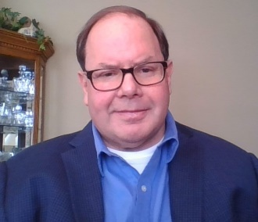
John Bricout, Ph.D. is a professor at the UMN School of Social Work (SSW). He served as the director of the SSW from 2017-2020. Professor Bricout’s research examines the socio-cultural aspects of participatory, ethical design for robotics and intelligent assistive technologies to enhance the capabilities and well-being of people with disabilities in a variety of settings. He is interested in how people with disabilities can be engaged with the design of ethical artificial intelligence to enhance learning and social participation. He also studies virtual interdisciplinary teamwork, community-engaged research partnerships, workforce learning, and inclusive design processes with diverse stakeholders. He has received funding from the National Science Foundation (NSF), the National Institute on Disability, Independent Living, and Research (NIDILRR), and the Centers for Disease Control and Prevention (CDC). Professor Bricout has taught graduate and undergraduate courses in ethics, research, policy practice, evaluation, community development, human diversity, and human behavior. He has a strong interest in international work and served as a Fulbright Specialist in the Republic of Georgia.

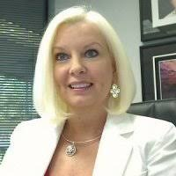
Kay Chiodo has over 30 years of experience in providing services to persons with sensory disabilities and is considered a leading Subject Matter Expert on the topic of accessible communications. In 2002, Ms. Chiodo founded Deaf Link, Inc. and developed the nation’s first Accessible Hazard Alert System (AHAS) to provide first responders and emergency managers with the tools to help ensure communication access to emergency information for persons with sensory disabilities. In 2007, Ms. Chiodo founded No Barriers Communications (NOBACOMM), a non-profit organization that provided services to Doctors without Borders during the 2010 cholera outbreak in Haiti. Since then, NOBACOMM has provided services and acted as an advocate and educator regarding the need for equal access in all areas of life. Ms. Chiodo is the recipient of the 2008 – 21st Century Achievement Award / COMPUT- ERWORLD, for Accessible Communications.

Young Mi Choi, Ph.D. is an Associate Professor in the School of Industrial Design at the Georgia Institute of Technology. She also serves as Associate Chair and is the Master’s of Industrial Design Program Coordinator. She teaches both product development as well as human factors and ergonomics. Her research activities focus on applying evidence-based design in innovation and human-centered design. Her research focuses on topics related to the roles played by users, industrial designers, engineers, and marketers during the process of creating new products and assistive technologies. In particular, current projects are focused on how new tools such as mixed reality technologies can be effectively utilized to both enhance design decision making and allow enhanced communication with and involvement from end-users during the design process. Dr. Choi received her Ph.D., from the Georgia Institute of Technology, College of Architecture in Industrial Design.

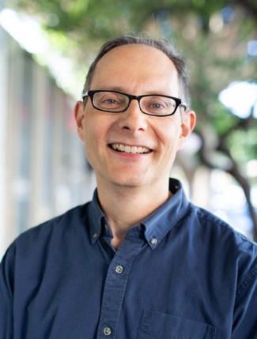
James M. Coughlan, Ph.D. received his B.A. in physics at Harvard University in 1990 and completed his Ph.D. in physics there in 1998. He is currently a Senior Scientist at The Smith-Kettlewell Eye Research Institute in San Francisco, California, where he is Associate Director of the Rehabilitation Engineering Research Center on Low Vision and Blindness. His main research focus is the use of computer vision and sensor technologies to facilitate greater accessibility of the physical environment for blind and visually impaired persons. Current and past accessibility projects include developing systems to provide audio-haptic access to physical objects such as documents and 3D models, the ability to find and read signs and other textual information, and navigation assistance indoors and at traffic intersections. He shared the 2020 Dr. Arthur I. Karshmer Award for Assistive Technology Research for his publication, “Towards Accessible Audio Labeling of 3D Objects,” which was awarded for the best submission to the Science/ Research Journal Track of the CSUN 2020 Assistive Technology Conference. In 2020 he was appointed to the NIH National Advisory Eye Council.

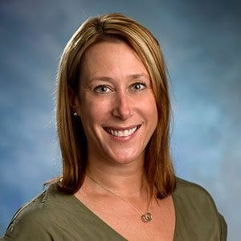
Claire Donehower, Ph.D. is an Assistant Professor in the Department of Learning Sciences at Georgia State University. She received her doctorate from the University of Central Florida in the Exceptional Education Program. Her research focuses on improving academic, social and behavioral outcomes for students with autism spectrum disorders (ASD) using innovative technology. In addition to her work with the Wireless RERC, Dr. Donehower currently serves as the Principal Investigator for a U.S. Department of Education Stepping Up Technology grant focused on integrating robotics/coding and social skills instruction for students with intellectual and developmental disabilities. Prior to her doctoral studies, Donehower worked at the Kennedy Krieger School Programs for nine years as an assistant teacher, special education teacher and assistant principal. She received a B.A degree in psychology from Boston College and an M.S. degree in special education of severe and profound disabilities from the Johns Hopkins University. Additionally, Donehower is a board-certified behavior analyst and has post graduate certificates in the Education of Students with Autism and Other Pervasive Developmental Disorders and Special Education Leadership and Administration.

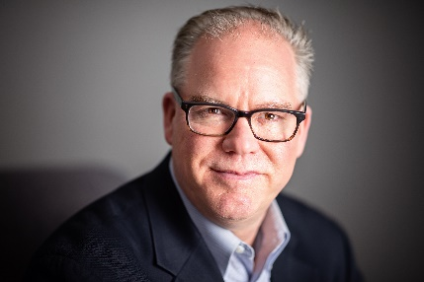
Dave Dougall, MBA, is the Compliance and Sustainability & Accessibility Director at BlackBerry Limited, which provides intelligent security software and services to enterprises and governments around the world. BlackBerry leverages AI and machine learning to deliver innovative solutions in the areas of cybersecurity, safety, and data privacy solutions and is a leader in the areas of endpoint security management, encryption, and embedded systems. In his role, Dave manages global regulatory requirements, policy development, and consumer outreach related to the accessibility of BlackBerry products for customers with disabilities. Dave manages environ- mental sustainability considerations for BlackBerry products and manages BlackBerry’s corporate carbon footprint. Dave is a member of the National Advisory Board for the Rehabilitation Engineering Research Center for Wireless Technologies and the National Advisory Council for the Rehabilitation Engineering Research Center for Advancing Cognitive Technologies. Dave holds a Bachelor of Science degree from Kettering University (GMI) in Flint, MI, and an MBA from the Ivey Business School at Western University in London, ON.

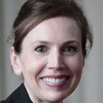
Joan Durocher, J.D., is the National Council on Disability’s General Counsel and Director of Policy. The National Council on Disability (NCD) is an independent federal agency charged with advising the President and Congress about the broad spectrum of issues impacting the lives of people with disabilities. She has previously served as NCD’s Interim Executive Director and Senior Attorney/Advisor. In these roles, she has overseen the development and publication of hundreds of recommendations and reports on issues affecting the lives of people with disabilities. Ms. Durocher served for almost a decade as the Designated Federal Official for International Watch, a Federal Advisory Committee tasked with advising on the development of policy proposals that will advocate for a foreign policy that is consistent with the values and goals of the Americans with Disabilities Act. Ms. Durocher has a Bachelor of Arts degree from Michigan State University and received her law degree from the University of Maryland, where she was awarded an Asper Fellowship and received the BARC Community Service and Leadership Award for her work at the Maryland Disability Law Center in Baltimore.

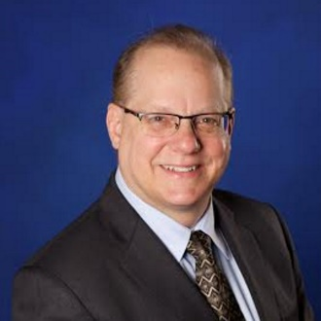
David Dzumba, M.S., has been with the Microsoft Corporate, External, and Legal Affairs (CELA) team since 2013, where he works on accessibility standards, internal requirements and conformance. Dzumba joined Microsoft after 15 years with Nokia. While at Nokia, he established the company’s accessibility program, including early innovations of text-to-speech on devices for customers who are blind, and an inductive loop for t-coil-equipped hearing aid users. He has served as the co-chair of the FCC’s Emergency Access Advisory Committee and as panelist for organizations including the European Year of Disabilities, NCLUDE/STAKES, Cost219bis, Tiresias, TAG, and U.S. Department of Homeland Security. Dzumba has a Master of Science in Engineering Telecommunications from Southern Methodist University in Dallas, Texas.

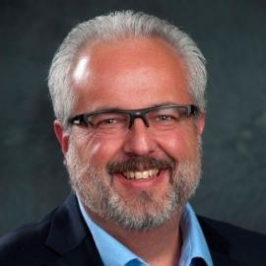
Brad Fain, Ph.D., is a Principal Research Scientist at the Georgia Tech Research Institute and executive director of the Center for Advanced Communications Policy (CACP). Housed in the Georgia Tech School of Public Policy, CACP focuses on key issues that influence the development, implementation and adoption of communications technologies. Fain directs Georgia Tech’s HomeLab research initiative and leads a team that is pioneering research into issues and products designed to assist with successful aging in place. He also currently leads a project to build a virtual reality usability testbed for first responder technologies enabled by FirstNet for the National Institute for Standards and Technology (NIST). The Wireless RERC works with FirstNet will ensure that the FirstNet information streaming system includes the needs of people with disabilities at its implementation. Fain pioneered the development of Consumer Product Integration (CPI) as a design process for the realization of products with universal design features. He conceived and led the development of an information portal containing information pertaining to the design and procurement of accessible electronic and information technologies.

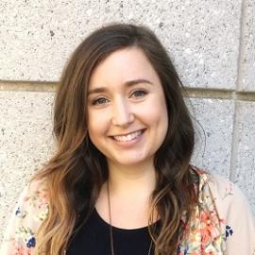
Sarah Farmer is a Research Scientist at Georgia Tech’s Center for Advanced Communications Policy and the Georgia Tech Research Institute, as well as managing director of Georgia Tech’s HomeLab. With a background in psychology and statistics, she has been executing research related to human performance and successful aging since 2012. She is a co-investigator in the RERC TechSAge research to assess user needs for home-based activities necessary to integrate effective technology into the lives of older adults with disabilities. As director of HomeLab, which is a home health test bed database of older adults in the metro-Atlanta area, Sarah has executed in-home studies that evaluated technologies that contribute to successful aging, including activity trackers, medication adherence technologies, and personal emergency response systems. She is the current technical lead for the evaluation of potential FirstNet first responder technologies in a novel virtual reality usability testing environment being constructed at GTRI. Sarah is currently the PI for HomeLab’s involvement in the RADx initiative.
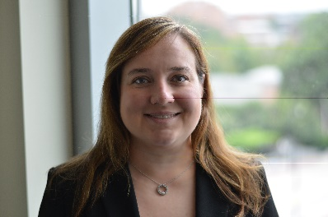
Maribeth Gandy Coleman, Ph.D., is the Director of the Interactive Media Technology Center in the Institute for People and Technology and a Principal Research Scientist at Georgia Tech. She received a B.S. in Computer Engineering as well as a M.S. and Ph.D. in Computer Science from Georgia Tech. In her twenty years as a research faculty member her work has been focused on the intersection of technology for mobile/wearable computing, augmented reality, human computer interaction, assistive technology, and gaming. She is the task leader for the Wireless RERC’s Wearable devices and connectivity development project. Maribeth has led a wide array of projects in the 12 years she has been a faculty member at Georgia Tech; ranging from social therapeutic games for people with cognitive impairment, to wearable haptic displays embroidered into clothing, and augmented reality systems for helping older adults to use smart home technology. She also teaches the “Video Game Design” course and the “Principles of Computer Audio” (which she created in 2001) in the College of Computing at Georgia Tech.

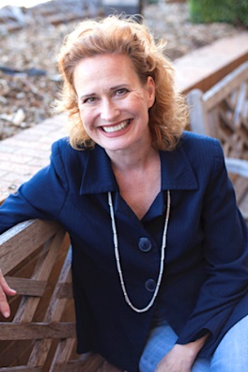
Julienne A. Greer, Ph.D., is the Assistant Chair and Assistant Professor of Theatre: Social Robotics and Performance, with the Department of Theatre Arts at the University of Texas at Arlington. She is the Director of UTA’s Emotional Robotics Living Lab, the home to multiple research social robots, and the UTA space for hands-on social robotic research for undergraduate and graduate learning. Dr. Greer earned a B.F.A in Drama from New York University’s Tisch School of the Arts, an M.A. in Media Arts from Texas Christian University, and her Ph.D. in Humanities at the University of Texas at Dallas, School of Arts and Humanities. Greer is a multi-disciplinary scholar + artist who produces, directs, performs, and writes in theater, robotics, cinema, humanities, and game studies disciplines. She brings performance expertise based in applied drama, empathy, embodiment, and multi-modal sensory data to interdisciplinary collaborations. She is a member of Inter-Disciplinary.net 2011 - present, Actors Equity Association (AEA), and the Screen Actors Guild and American Federation of Television and Radio Artists (SAG/AFTRA).
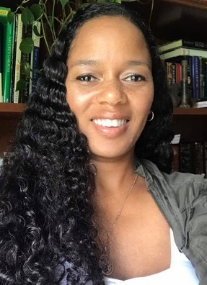
Salimah LaForce, M.S., is a Research Scientist at the Georgia Institute of Technology, a senior policy analyst at Georgia Tech’s Center for Advanced Communications Policy, and a project director for the Wireless RERC. She specializes in policy research, identifying and describing intended and unanticipated implementation outcomes. Her work spans a variety of topic areas, including increasing accessibility and usability of wireless technologies, improving employment outcomes for individuals with disabilities, building capacity for inclusive emergency response efforts, and cultural competency in delivering healthcare services. She has 14 years’ experience con- ducting user needs and experiences research utilizing study results to inform policy and practice recommendations. Presently, Salimah is the Principal (PI) Investigator for the American Sign Language-Accessible Diabetes Education (ASL-ADE) project; PI for the COVID-19 Information Access and Vulnerable Populations project. Salimah is the senior editor of the monthly newsletter, Technology and Dis- ability Policy Highlights, and has co-authored more than 86 conference papers, research reports, presentations, journal articles, and federal regulatory agency filings. Salimah earned her B.A. in English literature from Agnes Scott College and her M.S. in Clinical Psychology, applied research specialization, from the Harold Abel School of Social and Behavioral Sciences, Capella University.

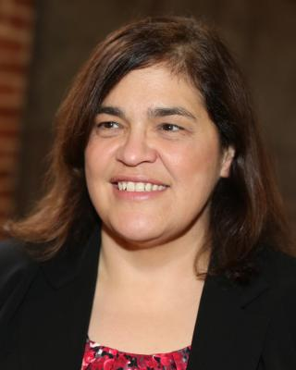
Maureen Linden, M.S., directs the Inclusive Emergency Lifelines development project of the Wireless RERC. She is the Associate Director of Research for the Center for Inclusive Design and Innovation (CIDI) in Georgia Tech’s College of Design. Her research focuses include accessible emergency communications and post-secondary education, workplace accommodations and accessible work environments, and assistive technology decision support tools. Much of this research is conducted incorporating data and social networking analytics techniques, as well as smart technologies and Internet of Things (IoT) data acquisition. Maureen delivered direct services to people with disabilities in both the medical and vocational rehabilitation service models under service standards required by Center for Medicaid and Medicare Services (CMS) and CARF. Linden has 15 years’ experience in development of performance standards for wheelchairs, wheelchair seating, and transportation for people with disabilities through the Society for Automotive Engineers (SAE), American National Standards Institute (ANSI) and the ISO. Linden holds two degrees from the University of Virginia: a Master of Science in Biomedical Engineering and a Bachelor of Science in Electrical Engineering. Presently, she is the President of RESNA, the Rehabilitation Engineering and Assistive Technology Society of North America.

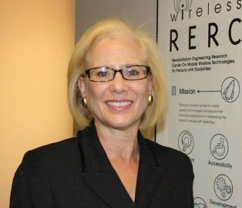
Helena Mitchell, Ph.D., is the Wireless RERC’s principal investigator (PI). Dr. Mitchell is a Regents’ Researcher at Georgia Tech. Her areas of specialty include accessibility of wireless technologies, regulatory and legislative policy, emergency/public safety communications, and advanced communications technologies. Helena has also been PI for several emergency communications projects funded by the U.S. Department of Homeland Security. Mitchell has held executive positions in academia, business, and government, contributing to her unique ability to see multiple perspectives. At the Federal Communications Commission, she was the Associate Chief, Strategic Communications for the Office of Engineering and Technology, Chief of the Emergency Broadcast System, and the first chief of the Emergency Alert System where her group received Organization of the Year. Previously she was director of telecommunications development for the National Telecommunications and Information Administration of the U.S. Department of Commerce, receiving the Silver Medal twice. Helena holds a Ph.D. from Syracuse University with a combined doctoral degree from the Maxwell and New- house schools. Her M.S. is from the Newhouse School at Syracuse, and her B.S. is from S.U.N.Y. at Brockport.
Nathan W. Moon, Ph.D., is a Senior Research Scientist at the Georgia Institute of Technology, and he serves as Director of Research of the Center for Advanced Communications Policy (CACP) at Georgia Tech. His research focuses on increasing access to education and employment for people with disabilities, with specializations in the accessibility of information and communications technologies (ICTs), workplace accommodations and employment policy, broadening participation in STEM education, and program evaluation. Dr. Moon is also Project Director for the Wireless RERC, where he leads the RERC’s Survey of User Needs and research on the sociocultural design factors for next generation wireless technologies. Moon is the Principal Investigator for a Field Initiated Project on the Contingent Employment of People with Disabilities (FIP-CE). This three-year research project is funded by the National Institute on Disability, Independent Living, and Rehabilitation Research (NIDILRR). FIP-CE investigates the participation of individuals with disabilities in contingent employment arrangements, including jobs obtained through web-based or app-based platforms associated with the nascent “gig economy” associated with services such as Uber, Lyft, and Handy. Dr. Moon received his Ph.D., in history and sociology of science and technology from Georgia Tech in 2009.

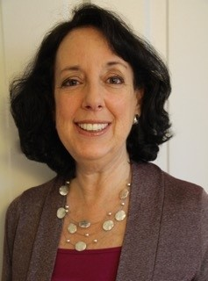
Karen Peltz Strauss, J.D., has spent four decades leading nationwide efforts to ensure that people with disabilities have access to communications and video programming technologies. In the Obama and Clinton administrations, Strauss served as Deputy Chief of the Federal Communications Commission’s Consumer and Governmental Affairs Bureau, where she oversaw the agency’s disability proceedings. Earlier in her career, representing Gallaudet University’s National Center for Law and Deafness, the National Association of the Deaf, and Communication Service for the Deaf, Strauss wrote and led efforts to achieve passage of landmark disability laws on closed captioning, audio description, telecommunications relay services, hearing aid compatibility, and accessible communications devices and services, including the 21st Century Communications and Video Accessibility Act. Strauss has frequently presented expert testimony to Congress and regularly presents at national and international accessibility conferences. In 2006, Strauss wrote A New Civil Right: Telecommunications Equality for Deaf and Hard of Hearing Americans, providing a behind-the-scenes history of our nation’s telecommunication accessibility laws. A graduate of the University of Pennsylvania Law School, Strauss also holds an L.L.M from the Georgetown University Law Center and an honorary doctorate from Gallaudet University, the latter for her work on communications access.

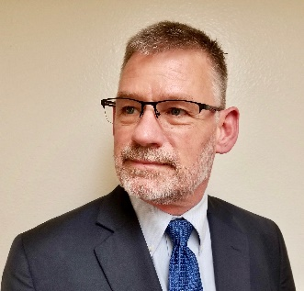
Richard Ray retired from the City of Los Angeles after serving over 35 years as an Americans with Disabilities Act Technology Access Coordinator while working in the field of telecommunication technologies, emergency services, and advocating for the civil rights of individuals who are deaf, deafblind, and hard of hearing in all levels of government. His goal is to ensure access for people with disabilities to all government programs, services, and activities through emerging technologies. He is actively involved as a co-chair of the National Emergency Number Association (NENA) Accessibility Committee and Federal Communications Commission (FCC) Disability Advisory Committee. Richard has served on the FCC Emergency Access Advisory Committee, North American Numbering Council Interoperable Video Calling Working Group, Emergency Access Advisory Committee, Emergency Communications Subcommittee, and Optimal Public Safety Answering Point Architecture Task Force. He is involved in projects such as Text to 9-1-1, Real-Time Text to 9-1-1, Next Generation 9-1-1, Emergency Notification Systems, and other issues concerning communication access in support of federal, state, and local governments. Richard was named one of the top 25 Doers, Dreamers, and Drivers and featured in Government Technology Magazine in 2018. In 2019, he was inducted into the NENA’s Hall of Fame.

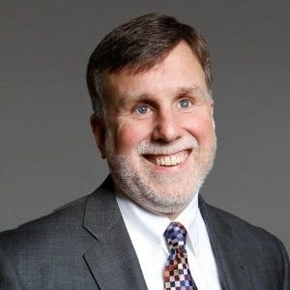
Paul Schroeder is Vice President, Government and Community Affairs at American Printing House for the Blind. Paul serves as a key advisor on matters pertaining to all government activities at APH, including the activities related to the Act to Promote the Education of the Blind. He also educates U.S. Congress members by raising awareness of the unique learning needs of student with visual dis- abilities and the products and services they need. Paul has more than 30 years of experience and leadership in the field of blindness and visual impairment. Most recently, he was Vice President, Public Policy and Strategic Initiatives at Aira Tech Corp. He served in several leadership positions, including Vice President, Programs and Policy at American Foundation for the Blind (AFB). He also worked as the Director of Governmental Affairs at American Council of the Blind and as the Special Projects Coordinator at the Governor’s Office of Advocacy for People with Disabilities, in Columbus, Ohio. Schroeder received his Bachelor of Arts, cum laude, in Political Science and International Studies from American University.

Bruce Walker, Ph.D., is a Professor at Georgia Tech, in the Schools of Psychology and Interactive Computing. His Sonification Lab studies the human-computer interaction (HCI) issues in non-traditional interfaces, ranging from mobile devices, to cockpits and vehicle displays, to multimodal interfaces in education and in complex task environments. Particular research interests include sonification and auditory displays. Professor Walker teaches HCI, Research Methods, Sensation & Perception, Auditory Interfaces, and Assistive Technology. In addition to academic research leading to over 250 publications, he has worked and consulted on projects for NASA, state and federal governments, the military, and private companies.

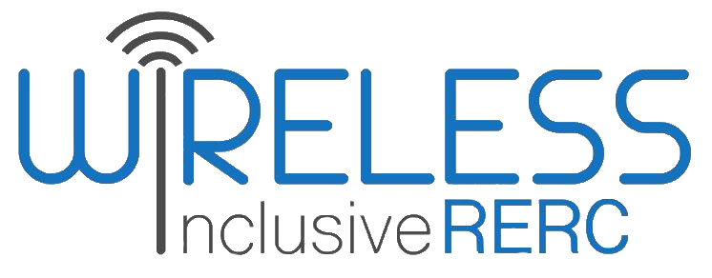

State of Technology Forum
This Forum is funded by the National Institute on Disability, Independent Living, and Rehabilitation Research (NIDILRR grant number 90RE5025-01). NIDILRR is within the Administration for Community Living (ACL), Department of Health and Human Services (HHS). The opinions expressed during the Forum do not necessarily represent the policy of NIDILRR, ACL, HHS, and you should not assume endorsement by the Federal Government.

www.wirelesssrerc.org

www.cacp.gatech.edu

