Rehabilitation Engineering Research Center for Wireless Technologies
Georgia Institute of Technology
Wireless Emergency Communications (WEC) Project
Table of Contents
Executive Summary 2
BACKGROUND: Wireless Emergency Communications Project 5
WIRELESS USE AMONG PEOPLE WITH DISABILITIES 8
Universal Access to Emergency Alerts 10
PROTOTYPING ACCESSIBLE WIRELESS EMERGENCY ALERTS 10
Mobile Alerting Framework 10
Prototype Systems 13
Methodology 16
Operational Factors 16
The Recruitment Process 17
Field-trial model 18
Findings – Wireless Device Ownership & Use habits 20
Findings – EAS (The WEC Method) 21
Overarching themes for deaf and hard of hearing 21
Overarching themes for blind and low vision 24
Findings – CMAS 26
EAS vs. CMAS 32
Focus Groups - ASL Video Alerts 34
RECOMMENDATIONS 35
Future Research, Policy and Practice Recommendations 37
ACKNOWLEDGEMENTS 40
This report of the Rehabilitation Engineering Research Center on Wireless Technologies is supported by the National Institute on Disability and Rehabilitation Research of the U.S. Department of Education, grant # 133E060061, and in part by the Center for Advanced Communications Policy, Georgia Institute of Technology. The opinions contained in this report are those of the grantee and do not necessarily reflect those of the U.S. Department of Education.

Executive Summary
The Wireless RERC is a federally funded engineering and research center focused on promoting universal access to and use of wireless technologies, exploring their innovative applications for people with disabilities and encouraging the adoption of universal design in future generations of wireless devices and applications. This includes equitable access to emergency alerts and information over wireless networks and devices. Wireless information and communication technologies play an increasing role in independent living for people with disabilities. In the annual Wireless RERC survey of more than 1600 people with disabilities, 85% used wireless devices, more than 77% said access to wireless was important, and 65% said wireless device was important during an emergency. For example, video phones and video relay services make it possible to have telephone conversations in sign language. Wireless technologies have become part of the unique social and cultural fabric of the deaf community. Text messaging is a key mode of communication for people who are deaf and hard of hearing. Emergency broadcasts and 911 telephone services are being adapted to utilize new wireless data networks and mobile devices. As more of these users rely on wireless devices as their primary source of communications, receiving emergency alerts and communications will need to be available in accessible formats; and capable of receipt by persons with disabilities over different networks and devices, including both wired and wireless.
Between 2006 and 2009 the Wireless RERC developed and completed a series of field trials under the Wireless Emergency Communications (WEC) project. The field trials underscored the important role which both broadcasters and wireless service providers have in alerting people with disabilities to emergencies. Twelve field trials and two focus groups were conducted to examine the accessibility and effectiveness of Emergency Alert System (EAS) and Commercial Mobile Alert System (CMAS) alerts to wireless devices. The 119 test participants were as diverse in their sensory limitations as they were in their technical skill level, ranging from those who were fully deaf or fully blind, to those with enhanced hearing (hearing aid/cochlear implants) or enhanced vision (glasses/contacts).
WEC test participants received alerts on cell phones in both the EAS and CMAS message formats. Under the WEC project, an EAS message format was used in the first nine tests as follows: “The National Weather Service has issued a Tornado Warning for Test County until 10:15 am.” The SMS message was limited to 160 characters and contained a hyperlink to a web page containing the alert’s full content, formatted for accessibility and mobile viewing. EAS message formatted tests are referred to herein as the WEC method because EAS messages are not currently sent to mobile devices in accessible formats. The CMAS message format was used in the three CMAS tests as follows: “Tornado warning for Atlanta until 3 pm EST. Take shelter. NWS.” CMAS messages were limited to 90 characters with the EAS Attention Signal and vibration cadence as specified in 47 CFR FCC Part 10, and did not include a hyperlink. In both EAS and CMAS tests, the mobile devices were loaded with client software capable of presenting alert content with accommodations for blind / low vision (text-to-speech) and hearing impaired users (specific vibrating cadences). Three to four simulated emergency alerts were sent to each participant’s mobile phone. Each participant was shadowed by an observer to monitor for system failure and log usability problems. Before and after each test, participants completed a survey to gather data on their experience with the system. Each field trial concluded with a focus group discussion.
Two additional focus groups were conducted to assess if American Sign Language (ASL) video enhanced the understanding of textual CMAS alerts for people who are deaf. This was an outgrowth of feedback from earlier field trials recommending that ASL would be important to end-users whose primary language is ASL. Participants were conversant in ASL and comfortable reading English. They were presented with conventional text alerts, as well as text alerts coupled with video clips presenting an ASL translation.
The majority of participants in both the WEC method trials (95%) and the CMAS trials (85%) currently receive alerts via television. In the pre and post test questionnaires for EAS, 92% said they confirmed their information by turning on their TV. In the CMAS tests, 100% said they would confirm by turning on their TV, indicating there is a link between CMAS (phones) and EAS (TV/radio) for obtaining and verifying emergency information. However when asked “What would improve your ability to receive emergency alerts and information?” many answered receiving them on their personal mobile devices would be preferential. 90% of EAS and 93% of CMAS trial participants would be interested in a mobile phone alerting service. Discussions with the participants revealed that though television is the prevalent method, it is not the preferred method because the information is not consistently accessible (lacks captions, video description and/or ASL interpreters), especially when emergency information is relayed by news reporters.
In the EAS (WEC method) trials, more than 83% of all participants stated the wireless emergency alerting system was an improvement over other methods they currently use to receive emergency warnings and alerts. Of blind and low-vision participants, 100% regarded the alerting of the accessible client software as an improvement, however only 43% regarded the alerts via SMS and the Web as an improvement over their current system. The low satisfaction of the SMS and Web system with this population appears to be due in part to the accessibility features of the mobile devices that they were given for the trial.
In the CMAS trials, 83% of visually impaired participants found the accessible CMAS system to be an improvement over their current source of emergency alerts. Of participants with hearing impairments, 70% found the CMAS alerts to be an improvement. Though the numbers don’t reveal it, based on the qualitative comments received during post-test discussion, generally speaking, the EAS method trials received higher rates of approval because more detailed information could be provided in the alerts, versus the very limited information allowed by the 90 character restriction and hyperlink prohibition prescribed by CMAS rules.
All ASL focus group participants agreed that ASL video alerts would be a useful tool for people that are deaf and literate in ASL. Some participants felt that the combination of text and ASL together gave them a fuller understanding of the message than either on its own. One surprising result of the evaluation was the difficulty of understanding some phrases typically used in NWS alerts, such as “take cover” or “low-lying area”; these idiomatic expressions do not translate well into Deaf English or into ASL, therefore the word choice used in text or ASL alerts should be carefully considered and vetted amongst this population.
Post-trial evaluations suggest that mobile devices may offer an opportunity to improve dissemination of emergency alerts to disabled populations. Testing of various prototypical solutions to make these alerts more accessible show that simple accommodations can be made that greatly increase the accessibility of these alerts to persons with disabilities. As government and industry move forward in rolling out next-generation alerting systems such as CMAS, the Wireless RERC recommends that manufacturers who incorporate emergency alerting into mobile wireless handsets examine features such as attention signal volume and vibration strength and consider making these features customizable in order to accommodate various end-user preferences; and clear labeling explaining emergency features is on product packaging and in stores and that sales staff understand the emergency and accessibility features in products.
Subsequent to the EAS and CMAS trials, the Wireless RERC is conducting two additional emergency communications projects: (1) a survey of how people with disabilities use social media to receive and/or share emergency information (2011) and (2) a technology demonstration to show the feasibility of supplementing CMAS messages with EAS message content received on wireless devices via an RBDS FM chip (2012).

BACKGROUND: Wireless Emergency Communications Project
Initial funding for the Wireless RERC began in 2001. During the initial five years, a State of Technology conference was held in 2004 discussing mobile wireless communications for people with disabilities. One of the results presented in the proceedings report emphasized that “maintaining emergency communications between public safety entities and communities most vulnerable during emergencies was critical.”
Later that year in August 2004, the Federal Communications Commission (FCC) released a Notice of Proposed Rulemaking (NPRM) to review the EAS. The FCC recognized the importance of creating a sound emergency communications system and requested comments from the public on how this could be accomplished. The Wireless RERC responded with feedback on the numerous ways wireless technologies could help people with disabilities in emergency situations. Discussions included insights into developing technology for people with limited visual and auditory abilities. For example, providing only auditory alerts prevents individuals who are deaf or hard-of-hearing from receiving the warnings. However, transmitting emergency message text by sending small amounts of digital information through the radio broadcast digital system (RBDS) allows users to view the message on a screen. Also noted was research performed by the Wireless RERC and survey results revealing that members of the Deaf community were often early adopters of 2-way text pagers, such as the Sidekick and Blackberry.
Several recommendations made by the Wireless RERC about the potential of digital wireless technologies to assist people with disabilities during an emergency appeared in the FCC's 1st Report and Order and Further Notice of Proposed Rulemaking, which stated: "we amend the FCC rules to ensure that persons with disabilities have access to public warnings." Regarding that amendment, the Wireless RERC commented that all wireless device users would benefit from a multi-modal approach to providing accessible, wireless emergency alerts communication. Through other Wireless RERC filings on the subject, comments also highlighted the potential uses of wireless technologies in providing public warnings and alerts to people with disabilities in a timely manner.
The 2005 hurricane season added urgency to the issue of emergency communications, prompting conferences and studies by several government agencies and interest groups, with staff of the Wireless RERC contributing input to many of these events. The RERC on Telecommunication Access sponsored the State of Science Conference on Accessible Emergency Notification and Communication that produced research and public policy recommendations geared toward accessibility issues. Columbia University sponsored the Consensus Conference on Considerations in Emergency Preparedness. Proceedings from these conferences as well as other reports emphasized the importance of incorporating the needs of people with disabilities in the development of emergency preparedness initiatives to ensure access to emergency communications for all.
In order to conduct unbiased research regarding the next-generation, digitally-based alert and warning systems that assure persons with disabilities be given equal access to alerts and warnings as other Americans, the Wireless RERC developed the Wireless Emergency Communications project (WEC).
In the summer of 2006 the Wireless RERC received notification from the National Institute on Disability and Rehabilitation Research (NIDRR) under the U.S. Department of Education grant number H133E060061 that the program would be refunded for another 5-year cycle. The new cycle began October 1, 2006, introducing new development projects, one of which was WEC. The project objectives were to: 1) examine several technology approaches to transmit specific emergency alerts and warnings to wireless devices; 2) evaluate potential interoperability issues associated with interconnection with other currently proposed or systems in testing; 3) develop prototypes of one or more promising technology approaches to broadcast local and targeted delivery of alerts and warnings to wireless devices in accessible formats; 4) field trial working prototypes; and 5) generate recommendations for the FCC and other stakeholders concerning the most feasible approach to ensure equal access to alerts and warnings by people with disabilities.
The WEC research team did an assessment of technologies used for emergency alerting. WEC reviewed the literature, analyzed rulemakings on the subject, and filed in rulemakings regarding the Matter of Review of the EAS. In most of the published rulemakings the Wireless RERC has had multiple references. Key questions that the project was to address were articulated by the FCC in their 2005 Further Notice of Proposed Rulemaking concerning access to wireless emergency communications by people with disabilities: (1) What steps should or could be taken to facilitate wireless provision of alerts and warnings? (2) How can a next-generation, digitally-based alert and warning system be developed in a manner that assures persons with disabilities will be given equal access to alerts and warnings as other Americans? (3) How can the Commission’s existing disability access rules be best incorporated into the development of a more comprehensive Emergency Alert System? The Further Notice of Proposed Rulemaking also recognized WEC’s comments regarding expanding the base of EAS participation – especially wireless handsets capable of receiving alerts; encouraging state use of the EAS network; proactive EAS training programs; and the important role that State Emergency Communications Committees (SECC) plans have in preparedness for emergencies and endorsing therefore “a mandatory state EAS plan filing requirement.”
The WEC team tracked the FCC’s Commercial Mobile Service Alert Advisory Committee’s (CMSAAC) progress toward achieving their October 12, 2007 deadline for submitting recommendations to the Commission. The October deadline was imposed by the Warning Alert and Response Network Act (WARN Act) passed in Congress in the Fall of 2006. The Act’s purpose was to establish a unified national alert system that incorporates a wide variety of media, including wireless telecommunications, for delivering alerts to multiple forms of technology (including wireless handsets), and contains mechanisms for ensuring access to alerts by people with disabilities. The Commission’s endorsement of the use of the Organization for the Advancement of Structured Information Standards (OASIS) Common Alerting Protocol (CAP) as the common messaging protocol for a future digitally-based alert system because of its capability to support delivery of accessible alerts to individuals with hearing and sight disabilities, thus facilitating the achievement of “functional equivalency,” has been an important step forward.
WEC was interested in several of CMSAAC’s technical recommendations to the FCC including: utilization of the OASIS CAP protocol; incentives to encourage carriers to voluntarily elect to participate in sending alerts; liability; and the participation of State Emergency Communications Committees (SECCs) and other critical constituencies in creating new CAP EAS plans. The latter became more pertinent after WEC’s review of thirty-five publicly available state EAS plans. The reviewed plans revealed that only one state plan addressed the needs of people with disabilities; one local plan provided procedures for sending text; and one local plan provided a note on captioning.
As a result of supplemental funding from the U.S. Department of Education, NIDRR, the project in 2009 was able to examine the impact of the FCC rulemaking regarding the Commercial Mobile Alerting System on providing wireless emergency alerts on devices used by people with disabilities. Mobile service providers will be rolling out CMAS over the next few years.
In addition to WEC’s regulatory activities, it was important for the WEC project to collaborate with the wireless industry in the research and development phase and as a result AT&T and Research in Motion (RIM) became active partners by providing devices and service for testing. Additionally, WEC had discussions with other projects with similar emergency notification concerns and a variety of technical approaches. These meetings allowed leveraging of shared expertise and resources. Solid alliances made with industry and disability organizations, the development of WEC custom software and policy recommendations filed with the FCC contributed to national level efforts to provide a next-generation, digitally-based alert and warning system that will be developed in a manner that assures persons with disabilities will be given equal access to alerts and warnings.

WIRELESS USE AMONG PEOPLE WITH DISABILITIES
In 2010, the American Red Cross responded to more than 60,000 disasters, large and small. Many of the injured were among the more vulnerable populations – the aged and people with disabilities. Unfortunately, current technologies designed for use during emergencies seldom address the needs of persons with disabilities.
An estimated 54 million United States residents have some type of disability including: 28 million with severe hearing loss, 18.6 million with visual disabilities and approximately 25 million with physical disabilities that impinge on mobility such as walking one-quarter mile or climbing a flight of 10 stairs. Not included in this number are approximately 38 million Americans (12.4% of the total population) who are over the age of 65 years and represent a population that frequently faces many of the same limitations as people with disabilities. By 2030 the over 65 population will double to 70 million or 20% of the total U.S. population.
Today, more than 93% of the U.S. population use wireless services or products. In 2009, the Wireless RERC conducted a survey of user needs which revealed that people with disabilities are significant users and early adopters of wireless products and services. The survey of more than 1600 people with disabilities showed that 85% used wireless devices, 65% used wireless devices every day, and more than 77% of survey respondents indicated that wireless devices were very important in their daily life. As more of these users rely on wireless devices as their primary source of communications, receiving emergency alerts on their wireless devices must be considered when developing technology to facilitate emergency and public safety communications.
Currently the public can subscribe to services which provide emergency alerts to their mobile phones or download emergency notification apps. Most of these services carry advertising, have limited features, are not always reliable and are in formats that are not accessible by people with disabilities. Some companies, such as Nokia, Research in Motion, and AT&T, have made the effort to establish internal disability offices to inform the development of accessible features for their consumer devices and to provide outreach to consumers with disabilities. Industry, academia and users working together can ensure that full accessibility to next generation alerting systems is available for the safety of all Americans.

Universal Access to Emergency Alerts
In the United States, wireless information and communications technologies play an increasing role in aspects of independent living for people with disabilities. For example, video phones and video relay services are making it possible to have telephone conversations in sign language. Wireless technologies are also becoming part of the unique social and cultural fabric of the deaf community. Text messaging has become a key mode of communication for people who are deaf and hard of hearing. Emergency broadcasts and 911 telephone services are being adapted to utilize new wireless data networks and mobile devices. Some of those involved in development activities are working toward assuring that the content in the emergency alerts and communications be understandable, available in accessible formats, and capable of receipt by persons with disabilities over different networks and devices, including mobile and wireless.

PROTOTYPING ACCESSIBLE WIRELESS EMERGENCY ALERTS
An important approach to the development of inclusive emergency communications systems is the design and implementation of appropriate user interfaces. The WEC technical team developed several prototype systems to study the experience of users with disabilities receiving emergency alerts on mobile phones and to identify the accommodations needed to ensure equal access to these services. The parameters were predicated on the existing EAS but for a wireless platform (hence referred to as EAS – The WEC method). These prototype systems include typical phones using conventional Short Message Service (SMS) and web services to deliver alerts, as well as systems with various accommodations to address the needs of users who are blind and deaf. The Mobile Alerting Framework, a framework to facilitate the development of small-scale mobile alerting services, was created to support the development of these alert systems.

Mobile Alerting Framework
The Mobile Alerting Framework is a server-side architecture and framework for development of small-scale services that disseminate alerts to mobile phones using SMS and mobile World Wide Web (WWW) access. The Mobile Alerting Framework provides a service infrastructure for acquisition of new alerts from a variety of sources, delivery of alerts to subscribers, and management of user subscriptions. These components can be customized and extended to support a variety of requirements.
Although SMS and the web may not be adequate channels for mobile emergency alerting on a massive scale, these technologies are ideal for evaluating the user experience of a mobile alerting system. Both are ubiquitous technologies that permit application development using readily available equipment, software and services. When coupled with customized client software running on the user’s mobile phone, the underlying use of SMS and mobile Web access as a transport channel can be rendered invisible to the user and allow the researcher complete control of the user experience.
SMS and mobile WWW work well together as complementary technologies. SMS is a “push” operation capable of delivering a message without an explicit request from a subscriber; however it has a limited message length of only 160 characters. On the other hand, there is no restriction on the amount of data that can be transferred from a web server; however this transfer requires an explicit request or “pull” by the client. Pairing the technologies allows SMS to push notification of an alert to the subscriber, following which mobile web service can be used to pull additional information from a web server.
The Mobile Alerting Framework consists of several modules which are depicted in Figure 1 and discussed in the remainder of this section.
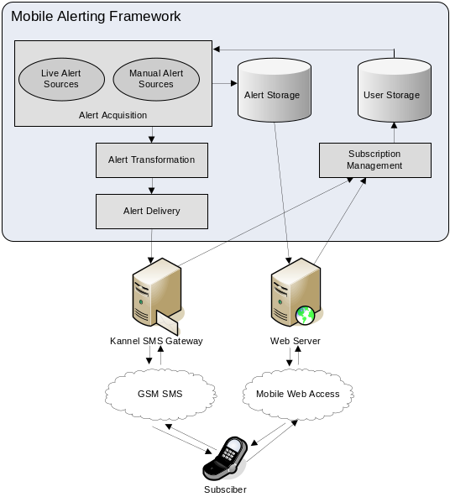
Figure 1- System Architecture of the Mobile Alerting Framework
Subscription and Location Management: The Mobile Alerting Framework provided an SMS interface for users to manage their subscription options. The framework supported location based alerting through subscriber submission of postal ZIP codes or latitude and longitude values. The need for users to manually submit their location can be eliminated if the user subscribes with a Global Positioning System (GPS)-enabled mobile phone running client software compatible with the Mobile Alerting Framework.
Alert Acquisition: For WEC’s prototype alerting systems it was desirable to have the capability of delivering authentic, real-time, real-world emergency alerts as well as having the ability to create artificial alerts to simulate various conditions and ensure activation of the system during evaluation periods. Several organizations including NOAA’s National Weather Service, United States Geological Survey and California Office of Emergency Services now provide live emergency alert feeds on the Internet in a standardized XML data format known as the Common Alerting Protocol (CAP). The Mobile Alerting Framework supported real-time acquisition of emergency alerts from these CAP feeds and can easily be extended to support other Internet-based sources such as Really Simple Syndication (RSS) feeds. If a new alert from one of these sources is matched with the location and preferences of a subscriber, it is ingested into the Mobile Alerting Framework for further processing and dissemination.
The Mobile Alerting Framework also provided a web interface allowing administrators to manually insert alerts into the system.
Alert Storage: After an alert has been ingested by the Mobile Alerting Framework, it is internally stored in CAP format and published to a web server. In this form the alert is available for later retrieval by client software via mobile web access.
Alert Transformation: Prior to dissemination, the alert data must be transformed into a format suitable for transmission as an SMS message. The CAP-encoded alert data is not formatted to be read by the user and is usually too verbose to be accommodated by the 160-character limitation of SMS messages. The Mobile Alerting Framework allows an alerting system to define the rules for transformation of the encoded alert data into a format and presentation suitable for its subscribers. In typical applications this will take the form of a user-friendly text message and may optionally include a Universal Resource Locator (URL) where the full alert may be retrieved from the web; however the SMS could contain encoded data intended for processing by client software residing on the subscriber’s mobile phone.
Alert Delivery: After alerts have been matched with subscribers and a formatting transformation applied, they are ready for SMS delivery. Both the Alert Delivery and Subscription Management components use the Kannel open-source Wireless Application Protocol (WAP) and SMS gateway (http://kannel.org) to send and receive SMS messages. Kannel can service a system with a small number of subscribers using a simple GSM modem, but for a larger scale system Kannel supports direct communication with SMS centers (SMSC) for bulk sending and receiving of SMS.

Prototype Systems
Several prototypes were implemented using the Mobile Alerting Framework. These prototype systems included mobile phones that receive and display alerts as conventional SMS messages and mobile web pages as well as mobile phones running client software capable of presenting alert content with accommodations for blind/low vision and hearing impaired users. These prototypes consisted of systems capable of receiving live alerts of weather emergencies from NOAA’s National Weather Service as well as systems that simulate the FCC’s forthcoming Commercial Mobile Alert System (CMAS).
In the weather alert system the body of the SMS message presented a concise human readable message containing the most critical information contained in the weather alert. This included the type of weather event (e.g. Severe Thunderstorm Warning), the affected area and the expiration time of the alert. Additionally, the message contained a hyperlink to a web page containing the alert’s full content formatted for accessibility and mobile viewing. Many mobile phones automatically recognize URLs as hyperlinks and when selected by the user will automatically open the link in the phones web browser (for example Windows Mobile, Nokia Nseries, Blackberry Pearl, Apple iPhone ). Figure 2 shows screenshots from a mobile phone viewing both the SMS alert message and associated web page.
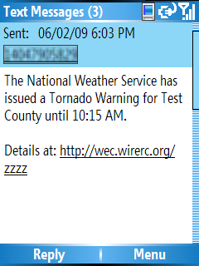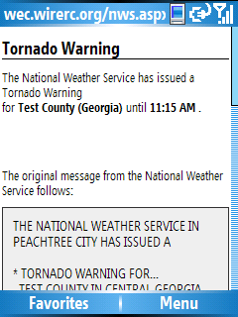
Figure 2- Mobile phone screens showing an SMS emergency alert (left) and associated web page
Although the SMS message body is friendly to human reading, the text conformed to a simple syntactic structure allowing a client application running on the users mobile to efficiently parse the message to extract the contained information. The URL also served a dual purpose; in addition to linking to a human-readable web page it also allowed software applications to request the full alert in the machine-readable CAP format.
By coupling the Mobile Alerting Framework with client software running on the subscriber’s mobile phone, a level of control of the user experience can be achieved that is not possible with the phone’s integrated SMS and Web applications. Without the client software, emergency alerts cannot be distinguished from ordinary incoming SMS messages and accessibility is limited to the features provided by the phone’s SMS application and web browser. With the client software, an incoming SMS alert was automatically identified, a distinctive alarm signal was raised and the content of the alert was then presented to the user in an accessible manner. Use of client software also affords the capability to override phone settings (such as disabled ring tone) that may interfere with the notification of a critical alert.
WEC’s client software was written for Windows Mobile 5 Smartphones, using the Microsoft .NET Compact Framework. This platform provided excellent programming interfaces to the phone’s SMS system and control of audio and vibration features. Our various mobile client applications were built from a shared codebase that provided a set of core features, including a simple menu system to manage location and subscription preferences; automatic interception of incoming SMS messages; downloading of full alert content from the web; distinctive alarm tones and vibration patterns; and the ability to override audio and vibration settings.
To accommodate visually impaired users, a mobile client was constructed featuring an auditory user interface. As with all of the project’s client software, users were notified of incoming emergency alerts with the standard attention signal of EAS consisting of the combination of 853 Hz and 960 Hz sine waves. Alerts with a lesser severity (such as a “Tornado Watch” versus “Tornado Warning”) were introduced with an attention signal of lesser intensity. This signal consisted of the EAS tone in a series of short, rhythmic bursts of decreasing amplitude. Synthesized speech was used to read emergency alerts to the user and for user interaction with simple spoken menus and prompts. Text to speech (TTS) synthesis was provided by Flite an open source speech synthesis engine designed for embedded devices.
To address hearing impairments, the mobile clients used distinctive vibration patterns to notify users of incoming alerts. Similar to the auditory attention signals, critical alerts were introduced with intense continuous vibration while alerts of lesser severity were introduced with a pattern of rhythmic bursts. In addition to a system using a conventional presentation of an alert as English text, a prototype was developed that used video to convey an alert in ASL as well as in standard English text. This ASL system was designed only to elicit user feedback on ASL as a possible enhancement to textual alerts, thus the system used prerecorded videos and was not functional as a “live” alerting system.
The WEC technical team also developed mobile clients to simulate the forthcoming CMAS as mandated by the FCC. These systems were simulations and did not interface with a live source of genuine emergency alerts. These mobile clients incorporated similar accessibility features as described above, however the message formatting and alert signals conformed to the requirements of CMAS. Alert message length was limited to 90 characters and the message included the five mandatory fields from CAP: event type, area affected, recommended action, expiration time and sending agency. The audio attention signal used the EAS two-tone signal in a prescribed temporal sequence of one long tone of two seconds followed by two short tones of one second with a ½ second pause between tones. The vibration attention signal followed the same temporal pattern.

Methodology

Operational Factors
12 separate field trials were conducted at three separate locations:
- Three trials at the Georgia Radio Reading Service (GaRRS) in Atlanta, Georgia;
- Six trials at Public Broadcasting Atlanta (PBA), Georgia; and
- Three trials at the North Carolina Department of Health & Human Services Division of Services for the Deaf and the Hard of Hearing (NC DSDHH), in Raleigh, North Carolina.
The locations were selected based on locale, building use and accessible features. The GaRRS site is a business environment, located in Midtown Atlanta. It is occupied by regular staff and volunteers who create radio programming for blind and low vision listeners. GaRRS shares the building with Georgia Public Broadcasting (GPB). The field trial participants consisted primarily of GaRRS volunteers, staff and board members. During the field trials, the receipt of alerts competed with the noise and movements of building personnel, visitors, and GPB television broadcasts in the lobby. The PBA is a busy site with many distractions. The environment was new to this next group of field trial participants, most of who had never been inside a television and radio broadcast facility. We added interactive tours of the various studios which included the opportunity for the participants to see themselves on screen. These distractions were meant to divert attention away from the alerts and offer a non-traditional experience environment. The NC DSDHH site is a government building where employees or volunteers work. The majority of participants were either employed by NC DSDHH or visited regularly to receive services such as obtaining telecommunication access equipment, advocacy and support, information referral, workshops and training, and communication support. Receipt of the simulated emergency alerts at NC DSDHH competed with foot traffic from regular personnel and the hustle and bustle of a government facility. Since many of the participants were employees of NC DSDHH they provided a tour of the facility to the observer and/or worked at their desks during the trial. Again, this allowed for a reality driven environment rather than a clinical setting.
At GaRRS there were 18 participants, at PBA, 16 participants, and at NC DSDHH, 28 participants. The final series of field trials took place at PBA and included 28 participants. The total of field trial participants was 90. Though the number of test participants varied, the field trial process was administered in the same manner at each location. In addition, a focus group of 13 people was convened to discuss the feasibility of CMAS alerts with ASL translations. All inclusive, more than 100 persons with a disability participated in the WEC project.

The Recruitment Process
Field trial subjects were recruited from Atlanta, GA and Raleigh, NC and represented people with various levels of self-identified disabilities, including deaf, hard of hearing, hearing enhanced (i.e, cochlear implant/hearing aide), blind, low vision, vision enhanced (i.e., glasses, contacts), and deaf-blind.
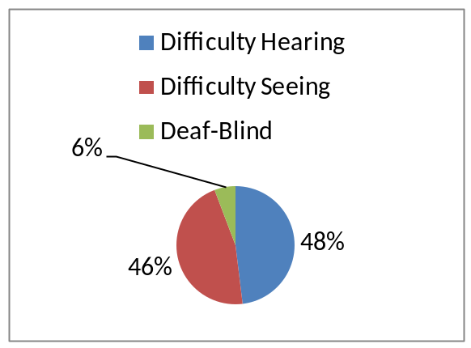
Figure 3: Percentage by Type of Sensory Limitation
Although the focus was on people with sensory disabilities, many of the test subjects reported having trouble with mobility, using their hands and thinking (i.e., concentrating or remembering). Another self-identified characteristic was technical level. The choices they were given are as follows:
- Technically savvy - frequently utilizing multiple applications on a wireless device;
- Some technical know-how - frequent use of a mobile device for voice or text communications;
- Infrequent user - only uses mobile device for emergencies or to make long distance calls.
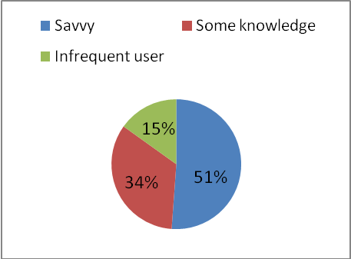
Figure 4: Percentage by Technical Ability
Demographic variables such as age range and gender were gathered at the time of the field trial and were not a high-priority consideration at the recruitment stage. Instructions were given to recruiters to try and provide a diverse sample of test participants, but given that participation in the study was voluntary, rejecting a potential test participant based on a demographic variable would have reduced the end-total amount of participants.
Following are graphical representations of the demographic breakdown of test subjects:
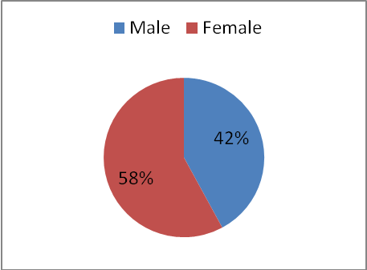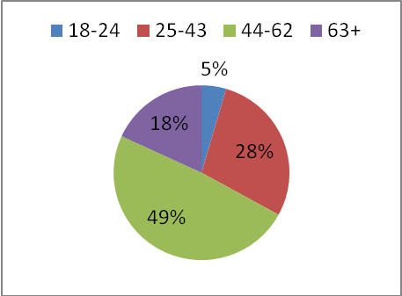
Figure 5: Gender by Percentage Figure 6: Age Range by Percentage

Field-trial model
The primary aim of WEC was to explore and evaluate various technology solutions for transmitting accessible emergency alerts and warnings over wireless networks. To accomplish this goal several tasks were undertaken, including “field trials” of the developed prototypes. The concept of “field trials” was used in the original modernization of the Emergency Broadcast System and establishment of the EAS. At that time, industry, disability organizations, emergency management agencies, and the FCC took prototype equipment to several of the country to observe, test and document any changes that would be needed in the emergency communications message chain to support dissemination of robust and redundant emergency alert messages over the EAS. “Field trials” were used instead of simulated lab tests to provide the most reliable information on the ability of the equipment to deliver alert messages successfully under real life/environmental testing scenarios. WEC’s “field trials” were conducted in a similar fashion.
Each site replicated and simulated the ability of the prototype equipment and software solution to successfully transmit emergency alerts to selected mobile wireless devices in outdoor and indoor public environments.
Prior to the field trials, the information model developed by the Access Alerts project was applied to create the message models. The information model includes the following requirements: compatibility with various transmission systems; warning message details provided in text and audio; and flexible extension of the format to meet future needs.
Project personnel (“observers”) monitored the field trials to 1) verify the successful transmission of accessible broadcast emergency alerts in multiple modalities to selected wireless devices and 2) observe the participants specific interactions with the device, device software and the impact of the environment on those interactions. The field trial results from the first three sites were used to further refine the prototype, as well as to contribute in the development of recommendations for the FCC.
At each site field trial participants were divided into three groups of no more than ten and no less than six. A participant was paired with an observer for the duration of the 1.5 hour trial period. The observers’ role was to take note of the field trial participants’ reaction to incoming alerts, how they handled the device (carried in pocket, purse, etc.), as well as note the characteristics of the environment (i.e., noisy lobby). Observers were strictly prohibited from assisting the field trial participant with the device itself. The session began with the group taking a pre-field trial questionnaire that assessed the extent to which the individual uses a mobile phone, how they currently receive, react to and confirm emergency information and their level of interest in and usefulness of receiving emergency alerts on their mobile phones. They then received the mobile devices and a technical briefing on the operation of the phone. They were asked to travel around the building and grounds and were sent a series of simulated emergency alerts. The participant experience was intended to mimic a real-life outing, interacting with people around them, touring the facility, or otherwise engage in an activity that diverted their attention from anticipating alerts. The observers knew how many alerts to expect and brought the field trial participant back to the general assembly area once all alerts had been received. At this point the participants were administered a post-field trial questionnaire which gathered qualitative and quantitative data on how the environment impacted the receipt of the alert and their level of satisfaction with the WEC or CMAS method. The session wrapped up with an open discussion to gain more qualitative data on the users’ experiences. This process was repeated 12 times during the course of four field trials.

Findings – Wireless Device Ownership & Use habits
As discussed earlier, the impetus for the modernization of EAS to include mobile devices and the forthcoming CMAS was in part, due to the rise of cell phone penetration in the U.S. In order to determine if the field trial participants’ ownership and use of wireless devices met the national statistic, a series of pre-trial questions were posed. Results show that field trial participants exceeded the national statistic with 96% owning a mobile phone or pager.
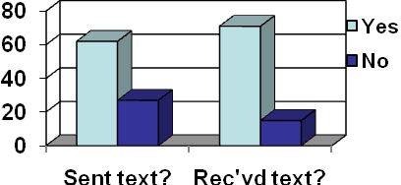
Figure 9: Use of Text Message Feature by All Participants

Hearing Impaired Participants: Results show that 92% of field trial participants with hearing impairments own a mobile phone or pager. 80% carry their mobile devices all of the time and 76% use it every day. 84% have sent a text message, and 82% have received a text message.
Visually Impaired Participants: Results show that 98% of field trial participants with vision impairments own a mobile phone or pager. 87% carry their mobile devices all of the time and 84% use it every day. 60% have sent a text message, and 76% have received a text message.

Findings – EAS (The WEC Method)

Overarching themes for deaf and hard of hearing
Thirty-nine of EAS field trial participants were deaf, hard of hearing or hearing enhanced. Of those 39, 51.3% were technically savvy, 38.5% had some technical know-how and 10.2% were infrequent users of technology. The vast majority of field trial participants currently receive emergency alerts via television (95%), with friends and family (56%), and e-mail (46%) falling in a distant second and third place, respectively. This is to be expected; given that television is the predominant way in which emergency alerts are disseminated to the public. The use of scrolling text makes it accessible to persons who are English literate and deaf or hard of hearing. However, the attention signal is often not heard by a person with significant hearing loss. That person would need to be looking at the television at the time the alert began scrolling or they would miss all or part of the emergency information. Further, if a person uses American Sign Language (ASL), some English text may be lost in translation. (This will be discussed in greater detail in the section on ASL video alerts to mobile devices.) Due to challenges regarding the accessibility of television broadcasts of emergency alerts, the field trial participants elaborated during open discussion, that receiving emergency alerts on their mobile devices would be an improvement over how they currently receive alerts. 78% of field trial participants that responded to that question on the post-test found it an improvement. Some, specific comments were:
- Very convenient way to get alerts.
- Because I am alerted if I am not at home or in front of the TV.
- I didn't have to run upstairs to check the NOAA radio.
- I would have had to rely on my husband contacting me on my cell or wait until I watched television at home. When the 9/11 bombing occurred I was clueless and my cousin was killed so it was a very traumatic experience.
- Mostly know about alerts only if I'm watching TV.
- Being alerted by cell phone was great because I always have it with me.

Of the 22% who selected that it was not an improvement, their reasoning and/or specific comments were:
- Too difficult to read different font size.
- I already have emergencyemail.org in my own pager. This website is good.
- Vibrate is working, however, we need special code light on pager.
- Text messages would alert me to check conditions, unless holding phone or BB wouldn't know it was vibrating and there was a message.
- Need stronger vibrations - several times.
- I felt the alert but couldn't get to the messages.
- Barely feel vibration.

Below are specific comments in response to the question “Do you have any suggestions for improving the system you tried today?”
- Make the speech software sound more human.
- Have a sound - I don't hear it, but my service dog would, make sure it is persistent and it should have a light flasher for visual cues.
- There needs to be a way to integrate alert to a signaler (bed shaker) at night when I can't hear and have it signal only for emergency alerts, not ordinary messages.
- Make sure it is programmable to a variety of pagers used by hearing impaired people such as Sidekick, Blackberry curve.
- Keep in mind the reception. Depending provider, in certain areas you may not receive the message.
- Warnings-Watch-Alert - The messages should be updated periodically on which levels, e.g., warning, watch, alert, emergency with flash - must identify which areas are affected.
- System works but should be able to override screen so that you don't need to fumble with buttons. The message should be displayed automatically.
- Since I am a cochlear implant user I am only totally deaf when I am sleeping. Linking mobile to home alerting system with bed shaker would help.
- Each alert has Internet address for more info. Would be nice if info. is available by a link on the mobile. Then don't need to find a computer.
- Add flash with vibration.
- Attachment light that would catch my eyes - Buzz - is ok but I don't carry the pager on my body. I leave it in my purse.
- Need stronger vibration and additional flasher.
- It would be helpful if the e-mails provide more details in case the link does not work.
- More graphics, more images…for example “Weather Push.”
- GPS enabled alerts.
- Use special code lighting on pager like red code, orange code, yellow code, serious emergency to minor emergency.
The prevailing theme for construction from this group centered on message features (font size), and handset features (vibration strength, lack of familiarity with handset). Fortunately, customizing how text is presented on handsets is available in some phone models, and the vibration strength depends upon the size of the motor. These issues can be addressed at retailers by selecting a handset that includes customization tools and a strong vibration signal. Others suggestions, like flashing lights and interfaces with bed shakers or lamps, are opportunities for further research and development. Though bed shakers are currently available, interfacing them with an emergency alert mechanism via a mobile phone has yet to be tested.

Overarching themes for blind and low vision
Twenty-four (24) of the EAS field trial participants were blind, had low-vision or vision enhanced. Of those 24, 54% were technically savvy, 25% had some technical know-how and 20% were infrequent users of technology. The vast majority of field trial participants currently receive emergency alerts via television (92%), with friends and family (71%), and radio (63%) falling in a distant second and third place, respectively. This is to be expected; given that television is an affordable, ubiquitous technology and the predominant way in which emergency alerts are disseminated to the public. However unlike the participants with hearing disabilities, radio falls in third place. This indicates that the visually impaired test participants rely more heavily on traditional methods than do the hearing impaired test participants. Both, however, rely most heavily on television. This is problematic, as anecdotal evidence reveals that EAS alerts via television broadcasts are inconsistent in their use of audio. People who are blind or have low vision will hear the alert signal, but when directed to news outlets for further information, video description is not always available and news persons often direct viewers to “look here” when pointing at maps or “read the website or phone number at the bottom of the screen” when directing viewers how to receive further information. Due to challenges regarding the accessibility of television broadcast of emergency alerts and news outlets relaying of more “detailed” emergency information, the field trial participants elaborated during open discussion, that receiving emergency alerts on their mobile devices would be an improvement over how they currently receive alerts. 87% of blind/LV/VE field trial participants that responded to that question on the post-test found it an improvement. Some, specific comments were:
- Depends on where you were. If you were out and about it would be great.
- This format should reach and protect more people with disabilities.
- It was verbal and I could understand it. I could get a repeat on it.
- Because I'm not always around TV, family, friends.
- Hard to get emergency information when you are blind and walking down the street.
- It was easy to hear and I am used to using messages.
- Very convenient way to get alerts.

Of the 13% who selected that it was not an improvement, their reasoning and/or specific comments were:
- Probably give more information about where to go and what to do.
- Too difficult to read different font size.
- I am a member of the weather channel and Jim Kamben, weather man e-mails, calls and text messages me regarding weather alerts.

Below are specific comments in response to the question “Do you have any suggestions for improving the system you tried today?”
- Emergency message should be a blinking text message in red or yellow.
- Larger font size and standardized size.
- Make sure cell phone alerts are accessible when you're outside of carrier's range (service area).
- Clearer diction of voice. Maybe volume control to turn it up if you were in a crowd.
- Make the speech output clearer and make the volume of the speech (not the tone) louder.
- Be able to repeat the warning and increase the volume. The alert could have clearer speech.
- Allow speech output to be adjustable by volume and/or via an adjustable pitch (higher/more intense).
- Speeding up the speech rate - the voice needs to go faster. Dedicated website with more information.
- Longer alerts and continued alerts if phone not answered.
- Improve and clarify voice. Improve contrast of phone controls.
- Make the speech software sound more human.
The prevailing theme for constructive feedback from this group centered on the quality and functionality of the TTS software. Commercial TTS software for mobile phones typically has better speech quality, but this comes at some expense to the end user. Some newer phones come with built-in TTS, but may not provide all the functionality of a full auditory interface a blind or low-vision consumer needs to use a mobile device. Despite the low rate of satisfaction with the TTS software, the field trial participants with difficulty seeing were enthusiastic about the potential of receiving alerts via their mobile devices.

Findings – CMAS
In examining the provisions of CMAS, the team determined that though the field trial methodology used would remain the same, the pre and post test questionnaires needed to be modified to gather data that specifically addressed CMAS specifications, as well as the refinements added to the WEC method. New questionnaires covered personal use (or lack thereof) of TTS software, types of alerts participants are interested in receiving (i.e., weather, terror, health threats), voice quality of the TTS software, the adequacy of message length, content, vibration and/or audio attention signal strength, length and volume, and how to enhance message content (i.e., use of graphics, video, etc.). In order to compare the WEC and CMAS methods we repeated questions that were posed in the WEC method field trials regarding how they currently receive emergency alerts, whether CMAS method was an improvement over current methods, and how to improve the system tested.
100% of CMAS field trial participants had a personal or business mobile device prior to the test. We asked users if they had TTS software on their mobile devices. 41% of the visually impaired users in this test did not have TTS software on their mobile devices. Had this been an actual emergency and not a test, they would not have heard the content of the alert, as the CMAS rules do not require embedded or encoded TTS within the alert message. In order to ensure that all cell phone users, regardless of sensory limitation receive the alert and are capable of accessing the content within the message, TTS would need to be (1) part of the message, or (2) CMAS capable handsets would need to be required to have TTS pre-loaded. To provide “functional equivalency” to a national alerting system, the rules would need to eliminate the added expense that a visually impaired user would incur to receive CMAS alerts by providing solution one or two noted above.
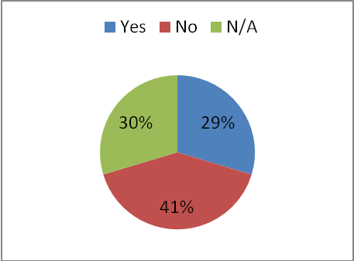
Figure 10: Chart – Does your mobile phone have text-to-speech software?
Following are graphs depicting a side-by-side comparison of vision impaired participants with hearing impaired participants to gain an understanding of the different needs and preferences based on sensory limitation.
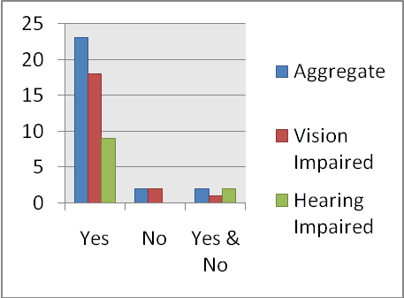
Figure 11: Graph - Did the alert message provide good information?
The quality or value of the information in the alert message received a good statistical rating among both the visually impaired (86%) and hearing impaired (82%). The percentage that did not think the information was good commented that “it explained what was happening, but too general as to where the disaster was occurring”; “would have wanted more specific instructions on what to do”; and “insufficient information.” Though the aggregate percentage of participants that found the information of little value is small compared to those that did (15% and 85% respectively); if you apply that 15% to a large population it becomes statistically significant. For example, in the Atlanta Urbanized Metro Area 378,132 non-institutionalized persons age 21 to 64 years have a disability. Applying our data to the Atlanta population of people with disabilities translates into 56,719 people who may find the emergency information insufficient. Insufficient emergency information reduces the likelihood of the individual taking the appropriate protective actions in a timely manner. Of course, this is an illustrative example, but it exemplifies the potential impact an uninformed public could have not only on their personal protection, but on the volume of calls for emergency assistance; taxing an already stressed emergency response effort during widespread disasters such as the Atlanta Tornadoes of 2008.
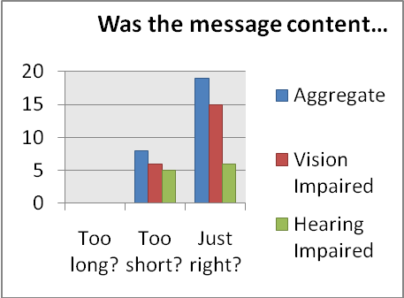
Figure 12: Graph Showing Satisfaction with Length of Message
In the main, the majority of all participants (70%) responded that the CMAS message length was “just right”, with the visually impaired group finding the 90 character message length more satisfactory than the hearing impaired group. Among the hearing impaired respondents 46% found the message was “too short” and 56% thought it was “just right.” Among the visually impaired respondents, 29% found it was “too short” while 71% found it was “just right.” 0% of respondents selected that the test message was “too long.” This begs the question, how much more information could be provided in the message before it became too much? What is the optimal amount of information for an emergency alert to a mobile device? Would more detailed information in the initial message facilitate speedier and more appropriate protective measures taken by the recipient?
A 2004 report for Congress on EAS and All Hazard Warnings identified deficiencies in the system, one of which was “limited ability to…provide directions for action to be taken by the general public” due, in part “to the capacity of technology to relay detailed messages.” Currently, the CMAS shares this shortcoming, suggesting a need to harmonize the human need for detailed information via a single device with the capacity of the network in which the device operates. Such a consideration brings in topics such as wireless spectrum, public safety networks and priority access, underscoring the inter-reliant nature of emergency alerts and the advanced communications ecosystem. Human factors and preferences suggest technical improvements; and in the best of cases drive development. In the CMAS case, with regard to message length/content, CMAS field trial findings indicate that the human factor is discordant to industry preference and technical requisite to limit character length, suggesting a need for technological inquiry and policy interventions.
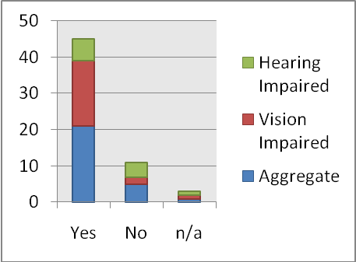
Figure 13: Graph - Was the vibration attention signal strong enough to get your attention?
The hearing impaired group found the vibration strength least satisfactory. Visually impaired users, with no hearing loss, could rely on the sound attention signal and the vibrating cadence to notify them of incoming alerts; users with significant hearing loss relied solely on the vibrating cadence. In open discussion and on the comments section of the questionnaires, many of the hearing impaired users recommended a light or screen flash function be added to the attention signal. People without sensory limitation can utilize multiple sensory cues to alert them to incoming calls or text messages whether carrying it on their body, in a bag, or even if it is sitting across the room. They may hear it, feel the vibration or hear the vibration on a tabletop. If one of their senses does not pick up the signal another usually will. For those with significant hearing loss the other sense employed for recognition of incoming alerts would be sight. However, the CMAS rules do not require the use of light as an indicator that an alert is incoming. Future rulemakings on CMAS, in its second generation, should seek comments on the need to require visual cues, as well as vibration and sound. This would further ensure accessibility for most people with sensory limitations; no less than two of their senses would be engaged to notify them of incoming alerts, greatly increasing the likelihood of the timely receipt of such alerts.
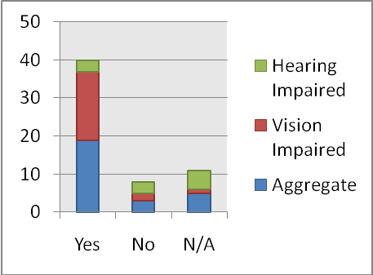
Figure 14: Graph - Was the sound alert attention signal loud enough and/or long enough to get your attention?
The sound alert attention signal for all users received a 70% satisfactory rate. Among the visually impaired users 86% stated it was loud enough to notify them of incoming alerts; and 50% of hearing impaired users (those who were not profoundly deaf) stated it was loud enough. This finding reiterates the need for more than one sense to be engaged in attention signals.
The following graphs compare the aggregate, hearing impaired and visually impaired participants’ answers to the question: Was this an improvement over how you currently receive emergency alerts?
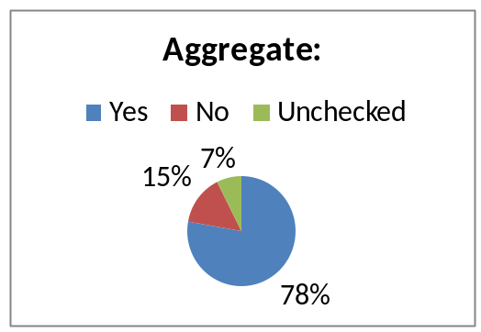
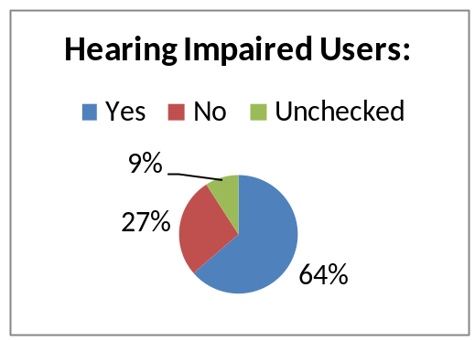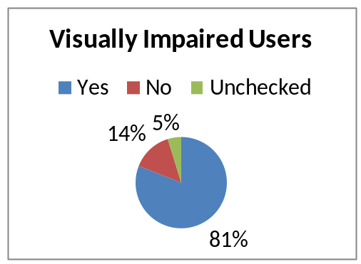
Figure 15: Graphs - Was this an improvement over how you currently receive emergency alerts?

The visually impaired participants were significantly more pleased with the CMAS alerting compared with their current method of receiving emergency alerts. Some, specific comments were:
- Because I don't have this type of alert. If you were away from other devices (TV, computer) you would still receive alert.
- Because I really don't unless people call to tell me what's going on.
- Because it was mobile and portable. It will be with me wherever I go.
- Because it talks and tells what type of alert it is.
The aggregate of those that did not find it an improvement (15%) stated it was “about the same [as current method];” “I currently receive emergency text messages from the weather service;” and “Yes and no. Need the vibration to be felt immediately if it is in my pocket.”

Below are specific comments in response to the question “Do you have any suggestions for improving the system you tried today?”
- More information about where to go or what to do. Improve voice quality.
- Make voice louder. In a crowded setting it might not be heard. More information should be provided.
- Make sure first word would come through clearly. Repeated four times and still wasn't clear.
- Signal should be louder and more distinct and repeated.
- Repeat the message at least twice. Text point size could be larger.
- More specific info. Or maybe where to go to find further information.
- The alert system needs to keep going off until it’s manually turned off.
- More detailed information, specific locations or sector. Atlanta is too large for this alert to be effective.
- There needs to be a delay between the alert tone and the voice.
- Color code message in red or blue (flashing) in addition to voice or display. 'ALERT' flashing during message delivery. Additionally use large fonts.

EAS vs. CMAS
The EAS (WEC method) was developed specifically for people with sensory disabilities, therefore it included TTS capability, the ability to override phone settings to present the alert (i.e., silent phone setting)/interrupt current activity on the phone (i.e, searching through contacts, viewing e-mail, etc.), ASL video alerts and the inclusion of URLs within the message. The CMAS final rules, however, do not require the use of TTS software within the message, will use text only, prohibits the use of URLs and the preemption of phone activity in order to deliver the alert as a priority.

Was this an improvement over how you currently receive emergency alerts?
 | EAS Method | Vision Limitation (EAS) | Hearing Limitation (EAS) | CMAS Method | Vision Limitation (CMAS) | Hearing Limitation (CMAS)
YES | 78% | 83% | 72% | 78% | 81% | 64%
NO | 21% | 13% | 21% | 15% | 14% | 27%
Not Answered | 8% | 4% | 7% | 7% | 5% | 9%
Table 1. Comparison of EAS vs. CMAS Methods
Generally speaking, the EAS method trials received higher rates of approval among all users. Discussions revealed that this was due to more detailed information being provided in the alerts, versus the very limited information allowed by the 90 character restriction of CMAS and exclusion of URLs. Results from field trials have shown that users with sensory disabilities prefer to have access to a second tier of more detailed emergency information that is accessed by way of the same device that provided the alert message, which in the prototype system, was furnished through a URL. When comparing the open discussion remarks between the CMAS field trials and the WEC field trials, it became apparent that the exclusion of this feature reduced satisfaction with the service.
Though quality of the text-to-speech software was cited as needing significant improvement, the inclusion of embedded TTS was appreciated. Not providing TTS functionality will bar access to the content of CMAS alerts by end-users who cannot afford the software and/or who do not feel they need the software because they only use their phone for voice calls. As shown in the CMAS Findings section a number of visually impaired users who own cell phones do not have TTS software.
Those with hearing limitations were the least satisfied with both methods. The low satisfaction with this population appears to be due in part to accessibility features of the mobile devices they were given as not being sufficient in addressing their particular accessibility needs. Some stated that the vibration was not strong enough to capture their attention unless they were holding the phone; however vibration strength varies among mobile phone models. For example, the BlackBerry devices used in the evaluation produced a stronger vibrating cadence than the Cingular 2125/3125 Smartphones. The prevailing theme from this group centered on message features (font size), and handset features (vibration strength, lack of familiarity with handset). Fortunately, customizing how text is presented on handsets is available in some phone models, and the vibration strength depends upon the size of the motor. These issues can be addressed at retail outlets by selecting a handset that includes customization tools and a strong vibration signal.

Focus Groups - ASL Video Alerts
American Sign Language (ASL) is the fourth most common language used in America. It has all the essential features a language requires to operate: rules for grammar, punctuation, and sentence order (National Institute on Deafness and Other Communication Disorders, 2000). According to participants in earlier field trials, in addition to captions or text, it is preferable to accommodate deaf individuals who utilize ASL as their primary language with ASL interpretation of written or spoken English. As discussed earlier, the FCC issued a new rule requiring that text-based emergency alerts be sent to mobile phones from all cell phone towers in areas affected by such emergencies. This new rule, raises the question: Do video alerts in ASL enhance understanding of public emergency alerts – above and beyond the text alerts – by people who are deaf?
Two focus groups were convened to explore this question. Participants included people who are deaf and who are conversant in ASL (13 total in 2 groups). 10 of the 13 participants were born deaf; two childhood onset; and, one late deafened. All were very comfortable conversing in ASL, 11 were very comfortable reading English, and two indicated they were somewhat comfortable reading English.
Three types of alerts were evaluated: text message (SMS) only, text message plus video alert in ASL (recorded as a complete message), and text message plus video alert in ASL (assembled from short video clips).
All agreed that the concept of ASL video alerts represented a useful tool for people who are deaf and all were pleased and delighted to see the ASL video on their cell phones. Two participants shared personal experiences of being unaware of national events or local emergencies until days or weeks later because of the limited availability of information in ASL. Finally, some participants noted that using the text and the ASL video together gave them fuller understanding of the message.
Discussion. Given the selection of the focus group participants, it is important to note that the education level of the participants may impact the need for ASL alerts. Most of the participants (9 of 13) had college degrees, and a few were school teachers at the Atlanta Area School for the Deaf (AASD). The strong command of written English shared by most of the participants (11 of 13) allowed them to understand the text alert. Nevertheless, all agreed that many who are deaf have little understanding of English and therefore have a strong need for tools like ASL video alerts for public emergencies. Following are improvements and considerations recommended by the participants:
There was some debate over the quality and intelligibility of the segmented video.
- Most preferred the continuous video – both for intelligibility and general enjoy-ability.
- There was general acceptance of the segmented video if it decreased costs or time to send alert.
- Most agreed that intelligibility was hampered by the way the segments were cut (where the segment breaks occurred). Example: “…in effect until 3:00 pm” was cut between “3:00” and “pm.” The break was found to be disconcerting.
- All hours of the day should be recorded as completed segments (e.g., “3:00 am” and “3:00 pm).
- Be careful where other breaks in phrasing are placed.
Some participants emphasized the fact that some phrases and expressions do not translate well into Deaf English, or are otherwise not easily understood by people who are deaf. Idiomatic expressions that have entered mainstream English such as “low lying areas” and “take cover” may cause confusion.

RECOMMENDATIONS
Disability stakeholder input in the regulatory process has lead to increased recognition that the needs of people with disabilities be considered proactively in the development of emergency communications policies to preclude the need for costly retrofitting of devices and lengthy revisions to policy. The modernization of EAS is still in the revision phase. However, CMAS will be commercially available in 2012. Work still remains to make CMAS a fully accessible solution for users with sensory limitations. Potentially, the second generation of the system can employ the use of video, audio, graphics, embedded TTS functionality and URLs to provide a more robust alerting experience that is applicable to the variety of needs experienced by people with differing levels of sensory impairment (i.e., late deafened, compared to pre-lingual onset of deafness, low vision compared to the fully blind).
On the industry side, the WEC team recommends that manufacturers who incorporate emergency alerting into mobile wireless handsets examine features such as attention signal volume and vibration strength and consider making these features customizable in order to accommodate various end-user preferences. We also recommend that people with disabilities be included in the early stages of development and field testing of mainstream and assistive products, features and software. Retailers can also benefit from these findings as other work with hearing aid compatible cell phones show that user and salesperson education is a critical factor in ensuring persons with disabilities purchase the correct products for their needs; industry is urged to make sure clear labeling explaining emergency features is on product packaging and in stores, and that sales staff understand the emergency and accessibility features in products.
“Emergency managers have learned and stated that accurate and timely information is as crucial as is rapid and coherent coordination among responding organizations. Effective information systems that provide timely access to comprehensive, relevant, and reliable information are critical.” WEC recommends the emergency management community create and document best practices to reach individuals with disabilities during emergency crisis situations. Insuring that CMAS and EAS alerts are disseminated simultaneously with complementary emergency information is essential, as WEC findings revealed that people will seek additional emergency information. To avoid confusion, response time loss, bolster and/or maintain trust in the systems, it is important that the two national alerting systems are in synch in both timing and content. Emergency managers that understand the use of inclusive and accessible technological solutions, as well as the instinctual behavior of the public once the alert is received can decrease response times to these populations, which can lead to more efficient use of public safety and emergency management personnel.
Evaluations by the WEC team suggest that mobile devices offer an opportunity to improve dissemination of emergency alerts to sensory impaired populations. Testing of various prototypical solutions to make these alerts more accessible show that simple accommodations can be made that greatly increase the accessibility of these alerts. They also reveal the complex relationship between stakeholder interests. As government and industry move forward in rolling out next-generation alerting systems, the needs of citizens with disabilities must be taken into account in the design and evaluation of such systems and the policy framework the systems will operate within, paying close attention to not only, national policy, but State and local emergency communications plans.

Future Research, Policy and Practice Recommendations
The WEC goal was to identify features that would enhance the accessibility of emergency alerts to mobile devices; and in so doing, uncovered areas for future research, some of which have policy and practice implications. They have been discussed in earlier sections of this report. Below is a synopsis of future research and policy recommendations:

Research Recommendations
- The hearing impaired participants that were profoundly Deaf, or that used hearing aids or cochlear implants, stressed the need to receive alerts while asleep. Future research should develop and test with end-users interfacing a lamp, bed shaker, or wearable/portable device, with emergency alerts to mobile devices.
- The CMAS will be commercially available in 2012. WEC recommends conducting a study, testing actual CMAS alerts and surveying a larger sample of people with sensory disabilities to determine if the alerts are reaching this population and prompting protective actions.
Policy and Practice Recommendations:
- Findings from the CMAS pre-field trial questionnaire revealed that 41% of blind or low vision participants did not purchase TTS software for their personal devices. The CMAS final rules do not require TTS capability. In order to ensure that all cell phone users, regardless of sensory limitation receive the alert and are capable of accessing the content within the message, TTS would need to be (1) part of the message, or (2) CMAS capable handsets would need to be required to have TTS pre-loaded. To provide “functional equivalency” to a national alerting system, the rules would need to eliminate the added expense that a visually impaired user would incur to receive CMAS alerts by providing solution one or two noted above.
- Some field trial participants found the CMAS message too general and wanted more detailed information. Providing more information or a reference to more information within the message is currently prohibited. Due to the negative impact on first responder resources and public safety in general, it is recommended that the FCC initiate a Notice of Inquiry to determine the technically viable method for including URLs without over taxing the network.
- WEC recommends the emergency management community create and document best practices to reach individuals with disabilities during emergency crisis situations. Emergency managers that understand the use of inclusive and accessible technological solutions can decrease response times to these populations, which can lead to more efficient use of public safety and emergency management personnel.
- Findings from the ASL focus groups revealed that translation of idiomatic expressions often used to convey protective measures, such as “take cover” and “avoid low-lying areas” may cause confusion. WEC recommends that the NWS review and revise their alert nomenclature to exclude idiomatic expressions. A preliminary inquiry of the NWS reveals that a standard nomenclature for alerting does not exist, as much of the language used includes regional expressions. Likewise, this holds true for ASL, which further complicates creating a standard. This too represents an area where further investigation is needed.
- With regard to message length/content, CMAS field trial findings indicate that the human preference for more detailed information is discordant to industry preference and technical requisite to limit character length, suggesting a need for technological inquiry and policy interventions.
- The hearing impaired group found the vibration strength least satisfactory. Although factors such as the small motor in the Cingular 2125/3125 phones used in the test could have negatively impacted perception of the strength of the vibration cadence. Visually impaired users, who did not have any hearing loss, could rely on both the sound attention signal and the vibrating cadence to notify them of incoming alerts. For those with significant hearing loss the other sense employed for recognition of incoming alerts would be sight. However, the CMAS rules do not require the use of light as an indicator that an alert is incoming. Future rulemakings on CMAS, in its second generation, should include a requirement for the use of visual cues, as well as vibration and sound, greatly increasing the likelihood of the timely receipt of such alerts.
- Government agencies and disability organizations should motivate industry to design and develop accessible emergency alerting methods through educational outreach on the bottom-line benefit of accessible universal design. With the technological paradigm shift from analog to digital, wireline to wireless, and the aging population, what was once considered a niche market is fast approaching the norm.
Limited dissemination of information regarding available, accessible wireless alerting technologies, products and methodologies continues to be a barrier to the effective delivery, usage and understanding of such aides. Outreach and awareness are vital to successful utilization. Increased efforts at targeted research investigating the needs of people with disabilities, dissemination of research findings, and stakeholder activity in the policymaking process could facilitate the development of a more fully inclusive national alerting system.

ACKNOWLEDGEMENTS
Two advisory bodies, a Panel of Experts (PoE) and Advisory RERC Collaborators helped to guide the research and development activity of WEC. The PoE represented the Deaf and hard-of-hearing community, community of Blind and low vision persons, and experts in emergency communications. The PoE provided a wealth of technical expertise and guidance to best accomplish project deliverables. The Advisory RERC Collaborators represent the broad intersecting disciplines of the RERCs on access to telecommunications, workplace accommodations and low vision and blindness where accessible emergency alerts have relevance. The expertise of the PoE and Collaborators assisted in developing the parameters of the field trials; review and critique test findings; provide feedback on development and research activities; assist in drafting technology recommendations for the FCC, policymakers and the wireless industry and guiding the direction for the 2009 Emergency Communications State of Technology conference.
The WEC Team Advisory RERC Collaborators
Helena Mitchell, Ph.D. Co-project Director Judy Harkins, RERC Telecommunications Access
Frank Lucia, Co-project Director Jon Sanford, RERC on Workplace Accommodations
Ed Price, Technical Director John Brabyn, RERC on Low Vision and Blindness
Jeremy Johnson, Engineer
Salimah LaForce, Information Analyst
Laurel Yancey, Chief Policy Officer
Ben Lippincott, Industry Liaison

Panel of Experts
Marcia Brooks, The Carl and Ruth Shapiro WGBH National Center for Accessible Media
Elizabeth Davis, EAD Associates
Tom Ditt, North Carolina Division of Services for the Deaf and Hard of Hearing
Claude Stout, Telecommunications for the Deaf

The WEC team also wishes to acknowledge the contributions of the following individuals to the success of the research reported: Harley Hamilton, John Morris, and James Mueller.

American Red Cross (2010). Annual Report. Retrieved from http://www.redcross.org/flash/AnnualReport/2010/Disaster.html
Office of Minority Health, U.S. Department of Health and Human Services (1999). Closing the Gap. Retrived from http://www.hawaii.edu/hivandaids/Improving%20the%20Quality%20of%20Life%20for%20Minorities%20with%20Disabilities.pdf.
U.S. Department of Health and Human Services (2009). Vital and Health Statistics, Summary Health Statistics for U.S. Adults: National Health Interview Survey, 2008, Series 10, Number 242. Retrieved from http://deafness.about.com/gi/o.htm?zi=1/XJ&zTi=1&sdn=deafness&cdn=health&tm=15&gps=358_439_1436_637&f=00&su=p284.9.336.ip_p736.9.336.ip_&tt=2&bt=1&bts=0&zu=http%3A//www.cdc.gov/nchs/fastats/disable.htm
United States Census Bureau. (2008). Annual Estimates of the Resident Population by Sex and Five-Year Age Groups for the United States: April 1, 2000 to July 1, 2008 [NC-EST2008-01]. Available at http://www.census.gov/popest/national/asrh/NC-EST2008-sa.html.
Day, J. (1996). Population Projections of the United States by Age, Sex, Race, and Hispanic Origin: 1995 to 2050. Current Population Reports. U.S. Bureau of the Census 1996: 25-1130.
CTIA – The Wireless Association. (2010). Wireless Quick Facts Mid-YearFigures. Retrieved from http://www.ctia.org/advocacy/research/index.cfm/AID/10323
Organization for the Advancement of Structured Information Standards (2005). OASIS Standard CAP-V1.1. Retrieved from http://www.oasis-open.org/committees/download.php/15135/emergency-CAPv1.1-Corrected_DOM.pdf
Black, A., & Lenzo, K. (2001). "Flite: a small fast run-time synthesis engine", Proceedings of the 4th ISCA Tutorial and Research Workshop on Speech Synthesis. Perthshire, Scotland.
The deaf-blind participants were not profoundly deaf-blind, but retained some limited vision and/or hearing.
Dr. Mitchell was the former chief of the Emergency Broadcasting System and Emergency Alert System; Frank Lucia was senior engineer.
Access Alerts. Making Emergency Information Accessible to People with Disabilities. http://ncam.wgbh.org/about/news/pr_09152005
U.S. Census Bureau (2000). Sex by Age by Disability Status by Employment Status for the Civilian Non-institutionalized Population 5 years and over. [Atlanta, Georgia Urbanized Metro Area] Available at http://factfinder.census.gov/servlet/DTTable?_bm=y&-context=dt&-ds_name=DEC_2000_SF3_U&-CONTEXT=dt&-mt_name=DEC_2000_SF3_U_P042&-tree_id=403&-redoLog=true&-all_geo_types=N&-_caller=geoselect&-geo_id=40000US03817&-search_results=40000US03817&-format=&-_lang=en&-SubjectID=17498075.
These questions are posed with regard to human capacity for information intake via a mobile device, not network capacity.
Moore, L. K. (2004). CRS Report for Congress. Emergency Communications: The Emergency Alert System (EAS) and All-Hazard warnings. August 13, 2004, Washington, D.C.
Factors such as the small motor in the Cingular 2125/3125 phones used in the test could have negatively impacted perception of the strength of the vibration cadence. Large phones would have stronger motors and vice versa.
Van de Walle, B. and Turoff, M. (2007). Emergency Response Information Systems: Emerging Trends and Technologies. Communications of the ACM 50(3): 29-31.

