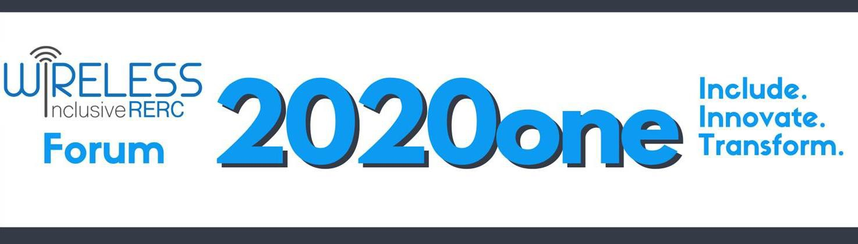

Tuesday, March 23rd
8:45 – 9:00 | Get Connected – Stay Connected  Technical Setup
9:00 – 9:10 | Welcome and Opening Remarks  Helena Mitchell, Principal Investigator, Wireless RERC
9:10 - 9:30 | Rapid Fire Research - Short targeted highlights of research projects  Young Mi Choi, Augmented Reality as a Design Tool John Bricout, Socially Assistive Robot for Respite Care
9:35 – 10:20 | A Discussion of the State of Research  Facilitator, Paul M.A. Baker, Wireless RERC  Nathan Moon, Survey of User Needs Paper Presentation  A discussion on the asked and unasked research questions that could generate new evidence, practices, and innovations for the field.  Together we will identify how research can better inform inclusive technology policy and regulations.
10:20 – 10:30 | 10-MINUTE BREAK
10:30 – 11:00 | Lightning Development Demos – A quick look at exciting projects with promising potential  Maureen Linden and Brad Fain, Inclusive Emergency Lifelines Maribeth Gandy Coleman, Wearable Design Tool  James Coughlan, Tactile Graphics Helper

11:05 – 11:50 | A Discussion of the State of Technology Development  Facilitator, Maribeth Gandy Coleman, IMTC Bruce Walker, Swan 2.0 Paper Presentation  A discussion on the direction of development needed to move the needle forward on transformational technologies for access and inclusion. We will identify how changes in technology can more universally result in inclusive products and services, including what needs to be preserved and sustained for compatibility purposes.
11:55 – 12:40 | A Discussion of the State of Stakeholder Engagement Facilitator, Karen Peltz Strauss, National Disability Consultant David Dzumba, Microsoft  Richard Ray, City of Los Angeles (Retired)  A discussion of mechanisms to engage consumer, industry and governmental stakeholders in policy and technology development to advance the mission of access and inclusion. Session will include a history of, and novel methods for, high impact stakeholder engagement, including the use of accessibility teams, advisory bodies, dispute resolution, and other collaborative methods to meet the accessibility challenges of evolving 21st century technologies.
12:40 – 12:45 | Instructions for Day 2  Salimah LaForce, Wireless RERC
Wednesday, March 24th
9:15 - 9:30 | Welcome Back and Get Connected Again  Technical Setup
9:30 – 10:00 | Highlights of Selected Papers  Claire Donehower, Facilitating Social Connectedness Sarah Farmer, Personas for Technology Policy Design Julienne A. Greer, Theatre and Robots
10:00 – 10:05 | InsightOut - Video Presentation

10:05 – 10:25 | Perspectives  Avonne Bell, CTIA  DeeDee Bennett, SUNY-Albany David Dougall, BlackBerry Limited  A distillation of day one discussions and kickoff for the closing  session. Reactors will share their observations, professional takeaways, recommendations as to how to implement ideas that arose during the Forum.
10:30 – 11:45 | Themed Discussion “The best way to predict the future is to invent it.” ~Alan Kay, computer scientist  Facilitator, Helena Mitchell, Wireless RERC
- What are the issues that researchers, technologists, and stakeholders believe need attention now?
Brad Fain, Center for Advanced Communications Policy Kay Chiodo, Deaf Link

- What are the remaining challenges and opportunities for the future?
Joan Durocher, National Council on Disability
Paul Schroeder, American Printing House for the Blind

- So, what are the next steps to help define what lies ahead?
Bill Belt, Momentum Dynamics
Stephen Bauer, National Institute on Disability, Independent Living, and Rehabilitation Research
11:45 – 12:00 | Wrap-up & Thank You  Salimah LaForce, Forum Co-Chair, Wireless RERC

