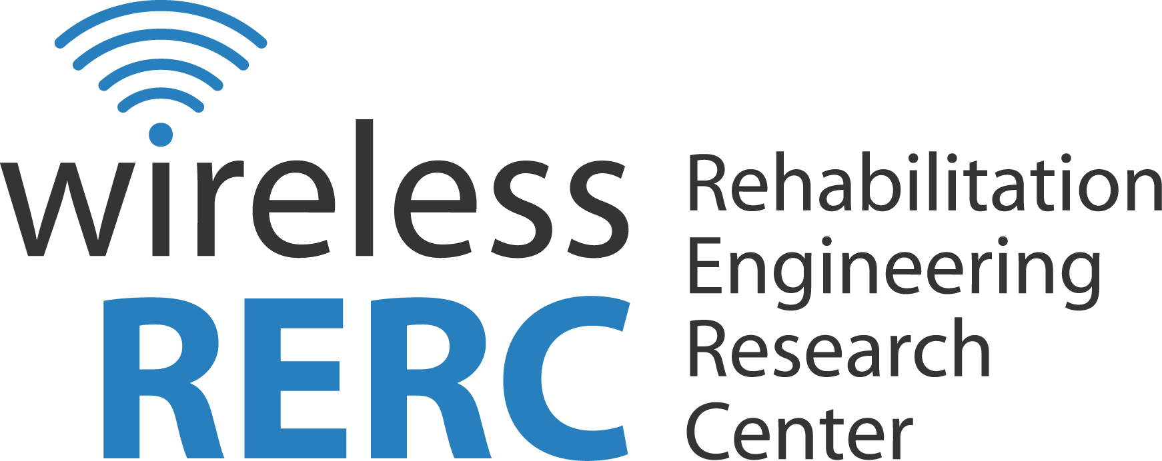
Technology and Disability Policy Highlights
August - September 2016

Overview
In September the White House hosted the Designing for All Showcase, a celebration that recognized the work and expertise of companies, designers, and engineers making strides in inclusive design, assistive technology, and prosthetics. At the event, many new technologies were announced, as well as government programs facilitating the inclusion of people with disabilities to engage in all aspects of society including school, employment, and recreation.
The Federal Communications Commission (FCC or Commission) has also been busy with efforts to improve technology and programmatic access. In August, the Consumer and Governmental Affairs Bureau (CGB) issued a Public Notice [CG Docket No. 10-213] seeking comment on the accessibility of communications technology for the 2016 Biennial Report. The report, detailing the impact of the 21st Century Communications and Video Accessibility Act of 2010, will address accessibility barriers to new communications technologies, effects of accessibility recordkeeping and enforcement requirements, and procedural matters. Turning the lens on themselves, the CGB commenced a review of Commission policies and practices in relation to their compliance with Section 504 of the Rehabilitation Act of 1973. They sought public input on their programmatic access and updates to the Section 504 Handbook. Other major FCC decisions included new rules enhancing Wireless Emergency Alerts (WEAs), additional Emergency Alert System (EAS) codes, revised hearing aid compatibility (HAC) rules to ensure that people with hearing loss have quality access to wireless devices/services, and the “iCanConnect” Deaf-Blind Equipment Distribution Program (NDBEDP), formerly a pilot, is now permanent.
In Wireless RERC news, Principal Investigator, Helena Mitchell, and, researcher, Young Mi Choi, were honored by Georgia Tech’s Office of Institute Diversity and featured in the Faces of Inclusive Excellence Video. Watch/Listen to the Video. Researchers were also busy with outreach efforts, speaking at the National Academies of Sciences, Engineering and Medicine workshop on “The Future of Emergency Alert and Warning Systems: Research Directions,” CTIA’s Accessibility Outreach Initiative Forum at Super Mobility Week, and the Integrated Public Alerts and Warning System (IPAWS), Office of Disability Integration and Coordination (ODIC) annual Roundtable.
Click the headings below to link directly to a particular section.

Executive Branch Activities Regulatory Activities Wireless RERC Updates Publications/Reports Other Items of Interest Upcoming Events

Executive Branch Activities

The Whitehouse’s Designing for All Showcase
September 15, 2016 - The White House hosted the Designing for All Showcase. The celebration recognized the work and expertise of companies, designers, and engineers making strides in inclusive design, assistive technology, and prosthetics. Creative minds have taken low-cost tools and technologies to create high-tech assistive devices and prosthetics, enabling the inclusion of people with disabilities to engage in all aspects of society including school, employment, and recreation. These new designs encompass assistive technology wearables and prosthetics with character. A notable program is the Open Style Lab at the Parsons School of Design. The inclusive design curriculum will combine students with clients who have a disability involving them in inclusive design at the beginning of the process. Other initiatives involve the introduction of the UNYQ Align™ scoliosis brace. UNYQ offers personalized prosthetics and orthotics that are customizable for comfort and fashion. Also regarding fashion, in 2017, ABL Denim, plans to launch a clothing line to calm anxiety for adults and children who experience a sensory processing disorder. Also, new clothing innovations by MagnaReady and PVH Corp will offer dress shirts with secure magnetic closures. At the event, they also announced several federal initiatives and resources for more inclusive living. They are detailed below:
- The Downs Designs Dreams (DDD) provides Veterans with adaptive clothing. DDD and the Department of Veterans Affairs have formed a partnership to offer Veterans in need DDD’s No Buttons No Zippers No Hassles line of jeans.
- The Department of Veterans Affairs (VA), Center for Innovation offers a training program with 3D printers to support Veterans return to work. The goal of the program is to provide 21st Century marketable skills with technical training utilizing 3D Printing and design skills. The intended outcome is new employment opportunities for Veterans through the acquisition of tools and ability to bring their idea to market or start their own company.
- The Administration on Community Living (ACL) at the Department of Health and Human Services announced a $2 million, five-year cooperative agreement to establish a National Resource Center for Self-Advocacy to empower people with intellectual and developmental disabilities (IDD).
- The National Institutes of Health will start their Research Plan on Rehabilitation addressing why some people with temporary or permanent disabilities can better adjust after injury, while others require more in-depth rehabilitation programs.

Additional Information:
Summary: White House showcases inclusive design, assistive technology, and prosthetics
[https://www.whitehouse.gov/blog/2016/09/15/designing-all]
National Resource Center for Self-Advocacy Grant Information
[http://acl.gov/NewsRoom/NewsInfo/2016/2016_09_15.aspx]
Research Plan on Rehabilitation [PDF not accessible to screen readers
[https://www.nichd.nih.gov/publications/pubs/Documents/NIH_ResearchPlan_Rehabilitation.pdf]

Regulatory Activities

FCC Improves Wireless Emergency Alerts
September 29, 2016 - The FCC released a Report and Order (R&O) and Further Noticed of Proposed Rulemaking (FNPRM) In the Matter of Improving Wireless Emergency Alerts and Community Initiated Alerting [PS Docket No. 15-91]. Some of the main enhancements to WEA included:
- Increasing the maximum WEA character length from 90 characters to 360 characters;
- Adding a fourth message type, “Emergency Governmental Information” which would allow for alerting authorities to send information concerning shelter locations, boil water advisories and other pertinent life and property saving information that comes in the wake of an initial emergency message;
- Enabling local authorities to test the WEA system; and
- Require the geotargeting of WEA messages to be more precise.
However, there are issues that remain to be resolved. The FNPRM section is seeking stakeholder input on a number of topics, but one of particular interest to people with disabilities is the inclusion of multimedia in the alert message. The Wireless RERC has long been a proponent of inclusion of ASL videos interpreting the content of the messages. However, the multimedia feature has not been mandated, and thus must continue to be provisioned by proprietary systems such as Deaf Link’s Accessible All Hazards Alerts (AHAS). Once the FNPRM is published in the Federal Register, stakeholders (e.g. the public, mobile phone manufacturers and service providers, organizations representing the interests of people with disabilities, academics, emergency managers, etc.) will have 30 days to submit comments and 60 days to submit reply comments.

Additional Information:
R&O/NPRM: Docx -- Pdf -- Txt
[http://transition.fcc.gov/Daily_Releases/Daily_Business/2016/db0929/FCC-16-127A1.pdf]

The FCC on Technology Access in Light of Advancements
September 21, 2016 - Karen Peltz-Stauss, Deputy Chief of the FCC’s Consumer & Governmental Affairs Bureau spoke at the 2016 Trumpeter Awards National Consumers League. Her remarks focused on the inclusion of people with disabilities as technology advances. She reflected how sometimes the latest technology advancements take away access instead of providing accessibility. Deputy Chief Peltz-Stauss provided the example of silent movies in the early 1900’s viewed by individuals with a hearing impairment. However, when speech was implemented in this arena, for about fifty years, TV and films were not accessible. Federal regulations for closed captioning was needed to make this form of entertainment more accessible. Her remarks also reflected on the rotary dial and push button phones that were accessible for many who experienced a visual limitation. The advancement of touchscreen phones, media devices, and other electronics changed this level of access, and many years passed before people with vision loss began to regain access. The FCC will soon require audio to navigate program menus. She stated that numerous websites and electronic devices remain inaccessible to people with disabilities. As the private sector incorporates accessibility, usability testing with people with disabilities, and universal design principles, access should continue to improve. Karen Peltz-Strauss stated, “Now, clearly, technological advances have improved our lives – and dramatically so. But staying ahead of the technological curve becomes a challenge when new innovations for the general public don’t consider the needs of people with disabilities.”

Additional Information:
Read the Remarks
http://transition.fcc.gov/Daily_Releases/Daily_Business/2016/db0923/DOC-341409A1.pdf

ADA Settlement Agreement with Humboldt County, California
September 7, 2016 — The U.S. Department of Justice filed a proposed consent decree with Humboldt County, California regarding Title II violation of the Americans with Disabilities Act (ADA) for allegedly not providing accessible facilities, activities, programs, and services to individuals with disabilities. The consent decree will be enforceable by the courts, and the county will have to pay $275,000.00 to individuals with disabilities who experienced barriers to equal access to the county’s activities, facilities, programs, and services. Also, the County must commit and comply with ADA regulations. This obligation includes hiring an ADA coordinator, independent licensed architect, web accessibility coordinator, and website accessibility consultant to bring services in compliance and adhere to ADA mandates. Other compliance measures include ensuring that emergency management procedures, policies, and shelters are accessible to individuals with disabilities. Principal Deputy Assistant Attorney General, Vanita Gupta, head of the Justice Department’s Civil Rights Division stated that “ADA compliance is not optional and the Justice Department works tirelessly to make sure that people with disabilities can live their lives with the dignity, respect and independence they deserve.”

Additional Information:
Read the Consent Decree
https://www.justice.gov/opa/pr/justice-department-settles-humboldt-county-california-resolve-americans-disabilities-act

FCC Evaluating Industry Compliance with Accessibility Requirements
August 23, 2016 - The Consumer and Governmental Affairs Bureau (CGB) of the FCC issued a Public Notice [CG Docket No. 10-213] seeking comment on the accessibility of communications technology for the 2016 Biennial Report. The report will address accessibility barriers to new communications technologies, effects of accessibility recordkeeping and enforcement requirements, and procedural matters. Comments submitted assisted the FCC in evaluating compliance with the 21st Century Communications and Video Accessibility Act of 2010, requiring that telecommunication services and advanced communication equipment be accessible to people with disabilities. The FCC sought input on their tentative findings concerning:
- The level of compliance with sections 225, 716, 718 of the Communications Act.
- The extent to which any accessibility barriers still exist with respect to new communications technologies.
- The effect of the requirements of section 717 of the Act on the development and deployment of new communications technologies.

Additional Information:
Consumer and Governmental Affairs Bureau Seeks Comment on its Tentative Findings About the Accessibility of Communications Technologies for the 2016 Biennial Report Under the Twenty-First Century Communications and Video Accessibility Act
[https://apps.fcc.gov/edocs_public/attachmatch/DA-16-961A1.pdf]

FCC Amendment to Emergency Alert System – New Codes
August 11, 2016 - The FCC released Final Rules in the Amendment to Emergency Alert System (EAS) [PS Docket No. 15–94; FCC 16–80]. Three new codes have been added to EAS to cover extreme wind and storm and revise the territorial boundaries of the geographic location codes for two offshore marine areas. The main purpose is to harmonize EAS with the National Weather Service (NWS) radio system. Implementation of the new codes is voluntary. However, the small number of EAS Participant areas that are affected are ready to move forward with utilizing the new codes. The revisions on the FCC EAS rules request that implementation start immediately with new codes and necessary software changes integrated into new equipment and available to EAS Participants no later than six months after the posting of the ruling. The three new codes are Extreme Wind Warning (EWW), Storm Surge Watch (SSA), and Storm Surge Warning (SSW). For more information about the Geographic Code Revisions for territorial boundaries for location codes 75 and 77, see pages 53040, 53041, and 53045. NWS will start using the new codes during the 2017 Atlantic Hurricane season, which is after the six-month deadline. Thus, providing time for updates and implementation for EAS Participants. The Wireless RERC anticipates that the additional codes, especially the storm surge watch, will benefit people with disabilities that reside in the areas impacted, providing more advanced notice of dangers that may require evacuation planning.

Additional Information:
Final Rules
[https://www.gpo.gov/fdsys/pkg/FR-2016-08-11/pdf/2016-18962.pdf]
[https://www.fcc.gov/document/fcc-adds-new-warning-codes-emergency-alert-system]

New Hearing Aid Compatibility (HAC) Rules for Wireless Devices
August 4, 2016 - The FCC is implementing new HAC rules to ensure that people with hearing loss that use cochlear implants or hearing aids have quality access to wireless devices. The new rules aim to maintain a balance between fostering accessibility and promoting innovation and investment. The Commission’s new HAC requirements apply to wireless service providers and manufacturers of digital wireless handsets. The service providers and manufacturers are required to offer two percentage benchmarks: 66% of offered handset models must be compliant following a two-year transition period for manufacturers, and 85% of offered handset models must be compliant following a five-year transition period for manufacturers, with additional compliance time for service providers. For entities offering only four or five handsets, the rules establish more limited obligations.

Additional Information:
FCC CHARTS COURSE TO COMPREHENSIVE HEARING AID COMPATIBILITY FOR CONSUMERS WITH HEARING LOSS
[http://transition.fcc.gov/Daily_Releases/Daily_Business/2016/db0804/DOC-340636A1.pdf]

The “iCanConnect” Program Becomes Permanent
August 4, 2016 - “iCanConnect” the Deaf-Blind Equipment Distribution Program (NDBEDP) launched by the FCC is now permanent. Due to the success of the pilot program in equipping thousands of people with hearing and vision loss with standard and advanced communications, the FCC voted to make the program permanent. iCanConnect provides $10 million dollars annually to organizations that distribute communications equipment to low-income, individuals that are deaf-blind. The free equipment makes telecommunications, Internet access, and advanced communications available to users. The program also provides installation, training, and other technical support. iCanConnect is being extended to include residents from the U.S. territories of Guam, Northern Marianas, and American Samoa, as well as the 50 states, the District of Colombia, Puerto Rico, and the U.S. Virgin Islands.

Additional Information:
FCC MAKES PERMANENT THE NATIONAL DEAF-BLIND EQUIPMENT DISTRIBUTION PROGRAM
[http://transition.fcc.gov/Daily_Releases/Daily_Business/2016/db0804/DOC-340634A1.pdf]

FCC Seeks Comments on Section 504 of the Rehabilitation Act of 1973
August 3, 2016 - The FCC’s Consumer and Governmental Affairs Bureau released a Public Notice [DA 16-884] stating they have commenced a review of Commission policies and practices in relation to compliance with Section 504 of the Rehabilitation Act of 1973. Section 504 requires that federal agencies make their programs and activities accessible to people with disabilities. The FCC is sought public input on their programmatic access, including their provision of sign language interpreters, the physical accessibility of their buildings and meeting spaces, captioning, and many forms of accommodation.

Additional Information:
THE CONSUMER AND GOVERNMENTAL AFFAIRS BUREAU SEEKS COMMENT ON THE COMMISSION’S POLICIES AND PRACTICES TO ENSURE COMPLIANCE WITH SECTION 504 OF THE REHABILITATION ACT OF 1973
[http://transition.fcc.gov/Daily_Releases/Daily_Business/2016/db0803/DA-16-884A1.pdf]

Wireless RERC Updates

Wireless RERC Researchers Featured in Faces of Inclusive Excellence Video
September 16, 2016 - Wireless RERC Principal Investigator, Helena Mitchell, and, researcher, Young Mi Choi, were honored by Georgia Tech’s Office of Institute Diversity and featured in the Faces of Inclusive Excellence Video. Watch/Listen to the Video.

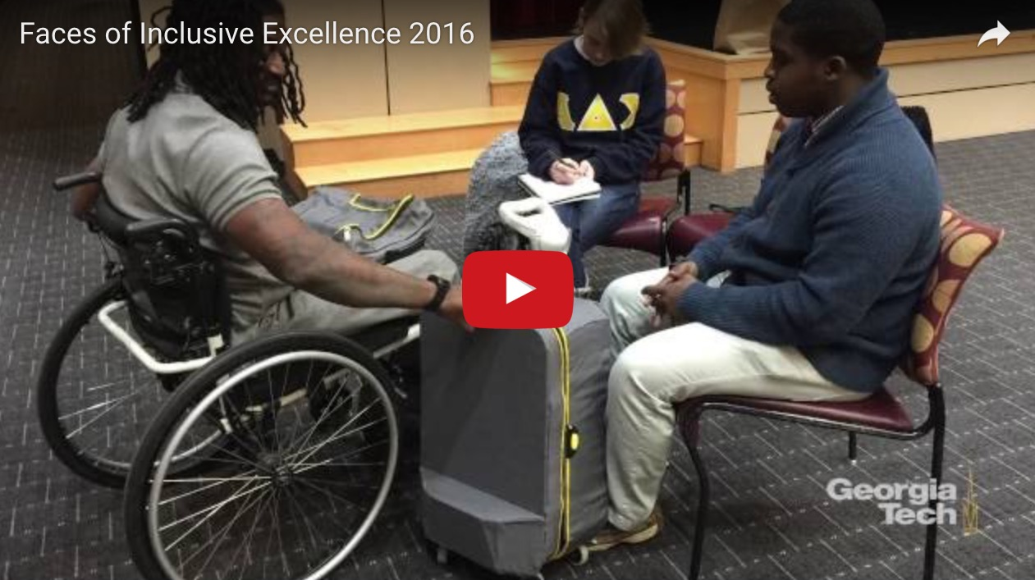

Wireless RERC at CTIA Super Mobility Week
September 7, 2016 - Helena Mitchell attended the 2016 CTIA – Super Mobility Week convention September 6-8th, 2016 in Las Vegas, NV. Dr. Mitchell was an invited speaker at the CTIA Accessibility Outreach Initiative Forum. The topic was “5G and its Impact on the Accessibility Community.” The session discussed 5G technologies and its expected capabilities including what this means for accessibility. The promise of next-generation benefits for the consumer as we move closer to a connected future was also explored.

Additional Information:
2016 CTIA – Super Mobility Week
[http://www.ctiasupermobility2016.com/]

Wireless RERC at The National Academies
September 1, 2016 - Helena Mitchell, Wireless RERC PI, attended a National Academies of Sciences, Engineering and Medicine workshop on “The Future of Emergency Alert and Warning Systems: Research Directions” sponsored by the Department of Homeland Security. Dr. Mitchell was an invited to discuss findings from two DHS-funded research and development grants and how these R&D results have contributed to improving emergency alerts that are accessible to people with disabilities. Her presentation also identified research gaps and suggestions for future research and development activities to create a platform that includes American Sign Language (ASL) videos, attention signals, and other accessible solutions for timely and effective alerting.

Additional Information:
National Academies of Sciences, Engineering and Medicine
[http://www.nationalacademies.org/index.html]

Wireless RERC in Washington
August 11, 2016 - Salimah LaForce, Wireless RERC project lead, presented WEA: Optimizing Message Content for People that are Deaf, at the FEMA ODIC-IPAWS roundtable. She shared preliminary results of usability testing of the Wireless Emergency Alerts Video Platform (WEA-VP) and IPAWS Symbology. Twenty-two individuals who are deaf and whose primary language is ASL participated in the usability testing. WEA messages were presented in the following formats: WEA text-based message only, WEA text message with IPAWS Symbology, and WEA messages supplemented by ASL video. Each received a total of nine messages, three in each format, and asked to explain what the message told them, and what they would do if they received it. Results suggested that the inclusion of symbology and the ASL video improved message comprehension, but additional education on the meaning of certain symbols would optimize their utility.

Additional Information:
FEMA IPAWS ODIC 2016 Roundtable Webinar
[https://femaipawslab.webex.com/ec3100/eventcenter/recording/recordAction.do?siteurl=femaipawslab&theAction=poprecord&ecFlag=true&recordID=13658237&internalRecordTicket=4832534b000000027e878aced0038d4b8e136b345c60f399187d3c8e5f1bc11699b0e84d85d2fbe7]

Publications/Reports

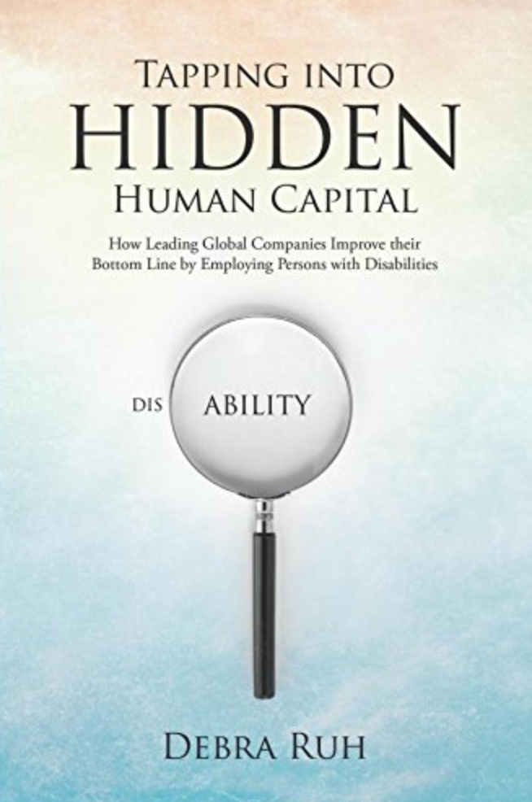
New Book Release: Tapping Into Hidden Human Capital
August 15, 2016- G3ict, also known as the Global Initiative for Inclusive Information and Communication Technologies, has published a new book titled Tapping into Hidden Human Capital: How Leading Global Companies Improve their Bottom Line by Employing Persons with Disabilities. The book was written by G3ict’s own, Debra Ruh, the EmployAbility Program Chair, where she presents “a game-changing” perspective about the employment of those with disabilities. With case studies from some of the largest companies in the world, Ruh illustrates how employees with disabilities contribute to companies’ competitiveness and financial performance. As well as pointing out the benefits to hiring employees with disabilities, she provides insights and strategies on making workplace accommodations, leveraging the employee’s skills and talents, and transforming their challenges into successes.

Additional Information:
New Book Released: Tapping Into Hidden Human Capital: How Leading Global Companies Improve their Bottom Line by Employing Persons with Disabilities
[http://globalaccessibilitynews.com/2016/08/15/new-book-released-tapping-into-hidden-human-capital-how-leading-global-companies-improve-their-bottom-line-by-employing-persons-with-disabilities/]

Other Items of Interest

House Committee Demands Explanation of Failure to Implement NG911
On September 30, 2016, the House Committee on Energy and Commerce sent a letter to the Washington, DC office of Assistant Secretary, Strickling, for the National Telecommunications and Information Administration (NTIA) at the Department of Commerce, and to Dr. Rosekind, Administrator for the National Highway Traffic Safety Administration (NHTSA). The House letter requests both agencies to provide explanations of why there has been a failure to implement the Next Generation 911 (NG911) Advancement Act of 2012, provide a timeline for implementation, and produce criteria regarding grant operations on NG911. The legislation covered a number of areas including updating the “911” system from analog to Internet Protocol type technology, and improved coordination among local, state, and federal entities. The agencies are required to respond to the House request by October 12, 2016.
The “911” system is a critical element of emergency infrastructure. As per legislation, advocacy organizations, and Wireless RERC research, NG911 implementation is critical to realizing parity of access to emergency services by people with disabilities. With the current system, people with disabilities, including but not limited to people with vision and hearing disabilities, may face challenges when placing “911” calls and communicating with emergency dispatchers. For example, if a person with a vision disability wants to call “911”, he or she may be unable to accurately describe the emergency situation if a visual description is required. Or, if a person with a hearing disability wants to call “911”, he or she may be unable to hear the PSAP operator clearly or at all, making the conversation challenging or impossible. NG911 enables users to communicate their emergencies through photos, text, videos, and data.

Additional Information:
Read the Letter
[http://energycommerce.house.gov/sites/republicans.energycommerce.house.gov/files/documents/114/letters/20160929NTIANHTSA.pdf]

Start Now, Start Here: Answer These Questions to Prepare for an Emergency
September 29, 2016 – The U.S. Department of Health and Human Services, Administration on Community Living posted a blog on emergency preparedness for people with disabilities. Following is a summary of the blog. An emergency can happen at any time. What is the best way to prepare for the unknown? Eliminate unknown factors by planning and preparing for an emergency. What are your responses to the following five important questions?
- When will you make your plan so that you are prepared for an emergency?
- What is my inclusive approach to emergency management?
- Who is in my network, and what role do they have in preparing for or responding to an emergency?
- How often should I update my plan?
- What can people with disabilities do to be more prepared for an emergency?
Schedule a time to create a plan. Make this a priority as you would any major activity you would normally schedule such as a vacation, doctor’s appointment, anniversary, or home/car maintenance. Develop an inclusive emergency management approach that will work for you, family, pets, service animals, and/or staff. The U. S. learned a great deal from Hurricane Katrina about the needs of people with disabilities. Many aspects of an inclusive plan and environment were left out, which included dissemination of and access to information, communication with people with disabilities, resources for transportation, accessible shelters, service animals, and planning for individuals with a disability. Incorporate these areas of focus in your emergency preparations, and be sure to plan for short and long-term recovery. The first 72 hours after a disaster can be very chaotic. First responders may not be in a position to assist right away. Make your plan, plan with your network, ask the tough questions, write the plan down, and practice your plan until you are familiar and confident with the execution of your plan. The National Disability Rights Network (NDRN), Federal Emergency Management Agency’s (FEMA) Office of Disability Integration and Coordination (ODIC), and Wireless Inclusive RERC invite Individuals with Disabilities and Others with Access and Functional Needs to view www.ready.gov as you craft your answers to the above questions and make your emergency management plans.

Additional Information:
ACL Blog
http://www.acl.gov/NewsRoom/blog/2016/2016_09_29b.aspx

Obi, the Robotic Dining Device Named R&D 100 Awards Finalist
August 17, 2016 - Obi has been named a finalist for the 2016 R&D 100 awards in the market disruptor and mechanical/materials categories. Obi, a robotic arm, was designed to make eating much simpler for people with mobile disabilities. Jon Dekar, a University of Dayton engineering student, developed the Obi prototype when he saw challenges that people with disabilities face. The robotic arm selects food from one of four different compartments and delivers the food to the diner’s mouth. With a single charge, Obi has enough energy to serve the diner four to six meals. It can give people with mobile disabilities independence from a caretaker and gives the user a dignified way to eat.

Additional Information:
Press Release
[https://meetobi.com/index.php/news/2016/08/17/obi-2016-rd-100-awards/]

New Assistive Technology Lab Opens
August 4, 2016 - Utah State University (USU) has opened a new Assistive Technology (AT) Lab at one of the school’s regional campuses in Roosevelt. The lab will help people with disabilities by providing tailor-made devices and technology, as well as lending technologies so that users “can try before they buy.” A $74,000 grant from the Christopher & Dana Reeve Foundation helps to fund the lab. The AT Lab will also be a resource for the professional community that seeks to provide technology accommodations for their employees with disabilities. The director of the Utah Assistive Technology Program, Sachin Pavithran, commended USU for establishing the Assistive Technology Lab.

Additional Information:
New USU Assistive Technology Lab Opens in Roosevelt
[https://www.usu.edu/today/?id=56044]

Introducing Graphiti, the Tactile graphics display
August 2, 2016 - Created by Orbit Research and American Printing House (APH), according to the press release, Graphiti is the world’s first affordable tactile graphics display. Graphical information such as charts, drawings, flowcharts, floor plans, images and photographs, can be “read” through an array of moving pins. The pins are set at different heights, enabling the display of topographical maps and other graphical elements to that can be sensed by the user’s fingers. It also features a touch interface that allows the user to “draw” on the display. Tracing a shape with their fingertip raises the pins along the path traced. This tactile feedback can have a positive impact on the education of students that rely on Braille, especially in subjects that use an abundance of graphs and charts, such as statistics, geography, and other sciences.

Additional Information:
Orbit Research and American Printing House for the Blind Announce the World's First Affordable Refreshable Tactile Graphics Display
[http://www.orbitresearch.com/news_details.php?id=14]

Pennsylvania Libraries Expand Accessible Reading Opportunities
August 1, 2016 - The Carnegie Library of Pittsburgh and the Free Library of Philadelphia entered a partnership with Benetech, a non-profit that manages Bookshare, the world’s largest online accessible library for individuals with print disabilities. The partnership provides Pennsylvania residents with print disabilities free, 24/7 access to more than 446,000 electronic books in digital audio, text, and Braille. The Library Services Manager at Carnegie Library of Pittsburgh-Library for the Blind and Physically Handicapped, Mark Lee says “This partnership greatly expands the number of accessible titles available to Pennsylvania residents who are print disabled. Now they will have the opportunity to access those titles instantly and through a device of their choosing.” Pennsylvania patrons can access New York Times best sellers, career guides, picture books and eBooks on tablets, smartphones, computers, assistive technology devices, and MP3 players.

Additional Information:
Pennsylvania Libraries Partner with Benetech/Bookshare to Expand Accessible Reading Opportunities for Patrons with Print Disabilities
[http://www.carnegielibrary.org/clp_press_release/pennsylvania-libraries-partner-benetechbookshare-expand-accessible-reading-opportunities-patrons-print-disabilities/]

LiveWell RERC App Factory
The Rehabilitation Engineering Research Center for Community Living, Health and Function (LiveWell RERC) seeks to enhance the use and usability of wireless technologies, included in this effort of inclusivity for all people of various ages and abilities is RERC’s mobile app development project, the “App Factory.” They are in the process of selecting developers based in the United States and Canada to develop accessible and/or assistive apps for mobile and tablet platforms as well as sensors, home automation, wearables, Internet of Things (IoT) and/or Cloud Computing. The app proposals are evaluated on the following criteria. The app must address accessibility or assistive technology need, be unlikely to be developed commercially, be technically feasible and have the technical capacity required, have a projected lifetime of the app, and is not a duplicate of another app. Decisions on App Factory awards are expected in October 2016.

Additional Information:
Assistive and Accessible Mobile Applications Call for Proposals
[http://static1.squarespace.com/static/5698f3670ab377ee41d1ff0b/t/5783ee47e4fcb51afa3f64a3/1469541957124/App+Factory+RFP_2016_FINAL.pdf]

Upcoming Events

2016 Online KT Conference: Communication Tools for Moving Research to Practice
The 2016 Online KT Conference will convene October 24th, 26th, and 28th, 2016 from 1:00 pm to 5:00 pm Eastern Standard Time each day. The conference focuses on using communication tools such as social media to enable researchers and stakeholders the ability to increase use of evidence-based research findings through knowledge translation (KT) activities. Conference attendees will be able to interact with presenters through Adobe Connect. Each day will have a different theme. Register now for this FREE event by Friday, October 21, 2016.

Additional Information:
Conference Website
[http://ktdrr.org/conference2016/]
Conference Agenda
[http://ktdrr.org/conference2016/agenda.html]

Technology and Disability Policy Highlights, August - September 2016

The Technology and Disability Policy Highlights (TDPH) reports on national public policy events and tracks emerging issues of interest to individuals with disabilities, researchers, policymakers, industry, and advocacy professionals. The TDPH is published monthly by the Wireless RERC. The Wireless RERC is a research center that promotes universal access to wireless technologies and explores their innovative applications in addressing the needs of people with disabilities. For more information on the Wireless RERC, please visit our website at [http://www.wirelessrerc.org].
For further information on items summarized in this report, or if you have items of interest that you would like included in future editions, please contact this edition’s editors Synge Tyson [synge@cacp.gatech.edu], Jamaya Powell [jamaya@cacp.gatech.edu] or Salimah LaForce [salimah@cacp.gatech.edu].
_________________________________________________________________________________
This newsletter was developed under a grant from the National Institute on Disability, Independent Living, and Rehabilitation Research (NIDILRR grant number 90RE5025-01-00). NIDILRR is a Center within the Administration for Community Living (ACL), Department of Health and Human Services (HHS). The contents of this newsletter do not necessarily represent the policy of NIDILRR, ACL, HHS, and you should not assume endorsement by the Federal Government.

