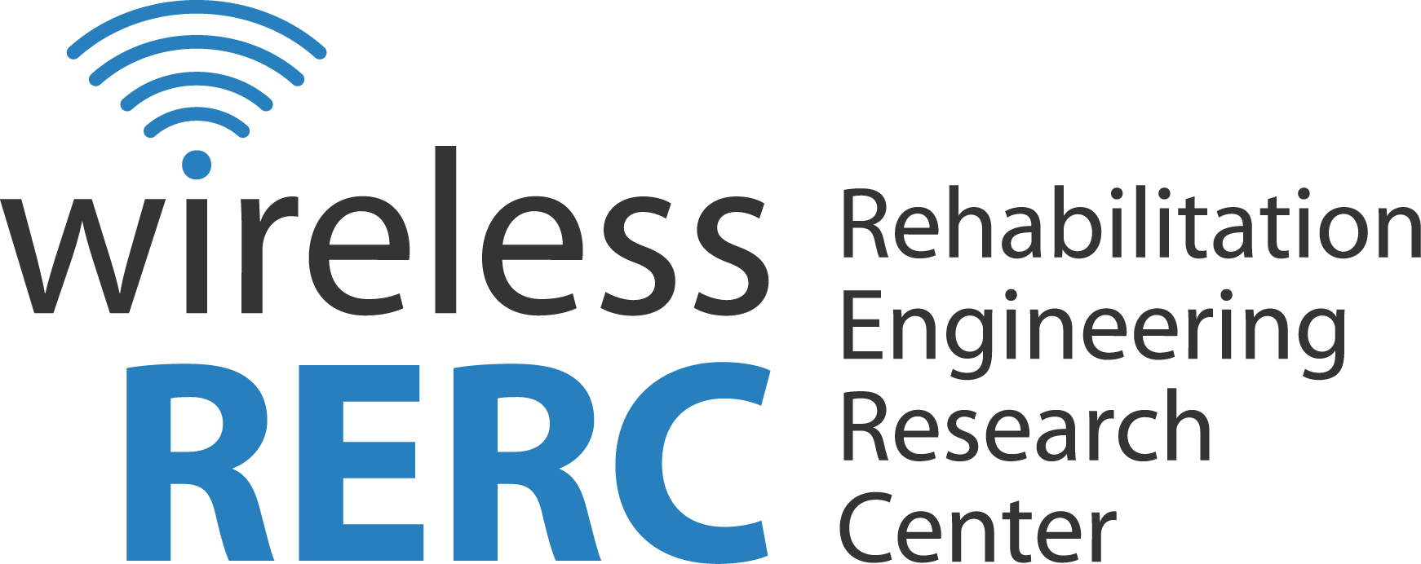
Technology and Disability Policy Highlights
March 2014

Overview
In March, H&R Block entered into a five-year consent decree with the Department of Justice (DOJ) following complaints that H&R Block violated the Americans with Disabilities Act (ADA) by failing to ensure accessibility on their website and mobile applications.
In regulatory news, the Federal Communications Commission (FCC) issued a Report and Order and Further Notice of Proposed Rulemaking, wherein new rules were adopted in accordance with Section 713 of the Communications Act to enhance the quality of closed captioning, including new standards to ensure that captions are accurate and synchronous in portraying the spoken words and background noises, are present for the whole program and are placed in such a way that they do not block important visual content. The FCC also issued a Second Further Notice of Proposed Rulemaking regarding development and deployment of NG911, asking for comments on a possible deadline for deployment and whether relay services should provide text-to-text and text-to-voice services “to support communication with [Public Safety Answering Points]” for consumers.
Click the headings below to link directly to a particular section.

Legislative Activities

Regulatory Activities

Other Items of Interest

Wireless RERC Updates

Upcoming Events

Legislative Activities

H&R Block Will Make Website and Apps Accessible
March 7, 2014 — H&R Block has entered into a five-year consent decree with the Department of Justice (DOJ). The decree follows complaints by the National Federation of the Blind (NFB) and two individual plaintiffs that H&R Block violated the Americans with Disabilities Act (ADA) by failing to ensure accessibility on their website and mobile applications. The complaints highlight that the website and mobile applications are incompatible with many assistive technologies such as screen readers and refreshable Braille displays. The complaint also stated that H&R Block failed to provide other accessibility features such as keyboard navigation or captioning.
Under the decree, H&R Block will work to enhance the accessibility of their services by ensuring that their website and mobile apps are in compliance with Level AA Success Criteria of the Web Content Accessibility Guidelines (WCAG) 2.0 by January 1, 2015, appointing a web accessibility coordinator and providing accessibility training for all web content personnel. H&R Block has also been ordered to “pay $45,000 to the two individual plaintiffs, and a $55,000 civil penalty.” Acting Assistant Attorney General, Jocelyn Samuels, notes, “This landmark decree ensures that individuals with disabilities will have an equal opportunity to independently and conveniently obtain information and complete taxes as others do. H&R Block is to be commended for working with the NFB and the Justice Department in resolving to take such steps.”

Additional Information
DOJ Press Release
[http://www.justice.gov/opa/pr/2014/March/14-crt-239.html]

Open Letter to LA Senators Urges Support for Assistive Technology
March 25, 2014 — Former New Orleans Saints player, Steve Gleason, issued an open letter to Louisiana Senators Mary Landrieu (D-LA) and David Vitter (R-LA) and other Louisiana Congress Members urging them to consider supporting a recent bi-partisan piece of legislation, The Ensuring Access to Quality Complex Rehabilitation Technology Act [S.948 and H.R. 942].
The Act would amend Title XVIII of the Social Security Act to ensure that complex rehabilitation technology is covered under Medicare. In his letter Gleason, who was diagnosed with Amyotrophic Lateral Sclerosis (ALS) in 2011, stresses that for individuals with ALS and similar conditions, assistive technology is essential, yet often an extreme financial burden. The proposed bill would help reduce this burden and grant individuals greater access to assistive technology. Gleason has also created a petition regarding this matter.

Additional Information
Steve Gleason's Open Letter
[https://www.facebook.com/teamgleason.org/posts/618777661531320]
Petition to the Obama Administration
[https://petitions.whitehouse.gov/petition/stall-centers-medicaremedicaid-services-cms-capped-rental-speech-generating-devices-pending-rewrite/Fz8bfNh2]
Ensuring Access to Quality Complex Rehabilitation Technology Act of 2013

[http://beta.congress.gov/bill/113th-congress/senate-bill/948]

Regulatory Activities

FCC Releases Rules to Improve Closed Captioning
February 24, 2014 — The FCC released a Report and Order (R&O) and Further Notice of Proposed Rulemaking (FRPRM) In the Matter of Closed Captioning of Video Programming [CG Docket No. 05-231]. The R&O adopts new rules in accordance with Section 713 of the Communications Act to enhance the quality of closed captioning, including new standards to ensure that captions are accurate and synchronous in portraying the spoken words and background noises, are present for the whole program and are placed in such a way that they do not block important visual content. It also adopted rules which require broadcasters “who utilize Electronic Newsroom Technique (ENT)” to ensure that all news scripted for the teleprompter is also captioned. In order to ensure technical compliance of the rules, the R&O specifies that video programming distributors must “monitor and maintain their equipment,” in addition to keeping records of any “maintenance, monitoring and technical checks of their captioning equipment.”
In the FNPRM, the FCC seeks comment on whether the proposed rules should be extended to require compliance for video programmers, a subset of video programming providers. The FCC also seeks comment on whether metrics should be established to measure the completeness of live and near-live captioning and if specific time intervals should be established for equipment checks. Regarding consumer complaints, the FCC seeks comment on methods to improve complaint handling and proposes a “public dashboard containing information about captioning complaints.” Finally, the FCC is requesting comments on the level of compliance regarding technical standards of captions and whether consumers have had any issues with recent “on-screen visual changes or textual depictions.” Comments on the section of the FNPRM entitled, “Responsibilities for Meeting the Closed Captioning Requirements” are due April 28, 2014, and reply comments are due May 27, 2014. Comments on all other sections of the FNPRM are due June 25, 2014, and reply comments are due July 25, 2014.

Additional Information
FCC R&O [CG Docket No. 05-231]
[http://transition.fcc.gov/Daily_Releases/Daily_Business/2014/db0224/FCC-14-12A1.pdf]

FCC Seeks Comment on Rules To Implement Text-to-911
March 5, 2014 — The FCC released a Second Further Notice of Proposed Rulemaking (FNPRM) in the Matter of Facilitating the Development of Text-to-911 and Other Next Generation 911 Applications and Framework for Next Generation 911 Deployment [PS Docket No. 10-255 and PS Docket No. 11-153] regarding the implementation of text-to-911. Primarily, the FCC seeks comment on the feasibility of a proposed timeframe, which would require text-to-911 to be made available by all text providers by December 31, 2014. Additionally the FCC seeks comment on location accuracy of emergency texts, “delivery of text over non-cellular data channels” and the use of text-to-911 for consumers who may be outside of their typical network and considered “roaming.” A final concern presented in the FNPRM is that of relay services used by individuals who are deaf, hard of hearing or have speech disabilities. Accordingly, the FCC seeks comment on whether relay services should provide text-to-text and text-to-voice services “to support communication with [Public Safety Answering Points]” for consumers. Comments on the document are due April 4, 2014, and reply comments are due May 5, 2014.

Additional Information
FCC 2nd FNPRM
[http://www.gpo.gov/fdsys/pkg/FR-2014-03-05/pdf/2014-04731.pdf]

FCC Launches New Website for Text-to-911
March 7, 2014 — The FCC launched a new website this week highlighting best practices currently in place for implementation of text-to-911. The website is designed to provide resources for text providers and public safety answering points (PSAPs), including lessons learned by the State of Vermont during their text-to-911 rollout and information on various technology solutions that can be used for text-to-911 implementations. Currently the site provides sources from public safety organizations, such as the National Emergency Number Association (NENA) and Association of Public-Safety Communications Officials (APCO) International, in addition to states where text-to-911 has been deployed. Going forward the site is meant to be an interactive “tool enabling text providers and PSAPs to contribute and refer to comments, best practices, and informational materials.”

Additional Information
FCC Blog Post
[http://www.fcc.gov/blog/fcc-launches-webpage-best-practices-implementing-text-911]
FCC Text-to-911 Best Practices Website
[http://www.fcc.gov/encyclopedia/best-practices-implementing-text-911]

Other Items of Interest

FEMA’s Integrated Public Alert and Warning System Program Management Office Receives “Greatest Citizen Impact” Award
March 1, 2014 – FEMA’s Integrated Public Alert and Warning System (IPAWS) Program Management Office (PMO) was honored with the “Greatest Citizen Impact Award” for its IPAWS system by the American Council for Technology’s (ACT’s) Industry Advisory Council (IAC) at their Igniting Innovation Showcase in Washington, D.C.
IPAWS is a national alert and warning system available for use by state, local, territorial, tribal and federal public alerting authorities to send emergency alerts to citizens. IPAWS receives and authenticates the messages transmitted by the alerting authorities and at the same time, routes them through a single interface to various systems such as the Emergency Alert System for radio and television, Wireless Emergency Alerts or WEAs sent by participating mobile carriers directly to cell phones, NOAA Weather Radio and other public alerting systems.
The ACT-IAC Institute for Innovation, an association that promotes government and industry interaction to produce government information technology innovations, selected 30 organizations to participate in a one-day event to showcase their technologies.
Leadership and staff in FEMA’s IPAWS PMO conducted live WEA demonstrations throughout the day, and spoke to showcase attendees about IPAWS and its impact on public safety officials and the American people, including those with disabilities and other access and functional needs. During the showcase, ACT-IAC judges, comprised of both government and industry representatives, viewed each demonstration. Attendees were allowed to vote for their favorite technical innovations.

Additional Information
Integrated Public Alerts and Warning System (IPAWS)
[http://www.fema.gov/integrated-public-alert-warning-system]

Sprint Relay Partners with United Cerebral Palsy
March 3, 2014 — United Cerebral Palsy (UCP) will partner with Sprint to promote Sprint Relay, a speech-to-speech (STS) service provided for people with hearing and speech disabilities. Although Sprint Relay has been providing communications assistance for over 20 years, UCP’s newfound partnership with Sprint will help raise awareness of these services. Specifically, Sprint Relay allows Sprint customers to dial *STS (*787) to directly access STS services and connect with a Communications Assistant (CA). The service also provides customers with the ability to “email call instructions for the STS CA prior to the call” and store up to 30 phone numbers, allowing the customer to ask for a caller by name instead of dictating the phone number.

Additional Information
UCP Press Release
[http://ucp.org/getinvolved/corporatepartners/ucp-partnership-with-sprint-relay/]

On Thin Ice – New Preparedness Initiative for People with Disabilities
March 10, 2014 – Due to the increase in emergency and disaster concerns in the Arctic, The Global Alliance on Accessible Technologies and Environments (GAATES) has embarked on a new initiative to ensure the protection, security and inclusion of people with disabilities in that region. On Thin Ice, a project funded by the Government of Canada’s Social Development Partnership Program, aims to implement international best practices, effective communications, compliance with regulations, emergency preparedness, capacity to sustain life during an emergency, school participation in emergency management and more. Details regarding involvement and important dates can be found on their website.

Additional Information
GAATES: On Thin Ice
[http://globalaccessibilitynews.com/2014/03/10/gaatess-new-project-on-emergency-preparedness-for-persons-with-disabilities-on-thin-ice/]

CVS Releases New “ScripTalk” Prescription Labels
March 18, 2014 — CVS Pharmacy announced that customers can now receive ScripTalk talking prescription labels when ordering online at CVS.com. ScripTalk is a free service which provides customers who are blind or have low vision with audible information about their prescription through the use of a ScripTalk reader provided by Envision America. Vice President of Programs and Policy at the American Federation of the Blind, Paul Schroeder, noted, “The lack of accessible labels on prescription drug containers puts people with vision loss at serious risk of medication mishaps. We applaud CVS pharmacy for taking steps to provide speech access to label information for customers with vision loss along with its willingness to evaluate methods to improve large print labels.”

Additional Information
CVS Press Release
[http://info.cvscaremark.com/newsroom/press-releases/cvspharmacy-now-offers-talking-prescription-labels-through-its-online]

President Obama Appoints Three New Members to the NCD
March 20, 2014 – President Obama announced appointments of Gary Blumenthal, Ari Ne’eman and Clyde E. Terry as new members of the National Council on Disability (NCD). Gary Blumenthal, CEO of the Association of Developmental Disabilities Providers of Massachusetts, also acted as CEO for the Florida State Protection and Advocacy Programs for People with Developmental Disabilities from 1998 to 2003. Ari Ne’eman, President of the Autistic Self-Advocacy Network, was awarded the Advocates in Disability award from the HSC Foundation in 2008, and Clyde E. Terry, CEO of Granite State Independent Living, sat on the boards of the ADA Watch Advisory Council and the National Task Force on Accessible Elections. All of the new appointees have been previously appointed to the NCD (Mr. Blumenthal in 2010, Mr. Ne’eman in 2010 and Mr. Terry in 2011). President Obama stated, “I am grateful that these impressive individuals have chosen to dedicate their talents to serving the American people at this important time for our country. I look forward to working with them in the months and years ahead.”

Additional Information
Obama New NCD Appointees
[http://www.whitehouse.gov/the-press-office/2014/03/20/president-obama-announces-more-key-administration-posts]

Funding Awarded to Refine Visually Guided Hearing Aid
March 24, 2014 — The National Institute on Deafness and Other Communication Disorders (NIDCD) awarded the Boston University College of Health and Rehabilitation Services with a five-year, $2.75 million grant for the testing and refinement of a Visual Guided Hearing Aid prototype (VGHA). Typical hearing aids work by amplifying all sound in an area. However, in many cases there may be sounds an individual would like to ignore. The VGHA is a hearing aid which will allow the user to choose the sounds they listen to by using eye-tracker technology to guide the hearing aid’s microphones to the desired sound. Currently the VGHA prototype is only lab-based. However plans for further development aim to make VGHA a “portable, wearable device.”

Additional Information
Boston University Press Release
[http://www.bu.edu/sargent/2014/03/18/bu-sargent-receives-2-75m-nih-grant-to-develop-visually-guided-hearing-aid/]
BU Today: Hearing Aid of the Future
[http://www.bu.edu/today/2014/hearing-aid-of-the-future/]

Wireless RERC Updates

Wireless RERC CSUN14 Presentations Now Online
Wireless RERC researchers were featured at the 2014 International Technology & Persons with Disabilities Conference (CSUN) in San Diego, California March 17-22, 2014. Links to presentations are below.
- Are we Neglecting the 20%: Accessibility of Emergency Management Websites, Dr. Dee Bennett
- Hearing Aid Compatibility: Results from a National Survey, Dr. John Morris
- Wireless Technology Uses and Activities by People with Disabilities, Dr. John Morris
- Future of Disabilities: Is Technology Failing Us?, Salimah LaForce

More Fun at CSUN, Hobnobbing with CEOs and Robots
While at CSUN, Salimah and John met with Boaz Zilberman, founder and CEO of Project Ray. He demonstrated the Ray smartphone interface software for people with vision loss. The innovation for this product is that the touchscreen controls center around the user’s touch point, eliminating the need to memorize the position of the icons; the controls adapt to wherever the person touches. According to Boaz, Project Ray’s simplified interface is good for individuals who have lost sight later in life. The target market is the elderly with vision loss and his typical customer is around 55 years old. Ray runs on Nexus 5 with the Android 4.2 operating system. Additionally, developers can create apps for the Ray environment the same way they develop standard Android apps. Ray is available commercially (in Israel) via Odin Wireless. Boaz, is exploring ways to introduce Ray to the US market.

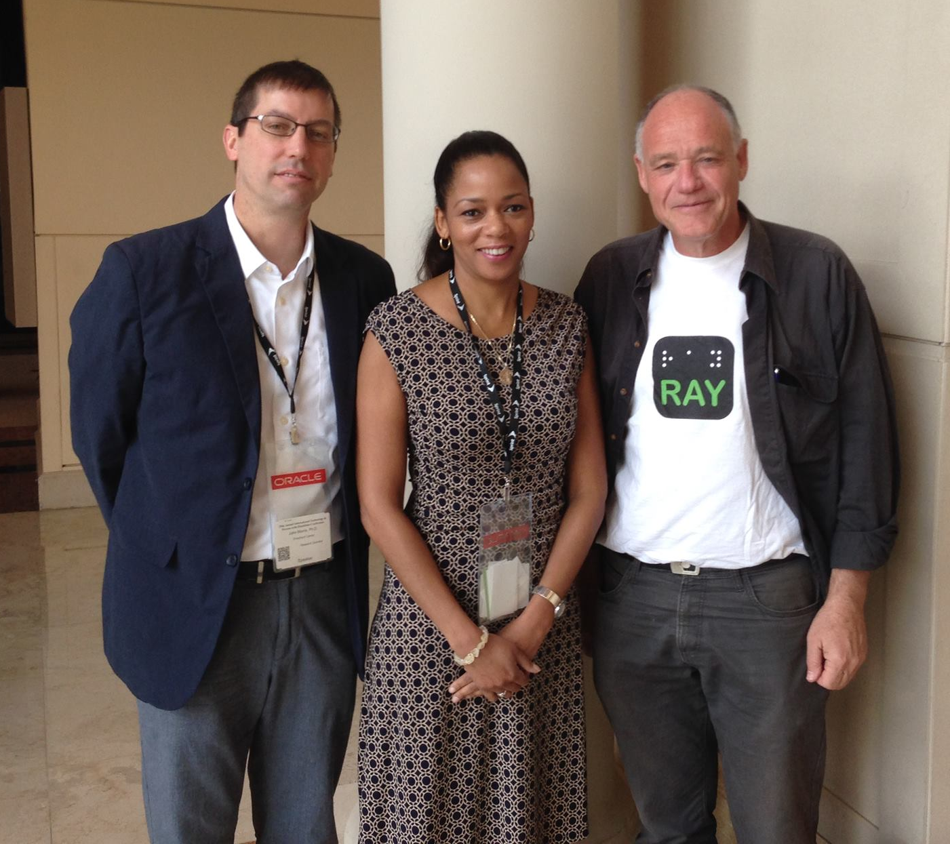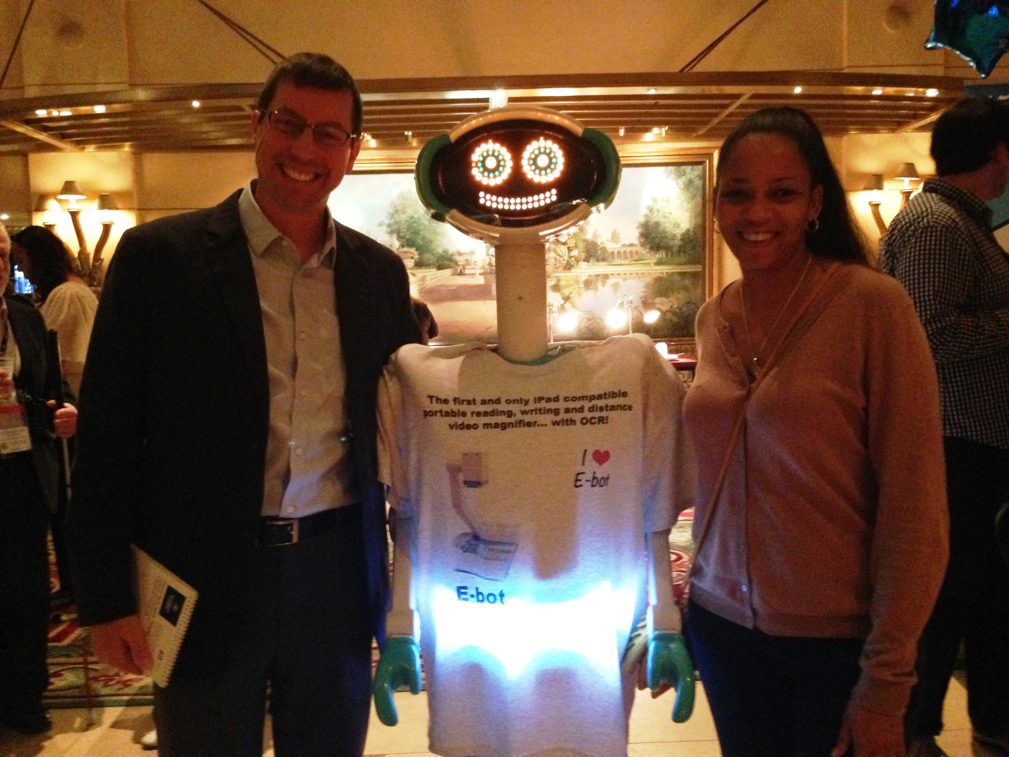

While making our way through the lobby look who we ran into! He (distinctly male voice) was quite witty. As John mused about who was controlling him, he quickly retorted, “Is Someone controlling you?” “Oh yes,” we replied, laughing.

Additional Information
Project Ray Demonstration
[http://www.project-ray.com/]

Assistive and Accessible Apps
John Morris presented “Smartphone and Tablet Apps for Case Managers and Their Patients,” at the Palmetto chapter of the Case Manager Society of America meeting on March 15, 2014. He shared information on the distinction between assistive and accessible apps and how to identify accessibility features within apps. Additionally John highlighted and described specific apps for memory, patient and family education and way finding. He closed with a discussion of how to evaluate apps. To view his presentation visit: http://b.gatech.edu/1jYZoaM.

Upcoming Events

Career Expo for People with Disabilities
The Equal Opportunity Publications (EOP) Career Expo for People with Disabilities will be held at the in Washington, D.C. on April 4, 2014. The Expo is an opportunity for people with disabilities to meet with companies and government agencies currently seeking to hire new talent. EOP urges all those interested in the Expo to register at http://www.eop.com/stemexpo and submit a resume, which will be sent to the recruiters present at the Expo regardless of attendance. Follow the link for other Expo dates and cities.

Additional Information
EOP Career Expo
[http://www.eop.com/expo]

Save the Date: 2014 Disability Policy Seminar
The 2014 Disability Seminar will be held in Washington, D.C. on April 7 – 9. The Seminar will offer individuals a chance to hear from “leading public policy experts, disability advocates and Congressional staff” as they discuss key topics relating to the disability community including Medicaid, employment, education and healthcare. Registration for the event will open soon, and any questions can be sent to Robin Powers at mailto:robin@cmig.com.

Additional Information
2014 Disability Policy Seminar
[http://www.thearc.org/page.aspx?pid=2173]

Arthritis State of the Science Meeting
The Center for Enhancing Activity and Participation among Persons with Arthritis (ENACT) in partnership with the National Institute on Disability and Rehabilitation Research (NIDRR) will host a State of the Science Meeting on April 7, 2014 in Pentagon City, Virginia. The meeting will bring together leading experts and researchers in the fields of rheumatology and rehabilitation science to discuss “Promoting Activity and Participation among Persons with Arthritis.” With the goal of advancing arthritis research, the conference will focus on current “innovations for promoting activity and participation within the community, rehabilitation, and employment.”

Additional Information
ENACT State of Science Meeting
[http://www.bu.edu/enact/sos2014/sos-april7/]

Public Policy Luncheon - Emergency Communications Alerts: Roles & Responsibilities of Industry
The Center for Advanced Communication Policy (CACP), Georgia Tech and The Federal Communications Bar Association (FCBA) present Public Policy Luncheon Series April 14, 2014, 12:00pm-1:30pm held at the Georgia Tech Research Institute (GTRI) Building 250 14th St., NW, Rm. 119 Atlanta, GA 30318. Public Policy Luncheon special topic event will highlight Emergency Communications Alerts: Roles & Responsibilities of Industry.
Panelists will include the Director of the Integrated Public Alert and Warning System (IPAWS), and representatives from Federal Emergency Management Agency, Department of Homeland Security, Cox Media Group/WSB-TV and Charter Communications. The panel will be moderated by Joiava Philpott, Vice President, Regulatory Affairs, Cox Communications, Inc. The doors will open at 11:30am. Panel discussion will begin promptly at 12:00pm.
Please RSVP to: Jackie Herndon or 404-385-4612 or Jackie@cacp.gatech.edu
Complimentary boxed lunches and beverages will be served. Sandwich selections will be comprised of the following: Ham and Swiss, Turkey and Swiss, Tuna Salad, Chicken Salad or Vegetarian.

M-Enabling Summit
The 2014 M-Enabling Summit will be held in Washington, D.C. from June 9-10. The Conference and Showcase are hosted by the Global Initiative for Inclusive Information and Communication Technologies (G3ict) and E.J. Krause & Associates. The focus is on accessible use of mobile technologies, applications and services as well as assistive technology solutions.

Additional Information
M-Enabling Summit 2014
[http://m-enabling.com/index.html]

Technology and Disability Policy Highlights
March 2014
Technology and Disability Policy Highlights reports on national and local public policy events, recent wireless technological advances and political activities; and tracks emerging issues of interest to individuals with disabilities. The TDPH is published monthly by the Wireless RERC. The Wireless RERC is a research center that promotes universal access to wireless technologies and explores their innovative applications in addressing the needs of people with disabilities. For more information on the Wireless RERC and/or to subscribe to the TDPH please visit our web site at [http://www.wirelessrerc.org].

For further information on items summarized in this report, or if you have items of interest that you would like included in future editions, please contact this edition’s editors, Braeden Benson [braeden@cacp.gatech.edu], Salimah LaForce [salimah.laforce@cacp.gatech.edu], or James White, Ph.D., [james@cacp.gatech.edu].
_________________________________________________________________________________

This is a publication of the Rehabilitation Engineering Research Center for Wireless Technologies supported by the National Institute on Disability and Rehabilitation Research of the U.S. Department of Education, grant # H133E060061. The opinions contained in this publication are those of the grantee and do not necessarily reflect those of the U.S. Department of Education.

