Common Misconceptions Regarding People who are Deaf & Rely on American Sign Language

American Sign Language
- Misconception - American Sign Language (ASL) is English and uses gestures and signs to represent spoken words or written English.
- Reality – ASL is the native language of the Deaf Community in the United States. Although it’s called “American” Sign Language, it has no roots in English.
ASL is taught in our colleges as a foreign language with its own unique syntax, vocabulary, grammar, and idioms.
- Misconception – Not many people use ASL.
- Reality – ASL is among the most common languages used in the United States.
- Misconception – Emergency information and alerts written in “simple terms” provides equal access.
- Reality – Text alerts do not provide “clear and effective” communication for persons who rely on ASL. Successful comprehension of an emergency message directly impacts the recipient’s appropriate response.
People with sensory disabilities must access information in the modality (ASL, Braille, voice, etc.) that best meets their needs.

ASL Translation Apps
- Misconception – ASL translation apps can replace interpreters.
- Reality – As their disclaimers state, “Not meant to replace a live interpreter.” These apps use English word order which is not used in ASL and can cause confusion; they are limited in their ability to provide adequate translation of English.
Example, type the phrase “you need to evacuate!” The avatar will use the correct sign for “you” and “need” but it will finger spell the word “evacuate.” An ASL user may only know that they needed something but not “what.” Finger spelling a word is almost the same as writing it in English.

Emergency Information on Local News
- Misconception - Captioning provides access to emergency information on TV.
- Reality – The Deaf Community is diverse. There are people who are born Deaf and are extremely fluent in English, but for most Deaf individuals English is a second language.
There are people who have become Deaf (late-deafened) and who do not know ASL. These are the people that rely on captions.
It is best if emergency messages and situational updates shown on TV have an interpreter on screen and captions in order for the information to be accessible to the Deaf Community.
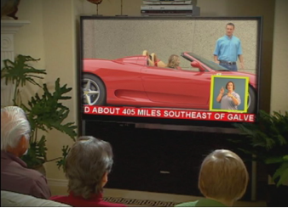

NOAA Weather Radios
- Misconception – Weather Radios will provide access to emergency warnings.
- Reality – Pillow vibrators or strobe lights can wake up/notify a person with sensory disabilities when there is an active alert.
For persons who are Deaf and rely on ASL, the vibration/light may wake them up but text displayed is inaccessible due to the language barrier. It does not provide them with “clear and effective” communication of the emergency messages.

Electronic copy of this document can be found at https://goo.gl/U6aL71, or scan the QR code on page two.

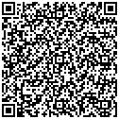

For more information: http://www.cacp.gatech.edu/ ● 404-894-8297 ● LaForce@cacp.gatech.edu

This is a publication of Georgia Tech’s Center for Advanced Communications Policy (CACP). This research and development is supported by the Integrated Public Alert & Warning System (IPAWS) Project Management Office (PMO) under contract # HSFE5-13-R-0031. The opinions contained herein are those of the grantee and do not necessarily reflect those of the U.S. Department of Homeland Security, IPAWS PMO.

