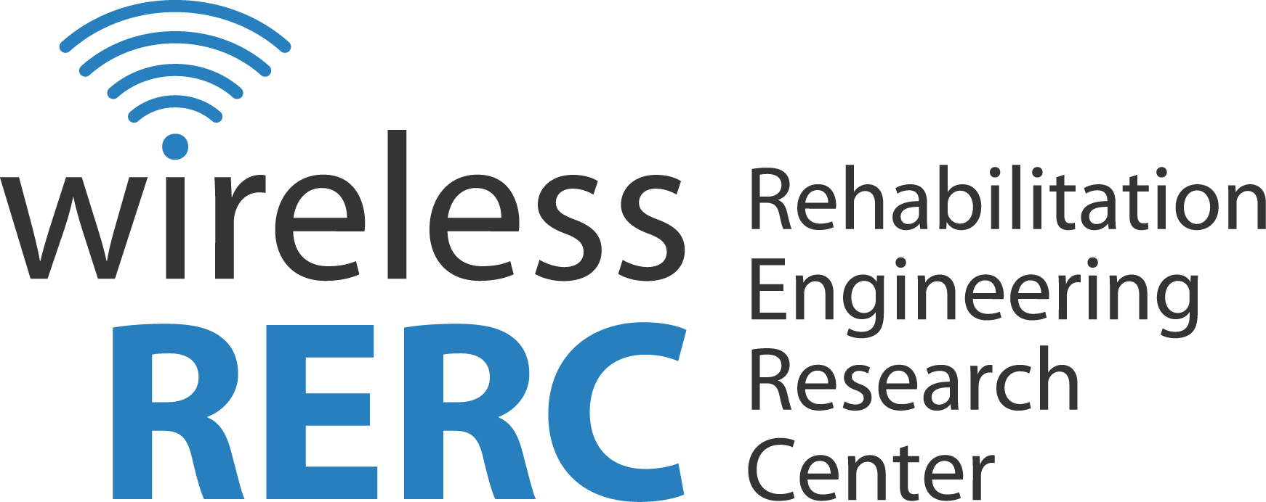
Technology and Disability Policy Highlights
August 2012

Overview
In August, due to recent requests for exemption from closed captioning and video description requirements the Federal Communications Commission clarified the definition of “economically burdensome,” maintaining the assessment factors outlined in the Communications Act of 1934 (as amended). The Commission is also prepared for their First Biennial Report to Congress on the state of accessibility of communications technologies and services, releasing for comment a Public Notice [CG Docket No. 10-213] of “tentative findings.” The Emergency Access Advisory Committee (EEAC) will meet on September 14, 2012 to report progress in their examination of technologies and practices that would enable people with disabilities to access forthcoming Next Generation 911 (NG911) emergency services.

Click the headings below to link directly to a particular section.
Regulatory Activities
Other Items of Interest
Wireless RERC Updates
Upcoming Events

Regulatory Activities

FCC Publishes Final Rule on Closed Captioning and Video Description
August 13, 2012 – The Federal Communications Commission released the Final Rule [47 CFR Part 79] regarding the definition of “economically burdensome” as it applies to evaluating individual applications for exemption to closed captioning and video description rules. The Twenty-First Century Communications and Video Accessibility Act of 2010 (CVAA) changed the language of the Communications Act of 1934, as amended, from “undue burden” to “economically burdensome.” The Final Rule maintains that though the terminology is different, the meaning remains the same. Therefore, applications for exemption will continue to be assessed using the following four factors: (1) the nature and cost of closed captions for the programing, (2) operational impact on the provider or program owner, (3) financial resources of provider or program owner, and (4) the type of operation.

Additional Information
Final Rule
[https://www.federalregister.gov/articles/2012/08/13/2012-18898/closed-captioning-and-video-description-of-video-programming]

Emergency Access Advisory Committee
August 22, 2012 – The Federal Communications Commission’s Emergency Access Advisory Committee (EEAC) will meet on September 14, 2012. The EEAC was mandated by the Twenty-First Century Communications and Video Accessibility Act of 2010 (CVAA) to investigate technologies, procedures and practices that would enable people with disabilities to access forthcoming Next Generation 911 (NG911) emergency services. The EEAC working groups will present on topics such as an interim text-to-911 solution, interoperability, incorporating communication assistance at the emergency call centers, such as American Sign Language interpreters, NG911 timeline, and more. The meeting is open to the public. For more information contact Cheryl King, Consumer and Governmental Affairs Bureau or Patrick Donavon, Public Safety and Homeland Security Bureau (contact information provided below).

Additional Information
Public Notice
[http://transition.fcc.gov/Daily_Releases/Daily_Business/2012/db0822/DA-12-1372A1.pdf]

Contact Information:
Cheryl King, Consumer and Governmental Affairs Bureau, 202-418-2284 (voice), 202-418-0416 (TTY), or Cheryl.King@fcc.gov
Patrick Donovan, Public Safety and Homeland Security Bureau, 202-418-2413, Patrick.Donovan@fcc.gov

State of Accessibility of Communications technologies
August 23, 2012 –The Consumer and Governmental Affairs Bureau of the Federal Communications Commission released a Public Notice [CG Docket No. 10-213] Seeking Comment on its Tentative Findings about the Accessibility of Communications Technologies. This included assessment of the impact of the passage of the Twenty-First Century Communications and Video Accessibility Act of 2010 (CVAA) on the accessibility of telecommunications and advanced communications services and equipment for the Commission’s First Biennial Report. With regard to compliance with Section 255, tentative findings/comments of consumer representatives stated that “devices covered under Section 255 are pervasively inaccessible.” Such devices include analog and digital handsets, cordless phones used with VoIP services and landlines, wireless services and equipment, including smartphones. However, the record is limited and certain sections are dominated by comments from industry representatives while other sections are dominated by input from consumer groups. The relatively small sample of commenters may bias the findings. The initial comment period closed September 6, 2012, but those interested may still file ex parte comments. [Source: Federal Communications Commission]

Additional Information
Public Notice
[http://transition.fcc.gov/Daily_Releases/Daily_Business/2012/db0823/DA-12-1391A1.pdf]

Wireless RERC News

Wireless RERC launches new Survey of User Needs!
The Wireless RERC’s consumer research team has just launched its updated Survey of User Needs (SUN), our cornerstone survey on wireless use and usability by people with disabilities. The SUN has been completed by over 5000 people with disabilities since it was first launched in 2003.

This latest version represents the third update to this critical survey. As technology changes, so has the SUN. The data we gather through the SUN provides important information to the wireless industry, government regulators, and other researchers to help them make wireless technology more accessible and more useful to people with all types of disabilities.

If you have a disability PLEASE consider taking this survey. If you know someone who has a disability, please forward the survey to them.

Additional Information:
Survey of User Needs
[https://www.surveymonkey.com/s/SUN_2012-2013]

Industrial Design Student UD Solutions Now On-line
The 2012 “Getting Wireless: Exploring Universal Design in Wireless Technologies,” student projects are available on the Wireless RERC’s website. Industrial design student teams at Georgia Tech and Virginia Tech competed last spring in the Wireless RERC’s “Getting Wireless” universal design (UD) competition. Some solutions include wrist accessories for smartphones, wearable medical devices, left/right hand detection and auto control adjustment, and concave screens. View all the entries and judge for yourself!

Additional Information
2012 “Getting Wireless” student design challenge
[http://www.wirelessrerc.org/content/projects/2012-student-design-challenge]

Other Items of Interest

Verizon Announces Mobile Accessibility Suite
August 17, 2012 – Verizon Wireless has made available a Mobile Accessibility Suite for their Android 2.2 or higher smartphones. According to Verizon, the Mobile Accessibility Suite is a collection of ten apps designed to enhance usability by people who are blind or have low vision. Some features include voice recognition, text-to speech software, and Braille output. Verizon also reports that consumers will be able to experience full access to the mobile browser.

Additional Information
Press Release
[http://news.verizonwireless.com/news/2012/08/pr2012-08-16i.html]

AT&T Offers Smart911
August 21, 2012 – AT&T, in collaboration with Rave Mobility Safety, is offering a free Smart911 service to citizens. Smart911 allows users to create SmartSafety profiles, outlining information such as type of disability, medical condition, allergies, medications, etc., to be automatically sent to 911 dispatchers upon placing a 911 call. According to AT&T, the purpose of the service is to enhance the effectiveness of 911. The service goes live in September 2012, but may not be widely available, because though the service is free to citizens, 911 call centers have to purchase and install Smart911 software.

Additional Information
Press Release
[http://www.att.com/gen/press-room?pid=23210&cdvn=news&newsarticleid=35176&mapcode=enterprise|mk-enterprise-security]

Emergency Weather Alerts for the Blind and Print Disabled
August 29, 2012 – The National Federation of the Blind (NFB) and AccuWeather® have joined forces to provide accessible weather alerts to the blind and print disabled. Audible weather alerts will be disseminated via NFB-Newsline®, a free service that offers hundreds of newspapers and magazines in audible formats. According to NFB, the service is the first of its kind, bringing independent access to emergency information to the blind.

Additional Information
Press Release
[https://www.nfb.org/national-federation-blind-collaborates-accuweather%C2%AE]

Upcoming Events

Get Ready Gwinnett! Emergency Preparedness Resource Fair & Speaker Series
The Gwinnett Emergency Preparedness Committee is hosting an Emergency Preparedness Resource Fair and Speaker Series on Saturday, September 15, 2012, from 9:000am – 4:00pm at the Annandale Village in Suwanee, Georgia. The goal of the event is to improve the preparedness of, and provide resources to people with disabilities, the elderly and others with access and functional needs.

Additional Information:
Registration
[http://getreadygwinnett.digitaldiplomats.com/speaker-series-registration/]
Help Line: 770-955-3339 / getreadygwinnett@gmail.com

Building Rehabilitation Research Capacity at the Nexus of New Technologies, Aging and Disability
The Rehabilitation Engineering Research Center on Technologies for Successful Aging with a Disability (OPIT-RERC) will hold their State of the Science Conference in Marina del Rey, California on October 25-26, 2012. The conference will discuss perspectives on aging and disability research and advances in new technologies with an aim to “develop a strategy for responding to future needs and opportunities and strengthening the comparative effective evidence-base for policy and practice decision-making that embodies the nexus perspective.”

Additional Information:
OPIT-RERC State of Science Conference
[http://www.isi.edu/research/rerc/coming_events/]

The State of the States in Cognitive Disability and Technology
The Coleman Institute for Cognitive Disabilities will host their 12th annual conference, The State of the States in Cognitive Disabilities and Technology, on November 2, 2012 at the Westin Westminster Hotel in Westminster, Colorado. The conference will “cover an annual review of the state of the economy, the state of federal disability policy and law, and the state of technology with projections for the future and explorations of impact on quality of life for people with cognitive disabilities.”

Additional Information:
The State of the States in Cognitive Disability and Technology
[http://www.colemaninstitute.org/]

Accessing Higher Ground
The University of Colorado at Boulder will host the 15th Annual Accessing Higher Ground Conference from November 12 – 16, 2012 at the Westin Hotel in Westminster, Colorado. The conference “focuses on the implementation and benefits of accessible media, universal design and assistive technology in the university, business and public settings.”

Additional Information:
Accessing Higher Ground
[http://www.colorado.edu/ATconference/index.html]

Assistive Technology Across the Lifespan Conference
WisTech in collaboration with The Stout Vocational Rehabilitation Institute, Cooperative Educational Service Agencies, and Milwaukee Public Schools will host the Assistive Technology Across the Lifespan Conference from December 6 – 7, 2012 at the Glacier Canyon Lodge Conference Center in Wisconsin Dells, Wisconsin. The conference will discuss “successful applications of assistive technology for persons with disabilities” and will also feature an exhibition hall with hands-on assistive technology sessions.

Additional Information:
Assistive Technology Across the Lifespan Conference
[http://www.atacrosslifespan.org/]

The Wireless Innovation Forum Conference
The Wireless Innovation Forum will be hosting a conference on Communications Technologies and Software Defined Radio (SDR-WInnComm) in Washington, DC from January 8-13, 2013. The conference will discuss “advancement of reconfigurable radio technologies from research through deployment.”

Additional Information:
The Wireless Innovation Forum Conference
[http://conference.wirelessinnovation.org/mc/page.do?sitePageId=102427&orgId=s1]

2013 International CES
The Consumer Electronics Agency (CEA) will host the 2013 International Consumer Electronics Show (CES) from January 8 – 11, 2013 in Las Vegas, NV. Conference sessions include business insights, home entertainment, lifestyle technology, wireless communications, emerging technology, disruptive technologies, and in-vehicle technology.

Additional Information:
Conference Website
[http://www.cesweb.org/]

Technology and Disability Policy Highlights
August 2012
Technology and Disability Policy Highlights reports on national and local public policy events and recent wireless technological advances and political activities; and tracks emerging issues of interest to individuals with disabilities. Technology and Disability Policy Highlights is published monthly by the Wireless RERC. The Wireless RERC is a research center that promotes universal access to wireless technologies and explores their innovative applications in addressing the needs of people with disabilities. For more information on the Wireless RERC, please visit our web site at [http://www.wirelessrerc.org].

For further information on items summarized in this report, or if you have items of interest that you would like included in future editions, please contact this edition’s editors, Salimah LaForce [salimah.laforce@cacp.gatech.edu], or James White, Ph.D., [james@cacp.gatech.edu].
_________________________________________________________________________________
This is a publication of the Rehabilitation Engineering Research Center for Wireless Technologies supported by the National Institute on Disability and Rehabilitation Research of the U.S. Department of Education, grant #H133E110002. The opinions contained in this publication are those of the grantee and do not necessarily reflect those of the U.S. Department of Education.

